

Hazardous Materials Contingency Plan
External Version

New Mexico Tech Office for Research
Last modified Oct 20, 2025

The purpose of this document is to provide guidance concerning the basic procedures to use in the event of fire, explosion, or any unplanned release of chemical or hazardous materials, or their constituents, to air, soil, or surface water.

This document is continually being updated; we would appreciate any information and/or insight that would help us develop stronger policies for NMIMT’s research community.

Table of Contents

- Definitions and Acronyms …………………………………………………………. 3
- Introduction…………………………………………………………………………… 4
- Control Procedures…………………………………………………………………… 5
  - Containment Areas…………………………………………………………………… 5
  - Prevention and Protection…………………………………………………………… 5
  - Training………………………………………………………………………………… 5
- Roles and Responsibility……………………………………………………………. 6
  - Faculty and Staff……………………………………………………………………… 6
  - NMT Hazardous Waste Response Team…………………………………………… 6
  - NMT Emergency Coordinator (Primary and Secondary…………………………. 6
  - Campus Police………………………………………………………………………… 6
- Implementation of the Contingency Plan………………………………………… 7
  - Criteria for Implementation of Contingency Plan………………………………… 7
  - NMT Emergency Coordinator Contact Information……………………………… 8
  - Emergency Equipment……………………………………………………………….. 9
  - Reporting an Emergency…………………………………………………………….. 10
  - Evacuation……………………………………………………………………………… 10
  - Control and Containment…………………………………………………………….. 10
  - Notification of Authorities…………………………………………………………….. 11
- Follow Up Actions……………………………………………………………………… 14
  - Storage and Disposal…………………………………………………………………… 14
  - Investigation of Incident……………………………………………………………….. 14
  - Reporting to the Regional Administrator…………………………………………….. 15
- Program Review………………………………………………………………………… 16
  - Annual Review………………………………………………………………………….. 16
  - Amendment of Contingency Plan…………………………………………………….. 16
- Appendix I: NMT Campus Maps…………………………………………………….. 17
- Appendix II: Types of Chemicals and Waste……………………………………….. 37

- Definitions and Acronyms

CFR Code of Federal Regulations: the codification of the general and
permanent regulations promulgated by the executive departments and agencies of the federal government of the United States. The CFR is divided into 50 titles that represent broad areas subject to federal regulation.

Contingency Plan A plan the describes the actions to be taken by university
personnel in the event of an unplanned release or spill of hazardous materials or hazardous waste.

EPA Environmental Protection Agency: an independent executive
agency of the United States federal government tasked with environmental protection matters.

HAZMAT Hazardous Materials: Solids, liquids, or gasses that can harm
people, other living organisms, property, or the environment. They are often subject to chemical regulations. Hazardous materials include radioactive, flammable, explosive, corrosive, oxidizing, asphyxiating, biohazardous, toxic, pathogenic, or allergenic substances. Included are physical conditions such as compressed gasses and liquids or hot materials, including all goods containing such materials or chemicals, or may have other characteristics that render them hazardous in specific circumstances.

OSHA Occupational Health and Safety Administration: is part of the
United States Department of Labor that ensures the safe and healthful working conditions for workers by setting and enforcing standards as well as providing training, outreach, education, and assistance.

NMED New Mexico Environmental Department: is a state government
agency responsible for "protecting and restoring the environment of the state of New Mexico to foster a healthy and prosperous New Mexico for present and future generations," according to its mission statement.

II. Introduction

New Mexico Institute of Mining and Technology (NMT) is committed to protecting the environment and providing a safe and healthy workplace for all employees. This document outlines NMT’s contingency plan for emergency response and prevention procedures related to hazardous materials and hazardous wastes. The procedures described have been designed to minimize risks to public health and the environment from major spills, explosions, fire, and the release of hazardous materials/waste. The plan was designed in accordance with all federal and state laws related to emergency preparedness and prevention of emergency events, including the Environmental Protection Agency (EPA) requirements in 40 CFR 264 subpart D, 40 CFR 265 subpart D, 40 CFR 279.52, (SPCC) 40 CFR 112.

Note: This version of the Contingency Plan has been redacted for public release.

Personal contact details of emergency coordinators and internal response personnel have been removed to protect privacy and security.

Full emergency contact information and detailed response procedures are maintained in the Internal Contingency Plan, available to authorized emergency response personnel and regulatory inspectors upon request.

III. Control Measures

A. Containment Areas

The primary chemical spill emergency measure will be the adequate provisioning of containment areas. Access to, and housekeeping of, each department shall be the responsibility of the organization that is the end user. The end user shall monitor the building to ensure chemical waste storage capacity is not exceeded and that all materials are stored exclusively with compatible materials.

B. Prevention and Detection

Personnel shall be educated and trained in the identification, handling, and storage of chemical products, including basic hazard communication and proper disposal of chemical wastes. Hazardous Waste Accumulation Areas and areas with a high potential for spills to occur shall be routinely inspected. Such inspections shall be conducted on a weekly basis, and immediately after a chemical emergency in the site.

C. Training

Campus personnel who have responsibilities in this plan will receive initial and annual training in accordance with 29 CFR 1910.120 (e)(1) and (e)(8). Hazardous waste handlers will also receive initial and annual training pertaining to their responsibilities. Each department shall maintain copies of all their training records.

IV. Roles and Responsibilities

A. Faculty and Staff

- Report chemically related incidents and emergencies to supervisor, Department Chair, and NMT’s Hazardous Materials and Laboratory Safety Specialist
- Inspect chemical waste storage areas.
- Contact the Campus Police in the event of an incident that requires implementation of this Contingency Plan. Campus Police will alert the Emergency Coordinators.
- Do not attempt to stop a spill or come into contact with the spilled material.

B. NMT Hazardous Waste Response Team

- Maintain and update this document as needed.
- Advice on environmental, health, and safety topics when consulted.
- Appoint and train Emergency Coordinators; continue training on an annual basis.
- Maintain records of all incidents.

C. NMT Emergency Coordinator

- Shall be “on-site” or “on-call”.
- Shall be notified immediately in the event of an actual or imminent chemical emergency.
- Initiate actions to contain the chemical spill and begin corrective actions.
- Shall have the responsibility of coordinating all emergency response procedures.
- Notify all applicable agencies as required.
- Will yield incident command to public authorities when they are called into the facility.
- Conduct an investigation of all incidents.
- Prepare reports of all incidents and provide information to appropriate agencies as required.

D. Campus Police

- Campus Police will alert the Emergency Coordinator(s) upon notification of a spill, release, or fire.
- Secure incident scene to prevent unauthorized access to the area.
- Oversee the evacuation of the affected area as necessary.

V. Implementation of the Contingency Plan

A. Criteria for Implementation of Contingency Plan

The Emergency Coordinator (or their designee) has full authority to make the decision to implement the Contingency Plan. This decision may be based on one or more of the conditions in this section.

The Contingency Plan will go into effect immediately under the following conditions:

- Fire or explosion related to:
  - Hazardous material.
  - Sudden or non-sudden release involving a “Poison by Inhalation” hazard.
  - Sudden or non-sudden release involving Hydrofluoric Acid.
  - Sudden or non-sudden release that would require use of greater than Level C Personal Protective Equipment (PPE) during response. For example, dust, fumes, or other exposure where a supplied air respirator is required.
  - Sudden or non-sudden release of hazardous material of greater volume than listed below (other than “Poison by Inhalation” or Hydrofluoric Acid listed above).

Material | Amount
Flammable Liquids | > 2 liters
Flammable Solid | > 1 pound
Dangerous When Wet | > 1 pound
Spontaneously Combustible | > 1 pound
Oxidizer | > 1 pound
Toxic Liquid | > 0.45 liters
Toxic Solid | > 1 pound
Corrosive | > 500 mL
Table 1: Hazard Thresholds for Implementing Contingency Plan

Chemical hazard information will be based on information described in Safety Data Sheets (SDSs), PPE requirements, and the assessment of the Primary Emergency Coordinator.

Furthermore, the Primary Emergency Coordinator has full authority to implement the Contingency Plan if the above criteria are not met, but the Primary Emergency Coordinator (or their designee) has assessed that there is an imminent or actual threat to human health or the environment.

Whenever there is an imminent or actual emergency situation, the Emergency Coordinator (or their designee) must immediately:

- Activate internal alarms or communication systems, where applicable, to notify affected personnel.
- Notify appropriate State or local agencies with designated response roles, if their help is needed.

Whenever there is a release, fire, or explosion, the Emergency Coordinator must immediately identify the character, exact source, amount, and area of extent of any released materials. Concurrently, the Emergency Coordinator must assess possible hazards to human health or the environment that may result from the release, fire, or explosion (e.g., the effects of any toxic, irritating, or asphyxiating gasses that are generated, or the effects of any hazardous surface water run-offs from water or chemical agents used to control fire and heat-induced explosions).

During an emergency, the Emergency Coordinator must take all reasonable measures necessary to ensure that fires, explosions, and releases do not occur, recur, or spread to other hazardous waste at the facility. These measures must include stopping processes and operations, collecting and containing released waste, and removing or isolating containers.

If the facility stops operations in response to fire, explosion, or release, the Emergency Coordinator must monitor for leaks, pressure buildup, gas generation, or ruptures in valves, pipes, or other equipment where appropriate.

Immediately After an emergency, the Emergency Coordinator must provide for treating, storing, or disposing of recovered waste, contaminated soil or surface water, or any other material that results from a release, fire, or explosion at the facility.

B. NMT Emergency Coordinator Contact Information

Personnel designated as Primary and Secondary Emergency Coordinators are listed below with their contact information.

Primary Emergency Coordinator
Benjamin Thomas
Hazardous Materials and Laboratory Safety Specialist
Work Phone: 575-517-0646

Secondary Emergency Coordinator
Mikell Coleman
Director of Research Compliance
Work Phone: 575-418-7155

C. Emergency Equipment

Table 2 contains a list of equipment items, their uses, and their locations.

Item | Use | Location
Bulk containers of vermiculite, Dry Rite, and Brooms | Absorbing and stopping the flow of chemical and/or petroleum release | Hazardous waste storage area
Respirator cartridges and respirator masks | For use by trained responders in a potentially hazardous atmosphere | Hazardous waste storage area
Level C full-face air purifying respirators, PPE gloves and boots, aprons, and lab coats | Personal protection during emergency response and clean up to reduce the chance of chemical exposure to skin contact | Hazardous waste storage area
Spill kits for minor spills | Absorption of chemicals from small quantity spills | All buildings that contain hazardous materials
Portable spill response kit containing small quantities of vermiculite, spill pillows, tape, sorbent brooms, and towels for small spills | For initial response to stop progression of spills, and for clean up of smaller quantity spills | Hazardous waste storage area
Fire extinguishers | For fire suppression to clear entrances and exits in order to evacuate building safely | Located in all buildings in paths of egress to doors
Table 2: List of Equipment Items, their Uses, and their Locations

- Cell phones and on-site phones are utilized in or near the Hazardous Waste Accumulation Areas.
- The fire alarm system monitors all smoke detectors, water flow alarms, manual pull stations, and fixed extinguishing systems. These systems will alert the Campus Police in the event of an alarm.

D. Reporting an Emergency

Contact NMT Campus Police at 575-835-5555 (ext. 5555 from a campus landline), and provide the dispatcher the following information:
- The nature of the emergency (chemical spills, injuries, fire, etc.)
- The location of the emergency
- What chemical was released (if known)
- The quantity of the chemical released (if known)

The fire alarm system may be activated manually by any employee using the manual pull stations located at each emergency exit in order to initiate an evacuation and to report an emergency. NMT Campus Police will also be alerted if an automatic alarm from the fire detection and extinguishing systems are triggered, but it is recommended that an individual contact the Campus Police with any information possible even in the case of an automated response.

E. Evacuation

In the event of a fire, explosion, spill, or other release, the Primary or Secondary Emergency Coordinator will notify NMT Campus Police if an evacuation situation is imminent. NMT Campus Police shall initiate an evacuation if directed to do so by the Emergency Coordinator. NMT Campus Police shall also dispatch an officer to the scene to establish a perimeter if the Emergency Coordinator deems it necessary.

Evacuation maps are located in hallways in each building. NMT personnel are instructed to treat hazardous chemical spill incidents as they would fire emergencies. Depending on the nature and amount of the material spilled. Evacuation would proceed in the same manner as a fire situation.

F. Control and Containment

This is the defensive action to halt the continued spread of a chemical spill or release and to limit the exposure from a chemical spill or release. These actions may involve public health and welfare protection activities, source control procedures, salvage operations, placement of physical barriers to halt the spread of the chemical by upstream impoundment, and the employment of certain materials to restrain the effects of the chemical on water sources. Initial containment will be undertaken only by qualified NMT personnel accompanied with authorized and qualified outside spill response contractors assisting as necessary. Cleanup action will include the use of absorbers and skimmers. Absorbents as listed in the Emergency Equipment table are available, and will be used as directed by the Emergency Coordinator. Cleanup actions for the chemical spills released to soil or water may require the use of the spill response contractor(s) identified in this plan.

G. Notification of Authorities

If the emergency coordinator determines that the facility has had a release, fire, or explosion which could threaten human health, or the environment outside of the facility, they must report their findings as follows:

- If their assessment indicates that evacuation of local areas may be advisable, they must immediately notify appropriate authorities. They must be available to help appropriate officials decide whether local areas should be evacuated. The Emergency Coordinator shall contact City of Socorro County Emergency Services (Fire, Emergency, and Police) if assistance is required at 911.
- They must immediately notify either: New Mexico Environmental Department at 1-800-219-6157 or the National Response Center at 1-800-424-8802.

The report must include the following:
  - Name and telephone number of the reporter
  - Name and Address of the facility
  - Time and type of incident (e.g. release, fire, explosion, etc.)
  - Name and quantity of material(s) involved, to the extent known
  - The extent of injuries, if any
  - The possible hazards to human health or the environment, outside the facility

If the chemical emergency meets the definition of a Comprehensive Environmental Response, Compensation, and Liability Act (CERCLA, aka Superfund) or a Superfund Amendments and Reauthorization Act (SARA) reportable release, the Emergency Coordinator shall contact the National Response Center at 1-800-424-8802.

An attempt to make emergency arrangements with local public safety agencies has been made specifying each agency’s function as listed in Table 3. Copies of this plan have been sent to these agencies, as well as information concerning generated hazardous wastes, Primary and Secondary Emergency Coordinators, and a map of the hazardous waste accumulation areas. Table 3 has information for internal emergency contacts at NMT.

Agency | Contact | Address and Non-Emergency Phone | Contact Number | Specific Function
City of Socorro Waste Water Division | Paula Taylor, Waste Water Superintendent | 111 School of Mines  Socorro NM, 87801 | 311  575-838-1606 | Release to Storm Drain
City of Socorro Utilities Division | Jay Santilles, Director | 111 School of Mines  Socorro NM, 87801 | 575-835-0240 | Release to Sanitary System
Socorro Fire Department | Lawrence Baca, Fire Chief | 200 Fisher ST.  Socorro NM, 87801 | 911  575-835-3969  575-835-4222 (Dispatch) | Fire Suppression and HAZMAT Response, EMS
Socorro Police Department | Angel Garcia, Police Chief | 406 Center St.  Socorro NM, 87801 | 911  575-835-4222 | Security and Perimeter Control, Emergency Dispatch
Socorro General Hospital | Veronica Pound,  Hospital Chief Executive | 1202 Highway 60 West  Socorro NM, 87801 | 575-835-1140  575-835-8700 | Medical Treatment of Personnel
Table 3: Local Agencies and Contact Information

Department/Division | Primary Contact | Office Phone
Campus Police | Jeremiah Benjey,  Interim Chief of Police | 575-835-5011
Office of Research Compliance and Safety | Benjamin Thomas, Hazardous Materials and Laboratory Safety Specialist | 575-517-0646
Office of Research Compliance and Safety | Mikell Coleman, Director of Research Compliance | 575-418-7155
Facilities Management | Robby Montgomery, Director of Facilities Management | 575-517-6699
Biology | Casia Barraclough Esparza, Lab Manager | 575-835-5509
Chemistry | Md Sydur Rahman, Lab Manager | 575-835-5263
Materials Engineering | T. David Burleigh, Professor | 575-835-5831
EMRTC | Tom Pleva, Research Technical Director | 575-835-5348
PRRC | Kate Wavrik, Research Associate | 575-835-5574
Physics | Carlos Lopez Carrillo, Assistant Teaching Professor | 575-835-5047
Petroleum Engineering | Sajjad Esmaeilpour, Assistant Professor | 575-835-5389
Chemical Engineering | Seth Price, Lab Manager | 575-418-8891
Earth and Environmental Sciences | Nicole Hurtig, Assistant Professor | 720-935-4911
Electrical Engineering | Chris Pauli | 575-835-5695
Bureau of Geology | Bonnie Frey, Associate Director | 575-835-5160
Mineral Engineering | Mehrdad Razavi, Associate Professor and Department Chair | 575-835-6447
Mechanical Engineering | Seokbin (Bin) Lim, Department Chair | 575-835-6589
CLASS | Taffeta Elliott, Department Chair | 575-835-5439
Environmental Engineering/Civil Engineering | Clint Richardson, Civil Engineering Department Chair | 575-838-5467
Table 4: Internal Emergency Contact Information

VI. Follow Up Actions

A. Storage and Disposal

Storage and disposal of recovered waste, contaminated soil, and contaminated water will be conducted in accordance with federal, state, and local laws, or instructions from the EPA.

B. Investigation of Incident

The NMT Emergency Coordinator shall conduct an investigation of each incident to determine the root cause of the incident and establish steps to prevent recurrence. Copies of this investigation will be submitted to the Incident Commander, Department Chair or Manager/Director, Research Compliance Office, Senior Administration (at VP level or above), and regulatory authorities if requested. Business continuity operations will proceed to ensure federal, state, and local authorities have been notified and that the resumption prerequisites have been met by those authorities.

C. Reporting to the Regional Administrator

NMT will note in the operating record the time, date, and details of any incident that requires implementing the contingency plan. Within 15 days after the incident, NMT will submit a written report on the incident to the Regional Administrator in accordance with 40 CFR Section 265.56 (j). This report must include the following:

- Name, address, and telephone number of the owner or operator
- Name, address, and telephone number of the facility
- Date, time, and type of incident (e.g. fire, explosion, etc.)
- Name and quantity of material(s) involved
- The extent of injuries, if any
- An assessment of actual or potential hazards to human health or the environment, where this is applicable
- Estimated quantity and disposition of recovered material that resulted from the incident

VII. Program Review

A. Annual Review

NMT’s Emergency Coordinator will review the following and report significant findings to the Assistant Vice President (AVP) of the university:

- Hazardous Waste Contingency Plan for completeness and accuracy, including contact numbers
- Deficiencies noted
- Recommend revisions in document and in practice

B. Amendment of Contingency Plan

The Hazardous Waste Contingency Plan shall be amended if any of the following criteria are met:

- Applicable regulations are revised
- The plan fails in an emergency
- The facility changes in its design, construction, operation, maintenance, or other circumstances, in a manner that would increase the potential for fires, explosions, or releases of hazardous waste
- Changes in the response necessary in an emergency
- The list of Emergency Coordinators changes
- The list of emergency equipment changes

VIII. Appendix I: NMT Campus Maps
Original pdf diagrams available by request from FM
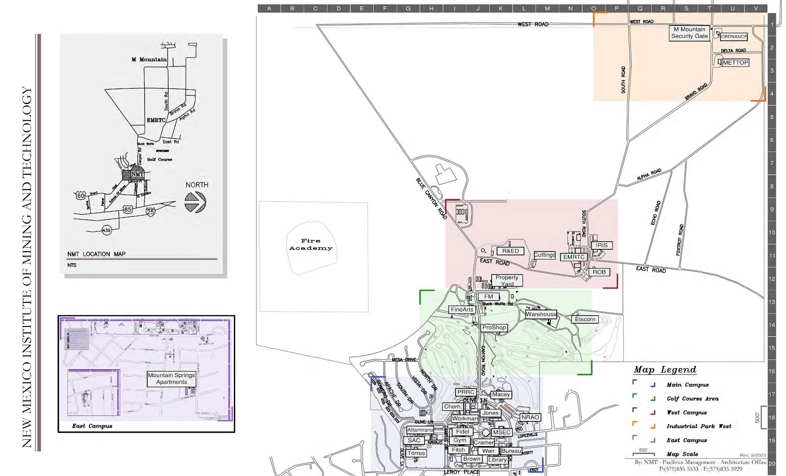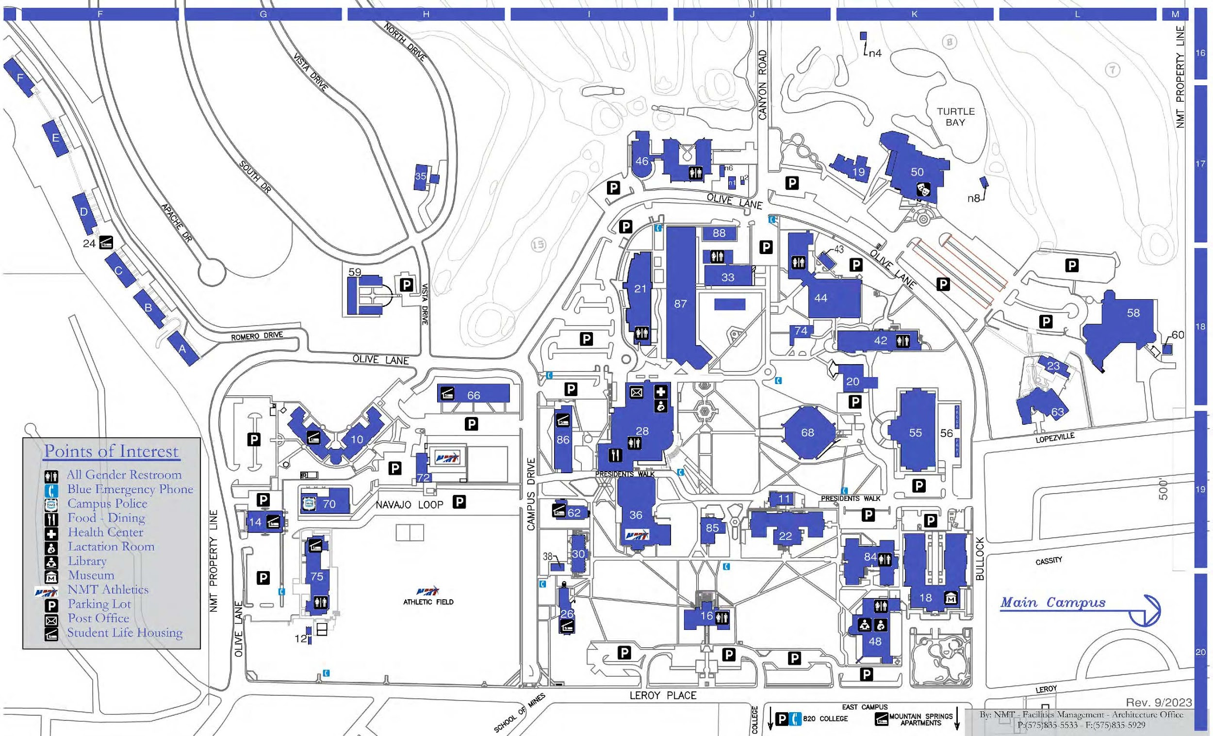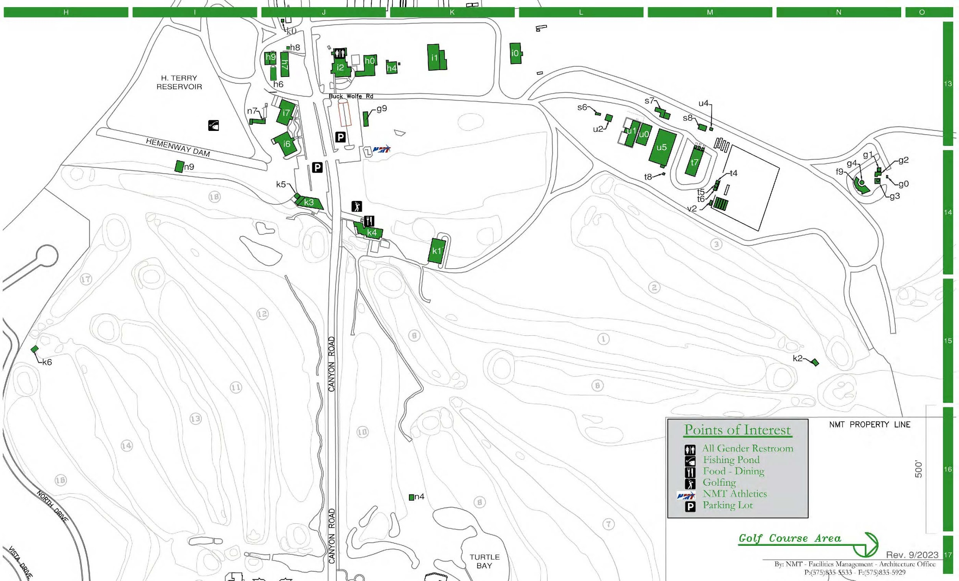
NMT Campus Map
NMT Main Campus
NMT Golf Course Area
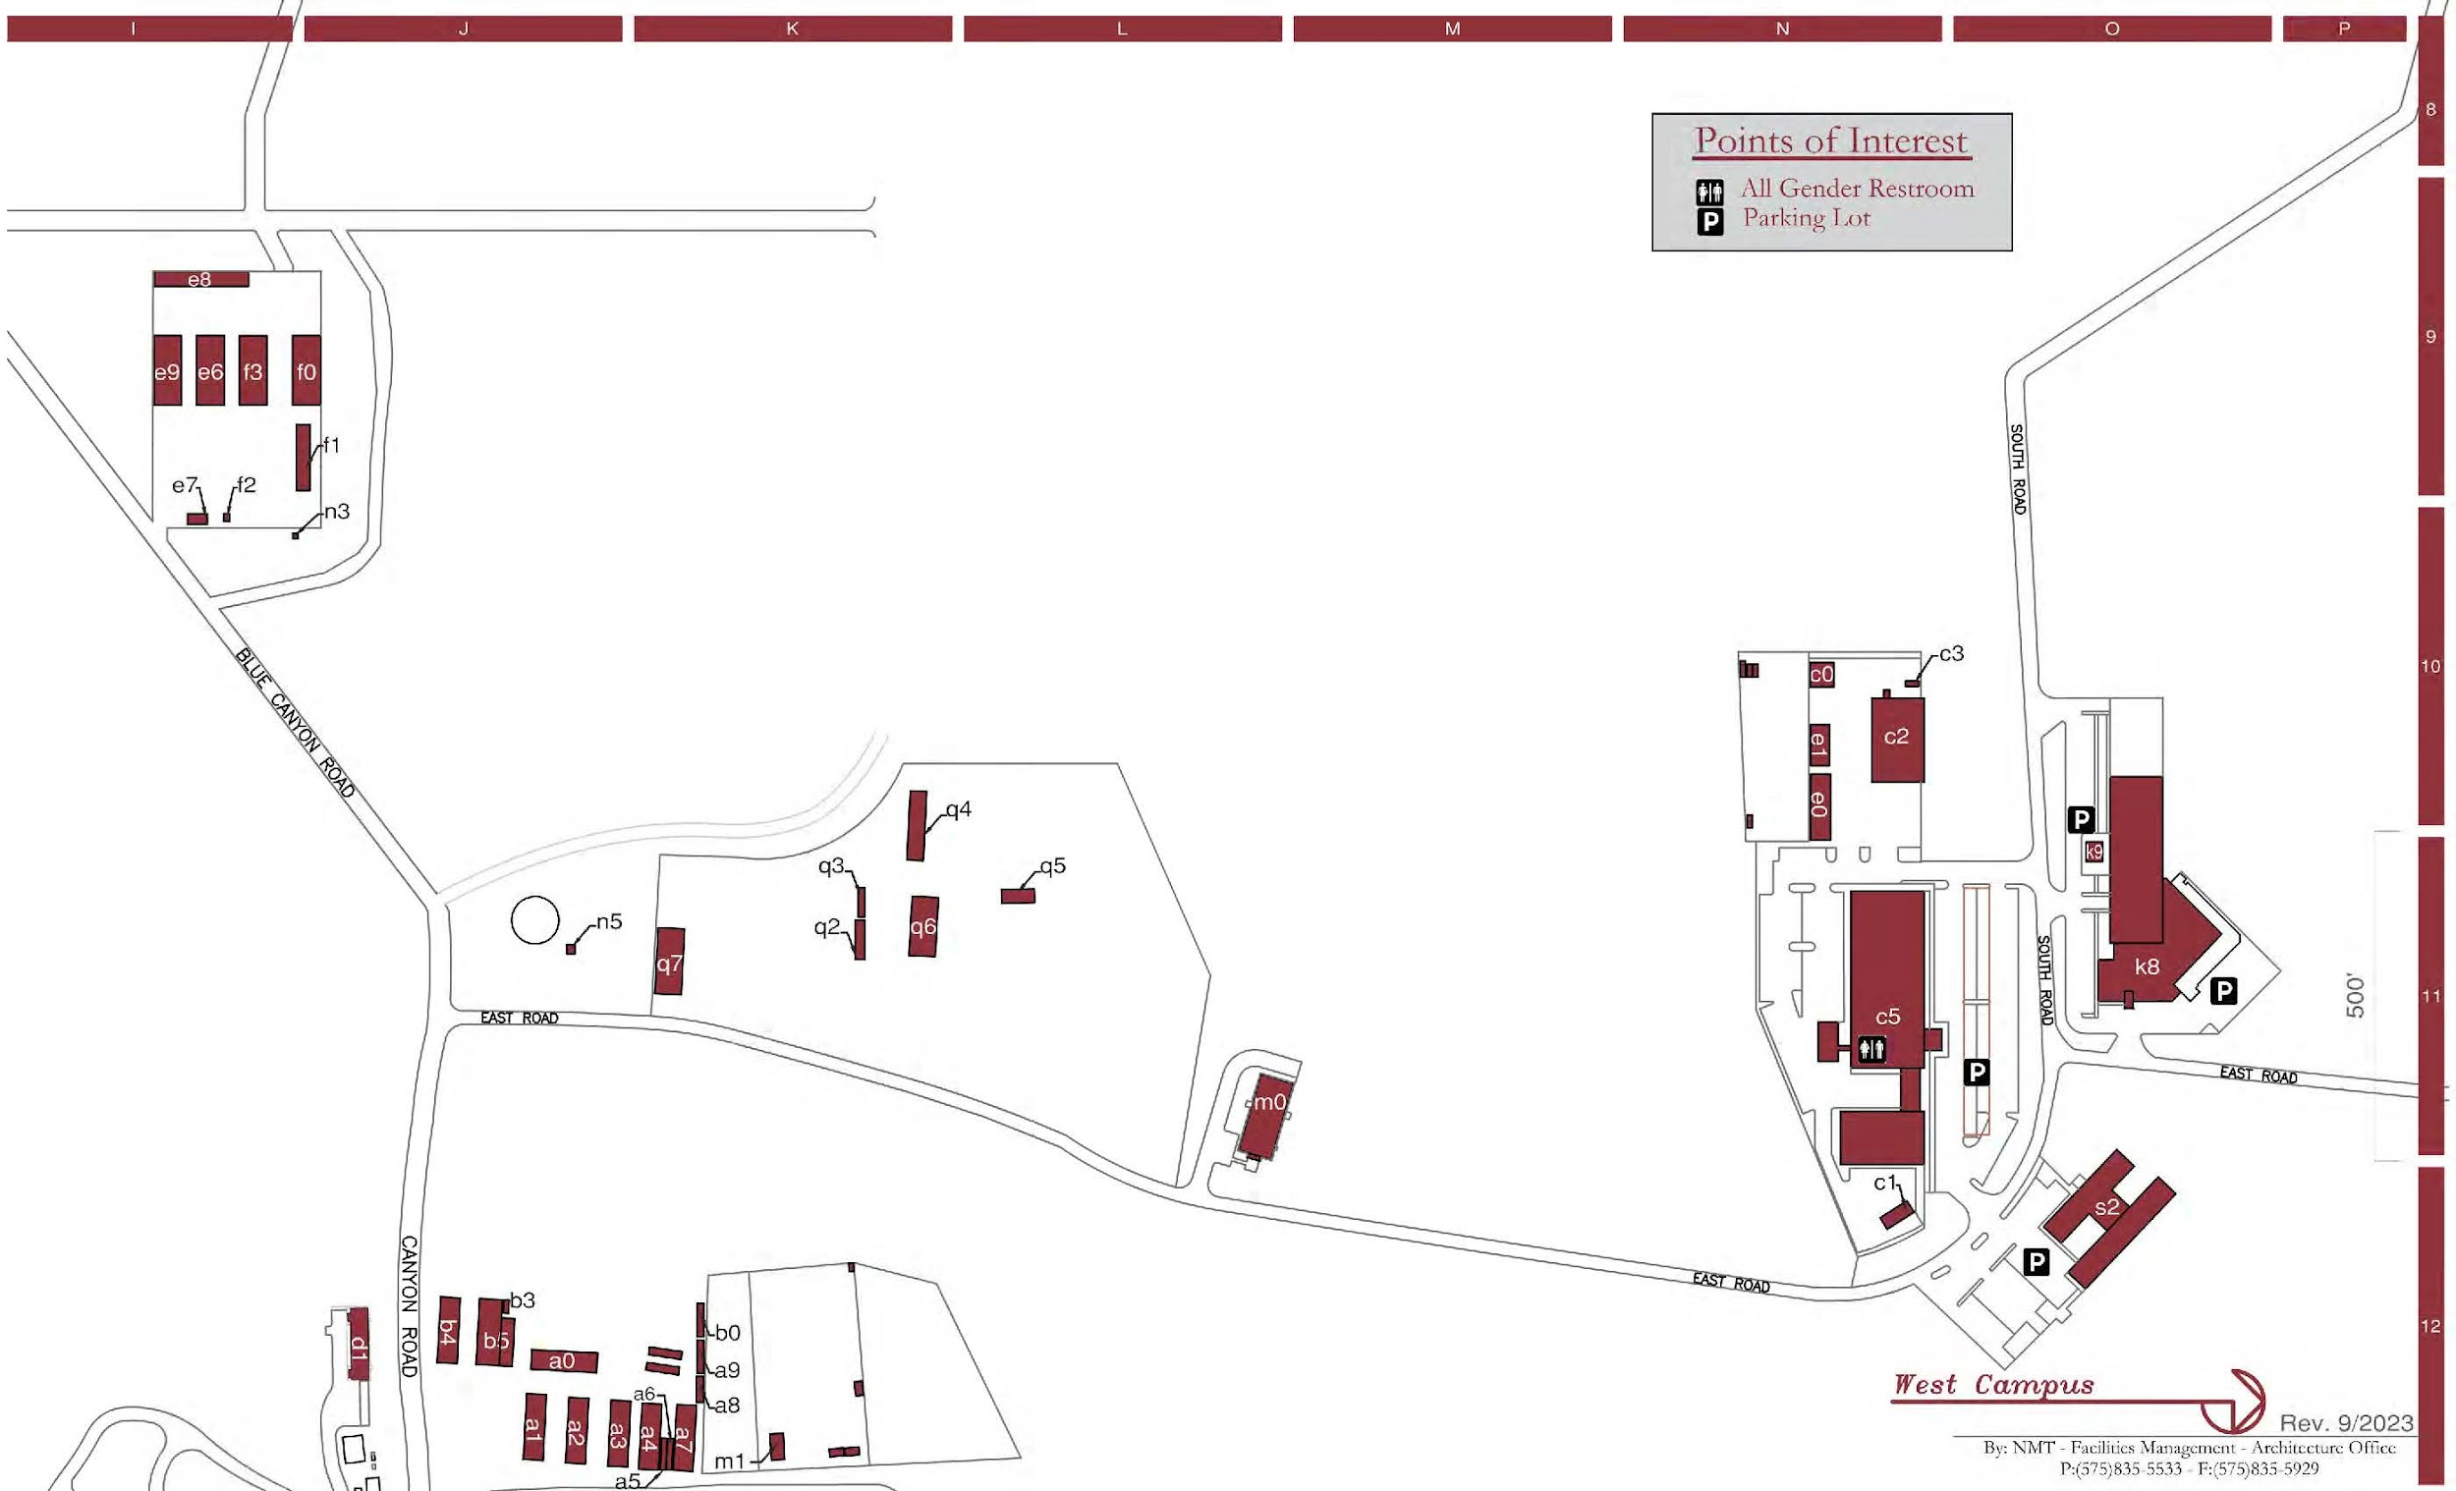
NMT West Campus
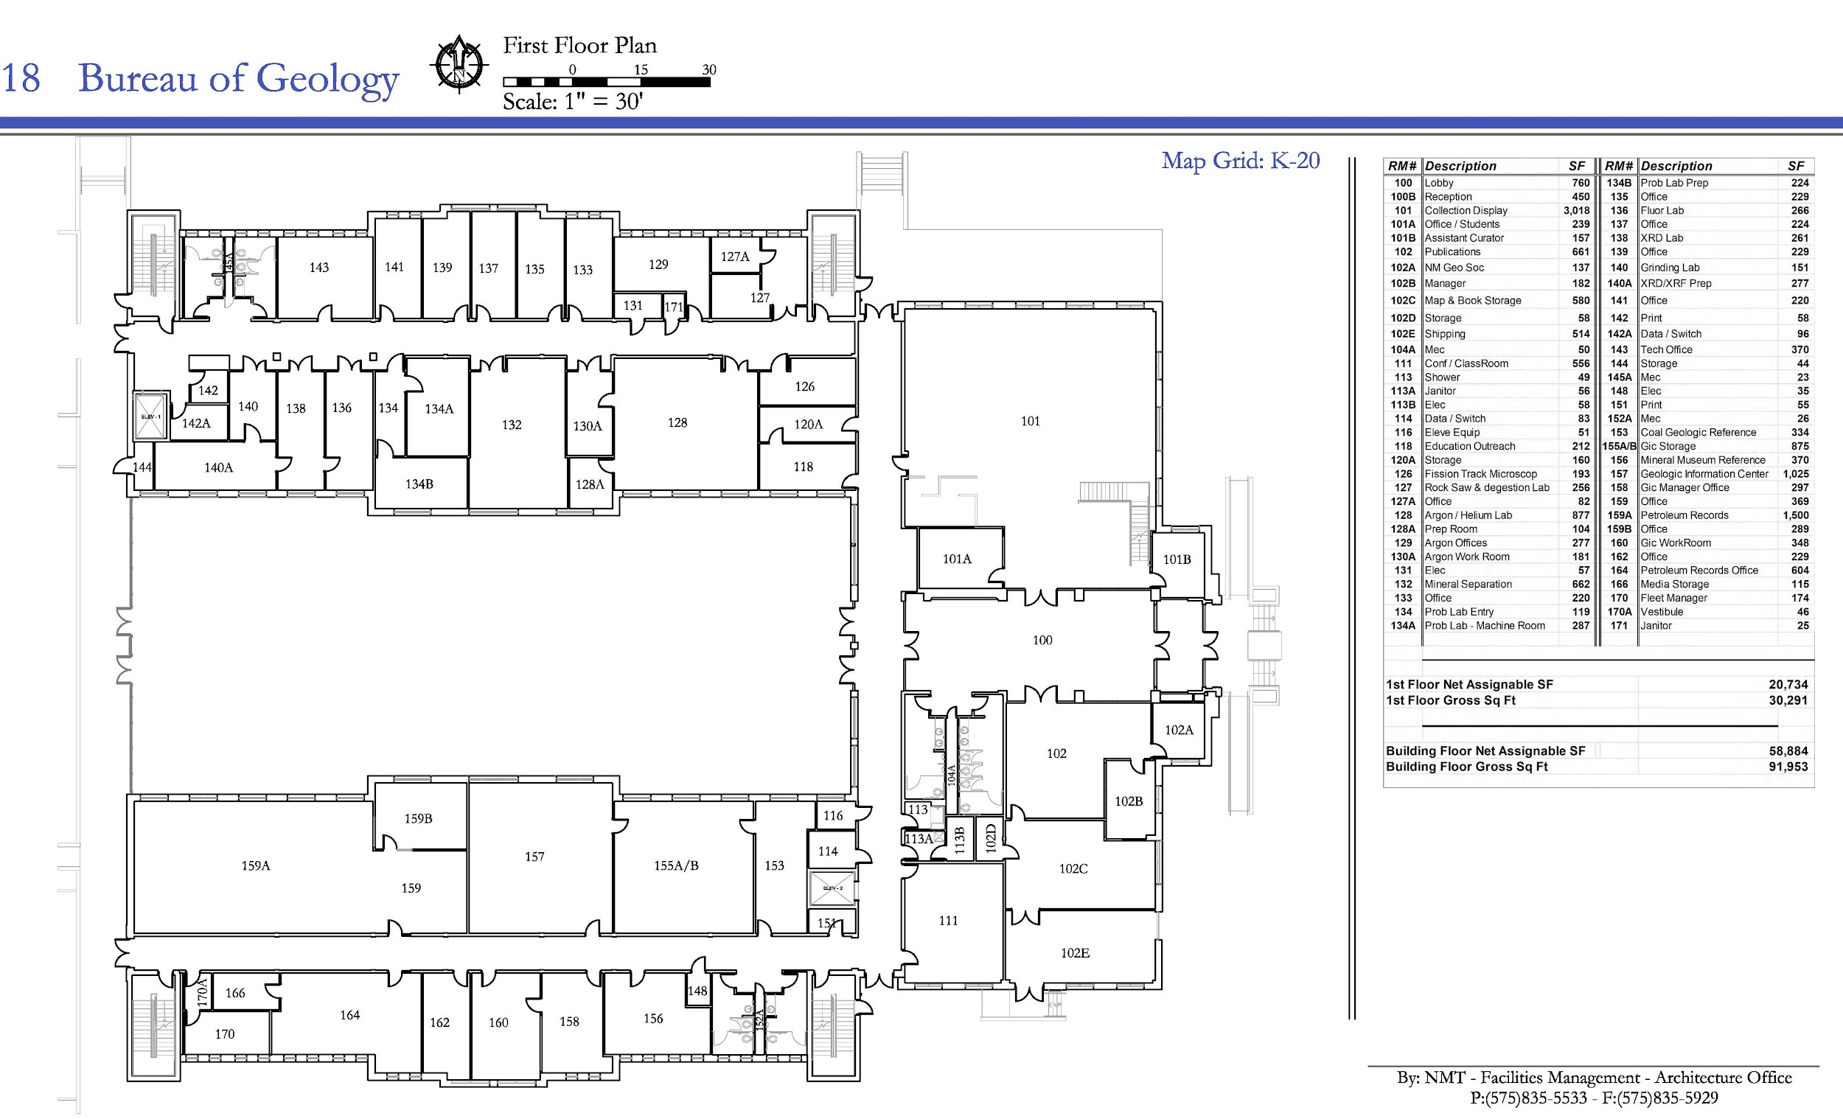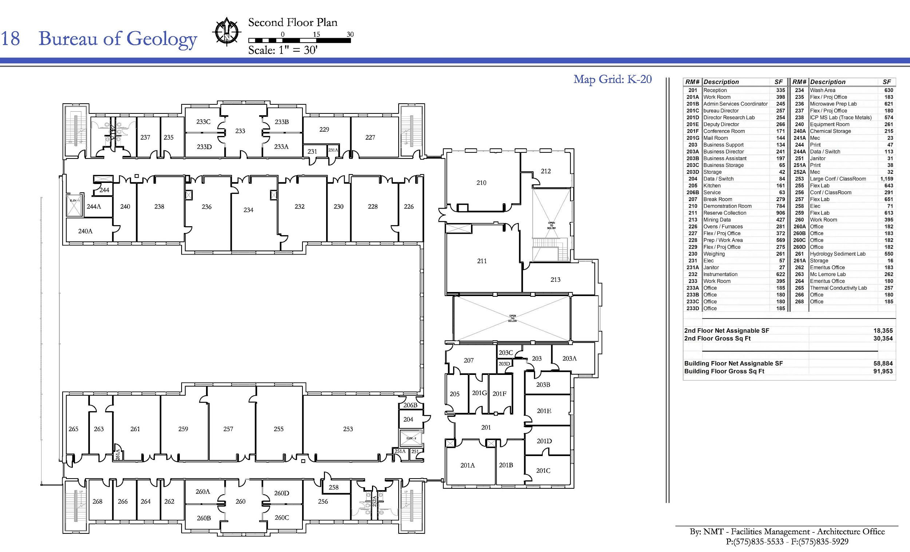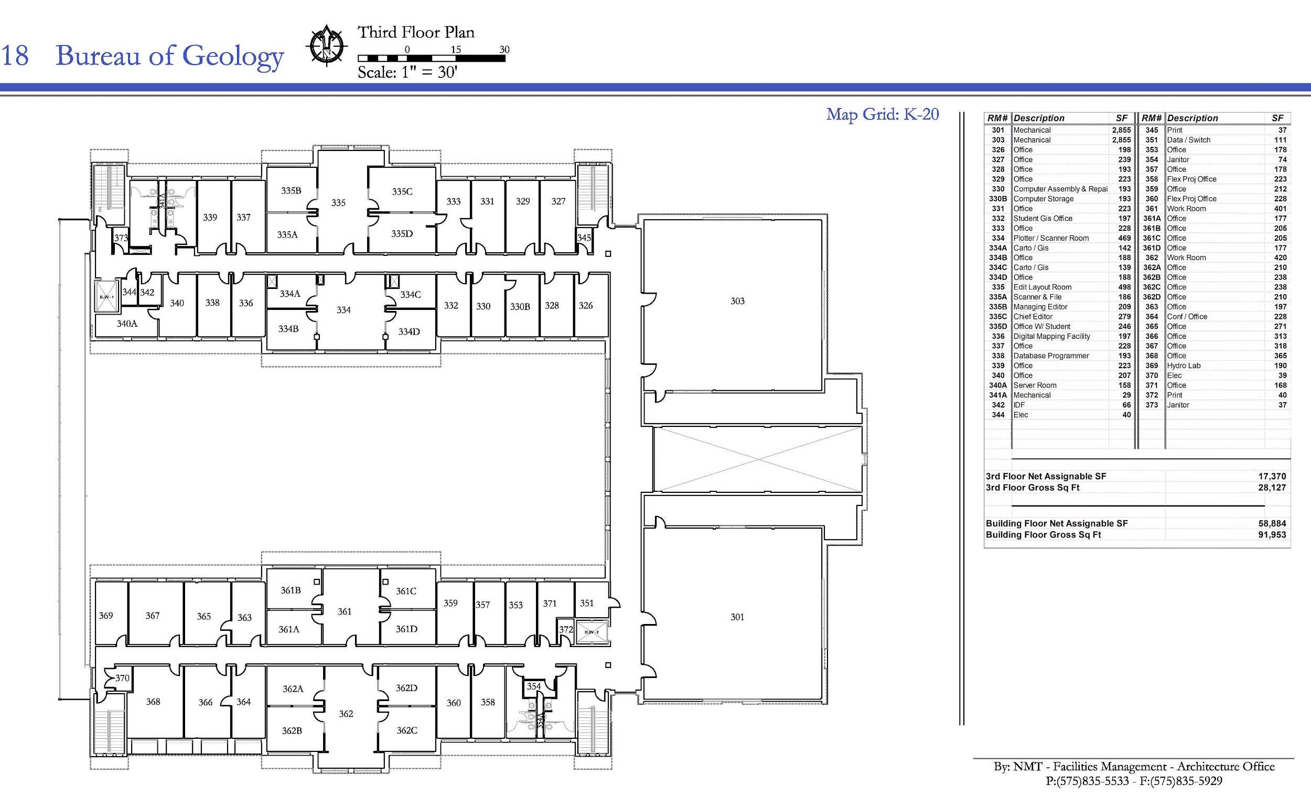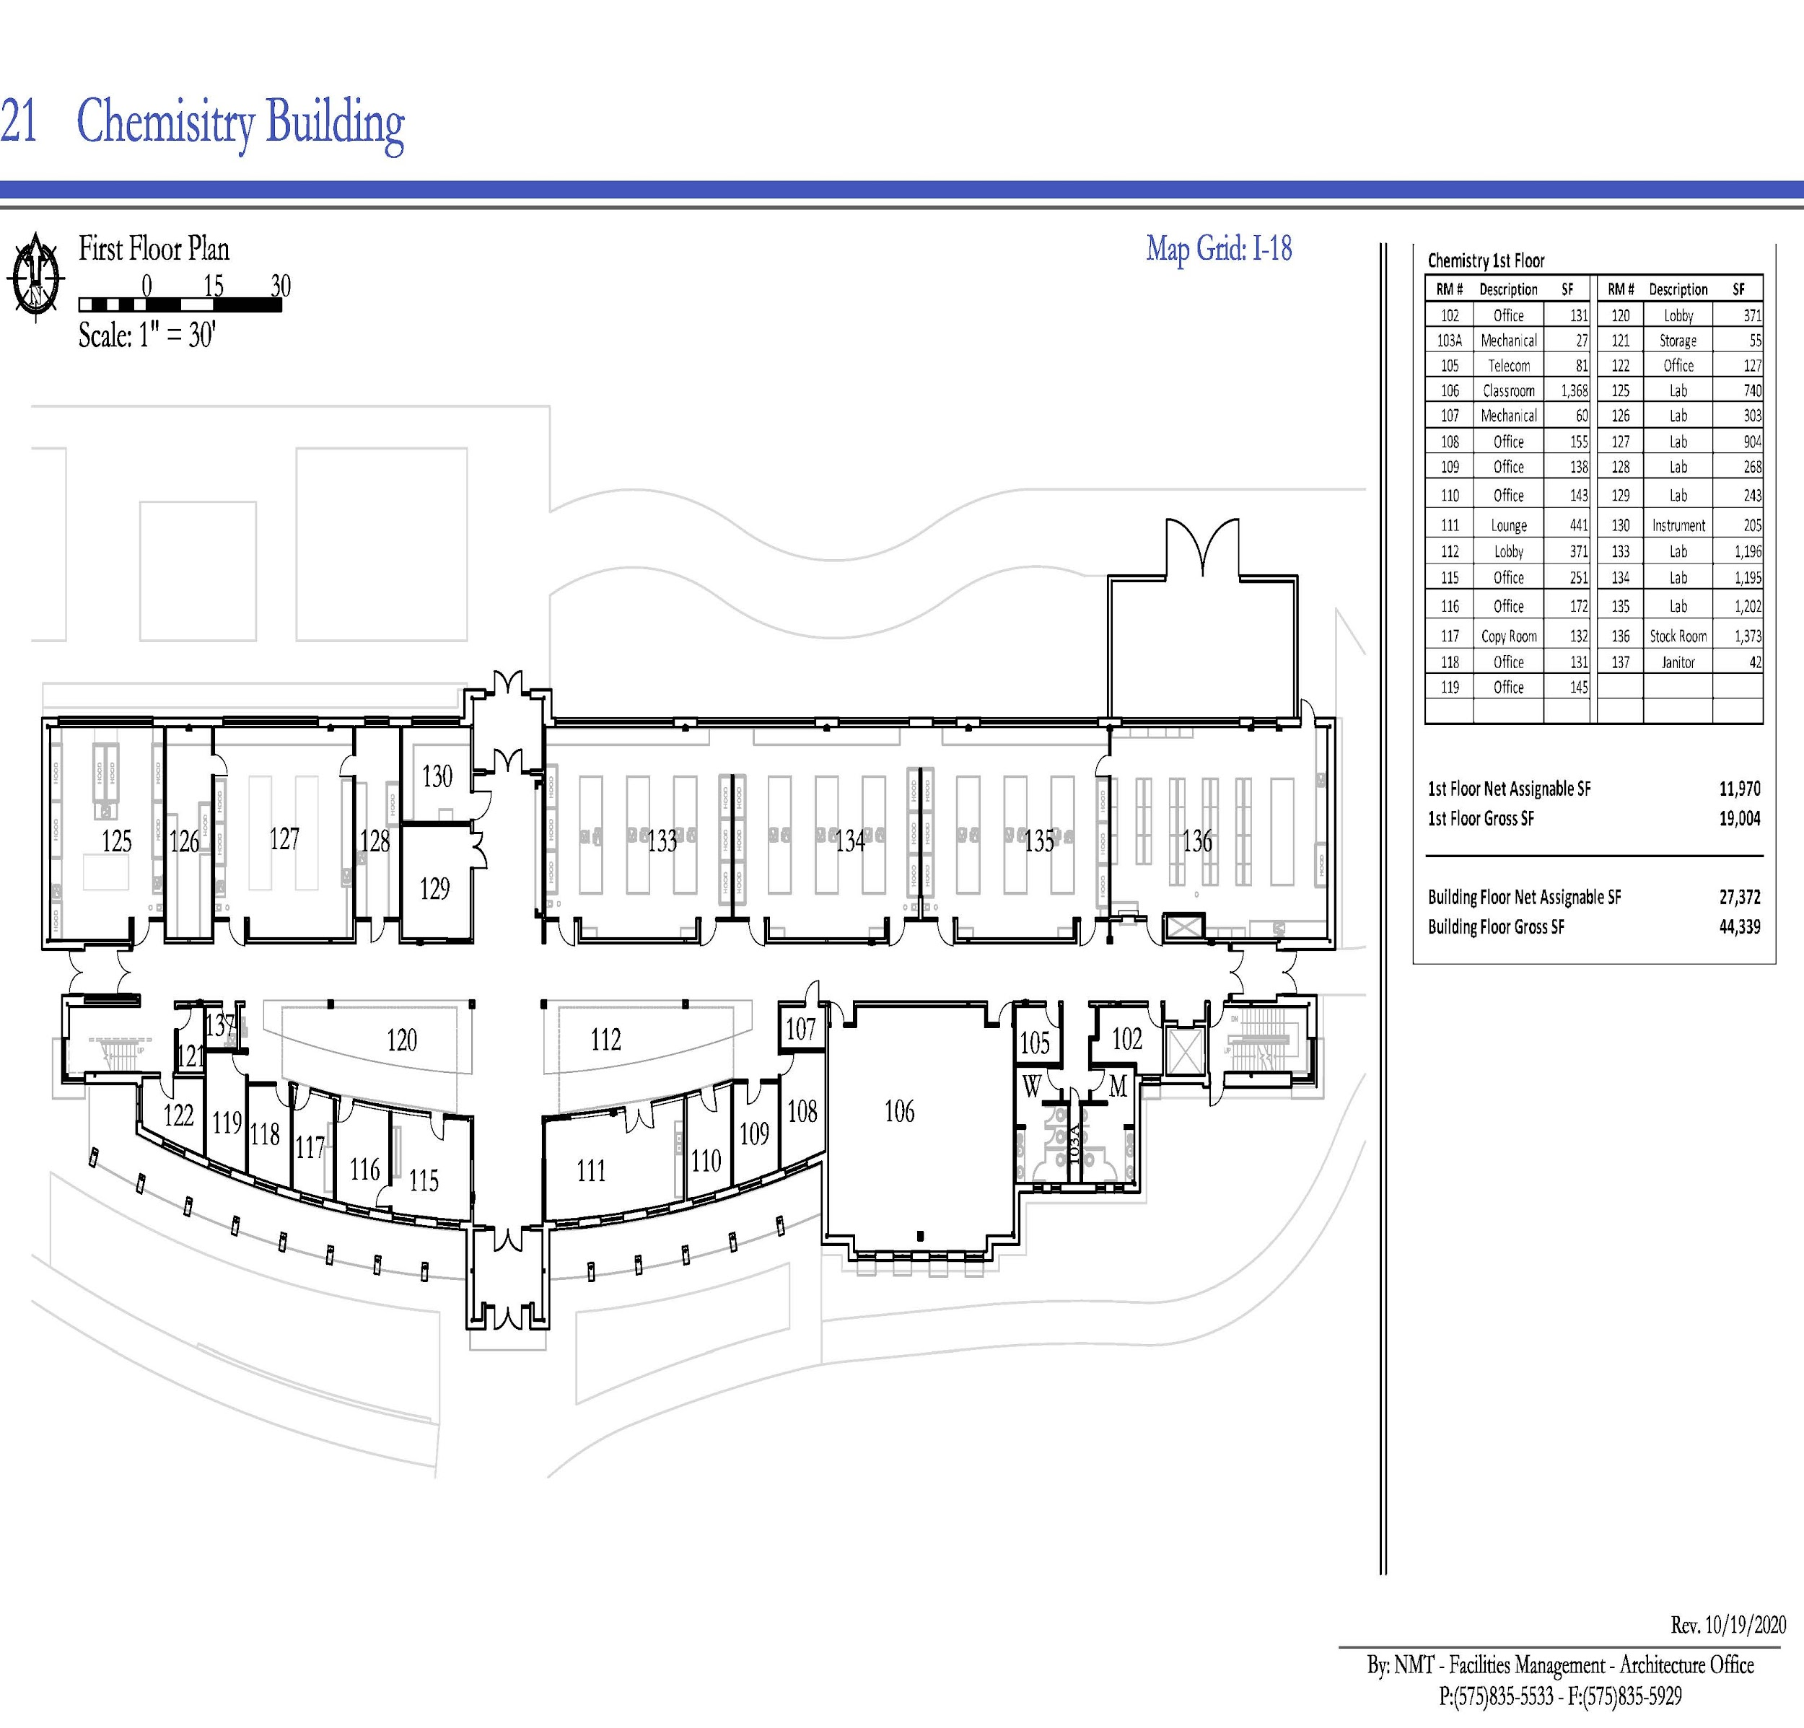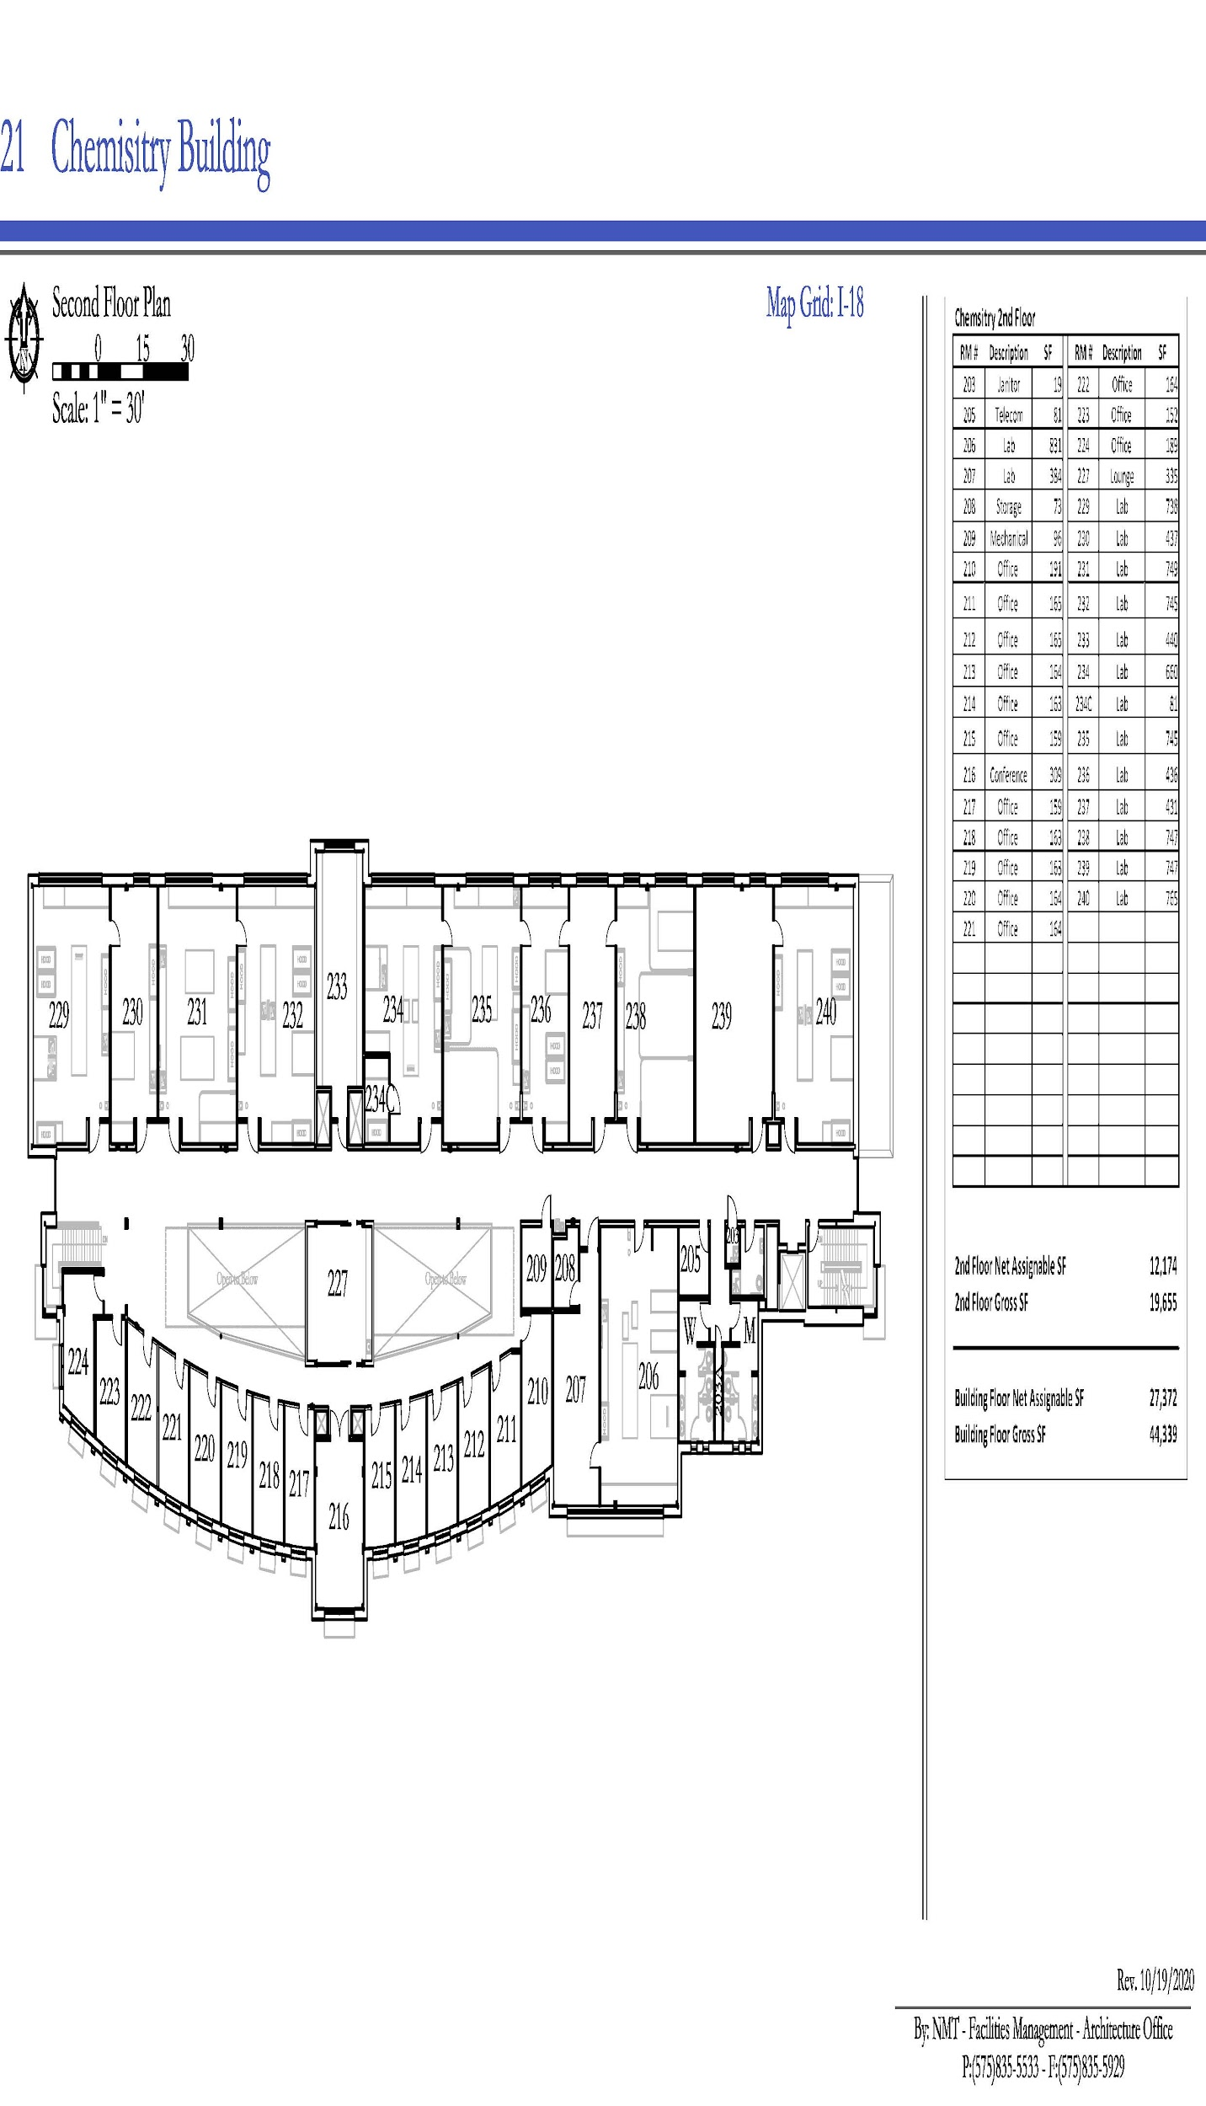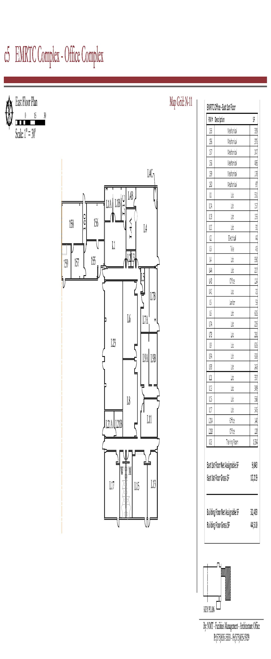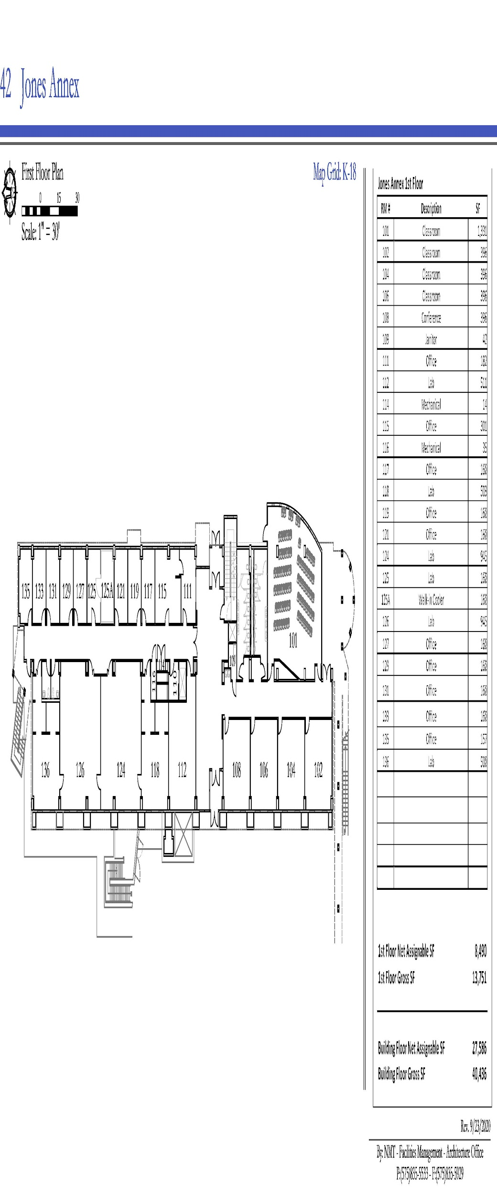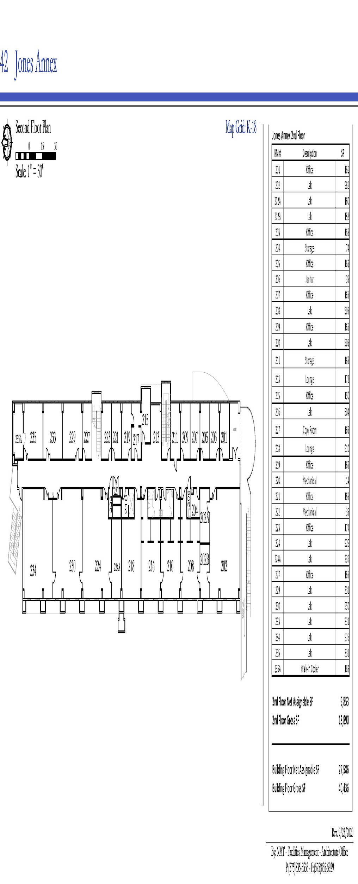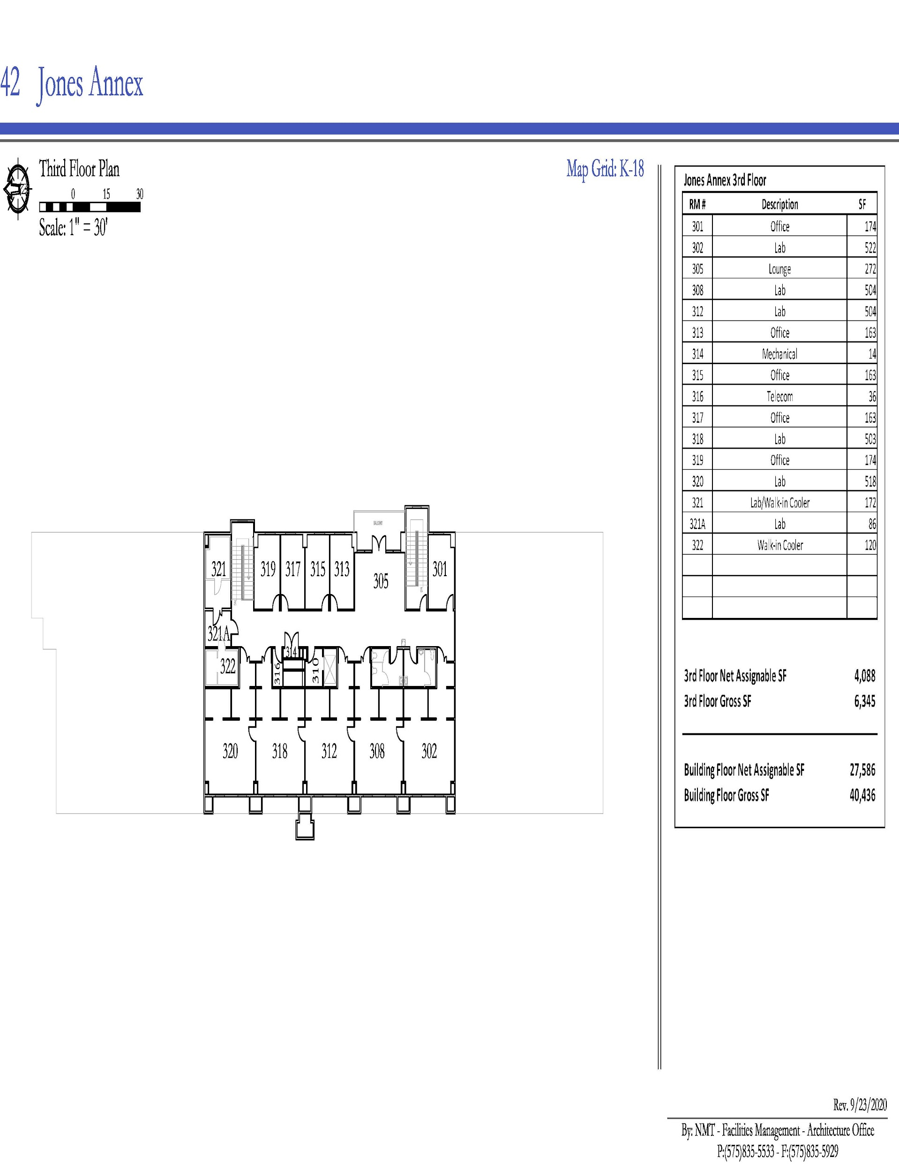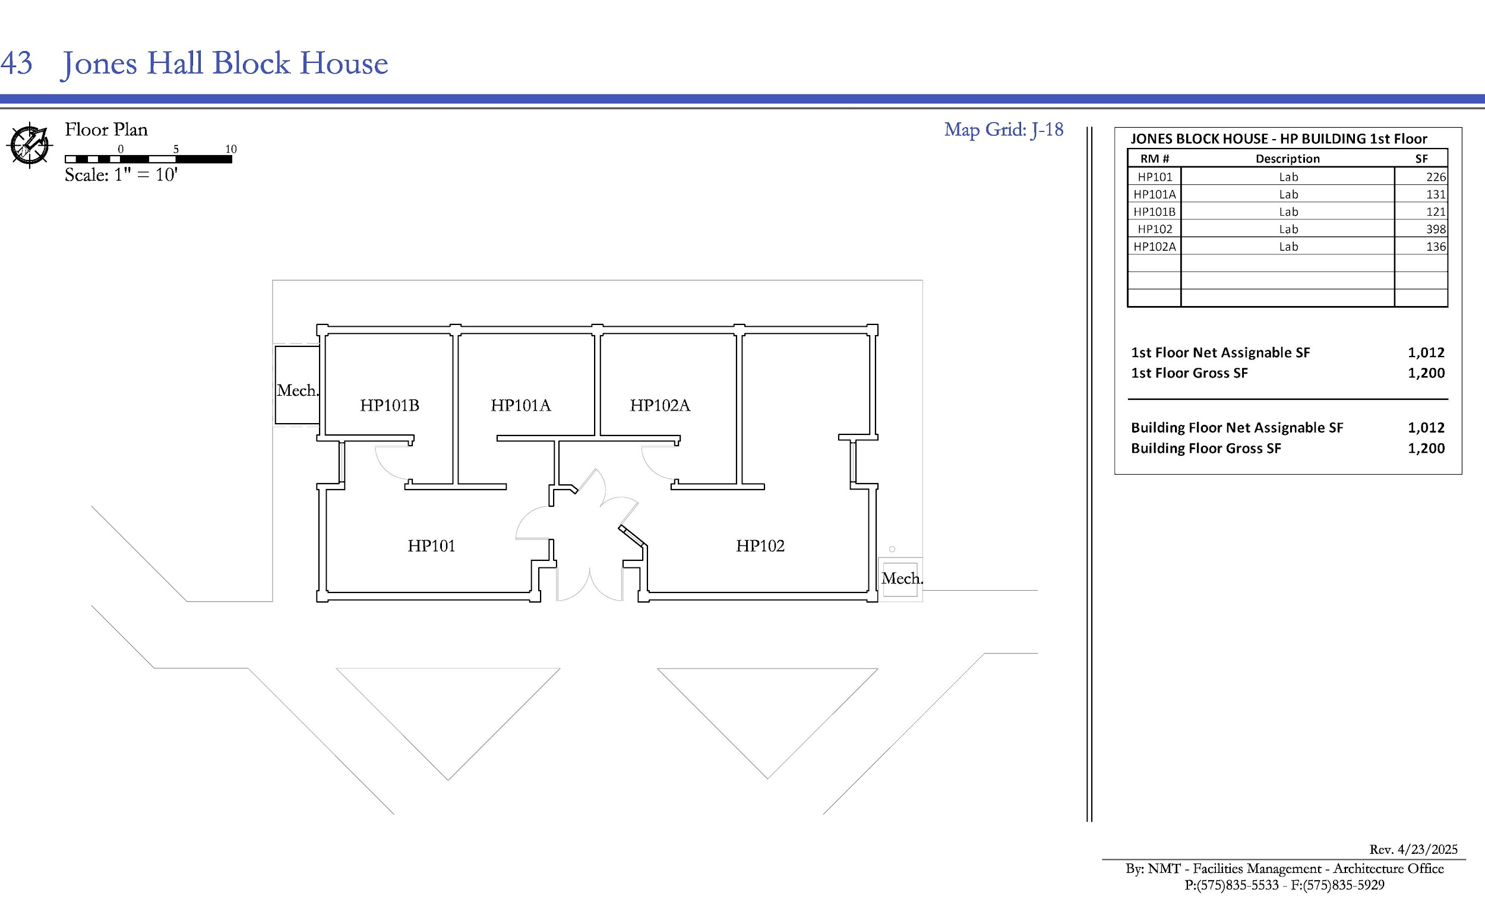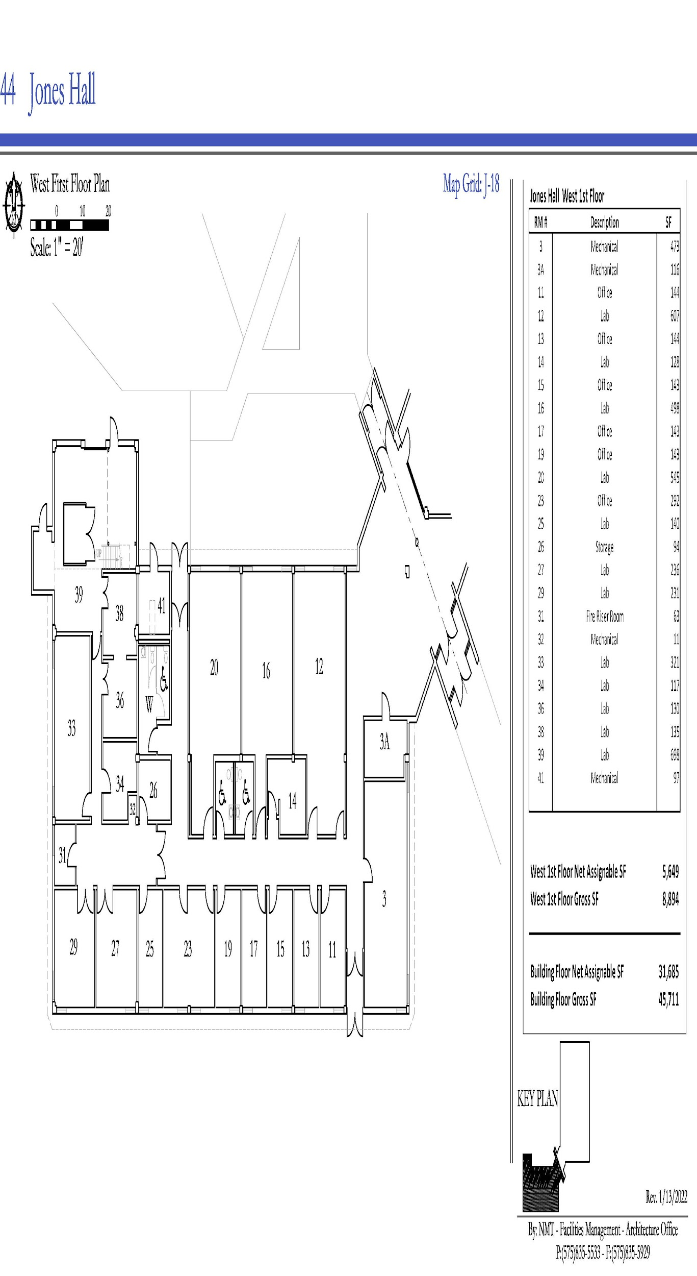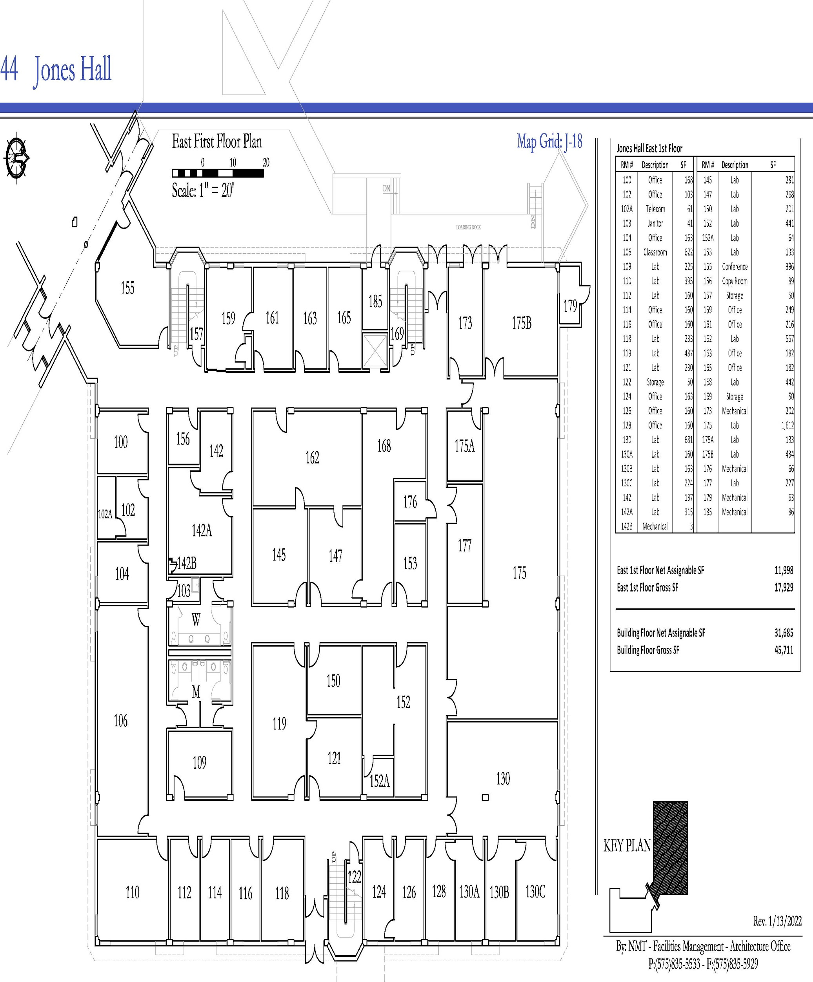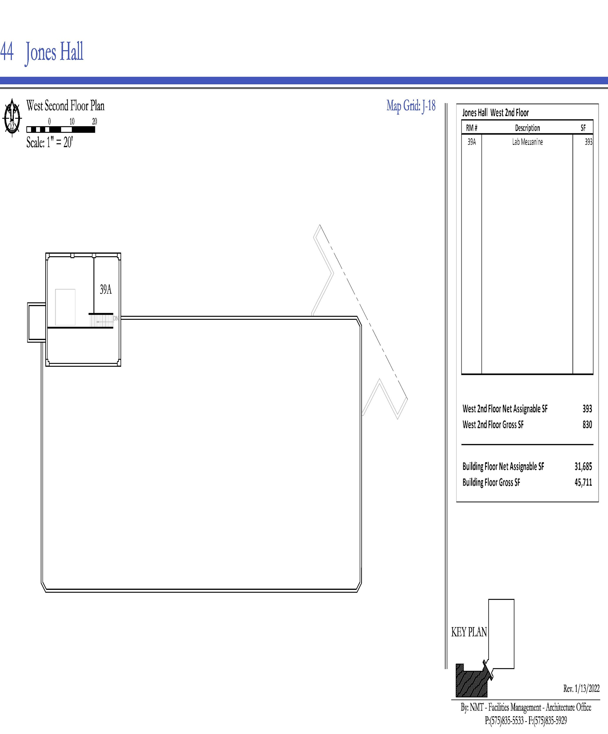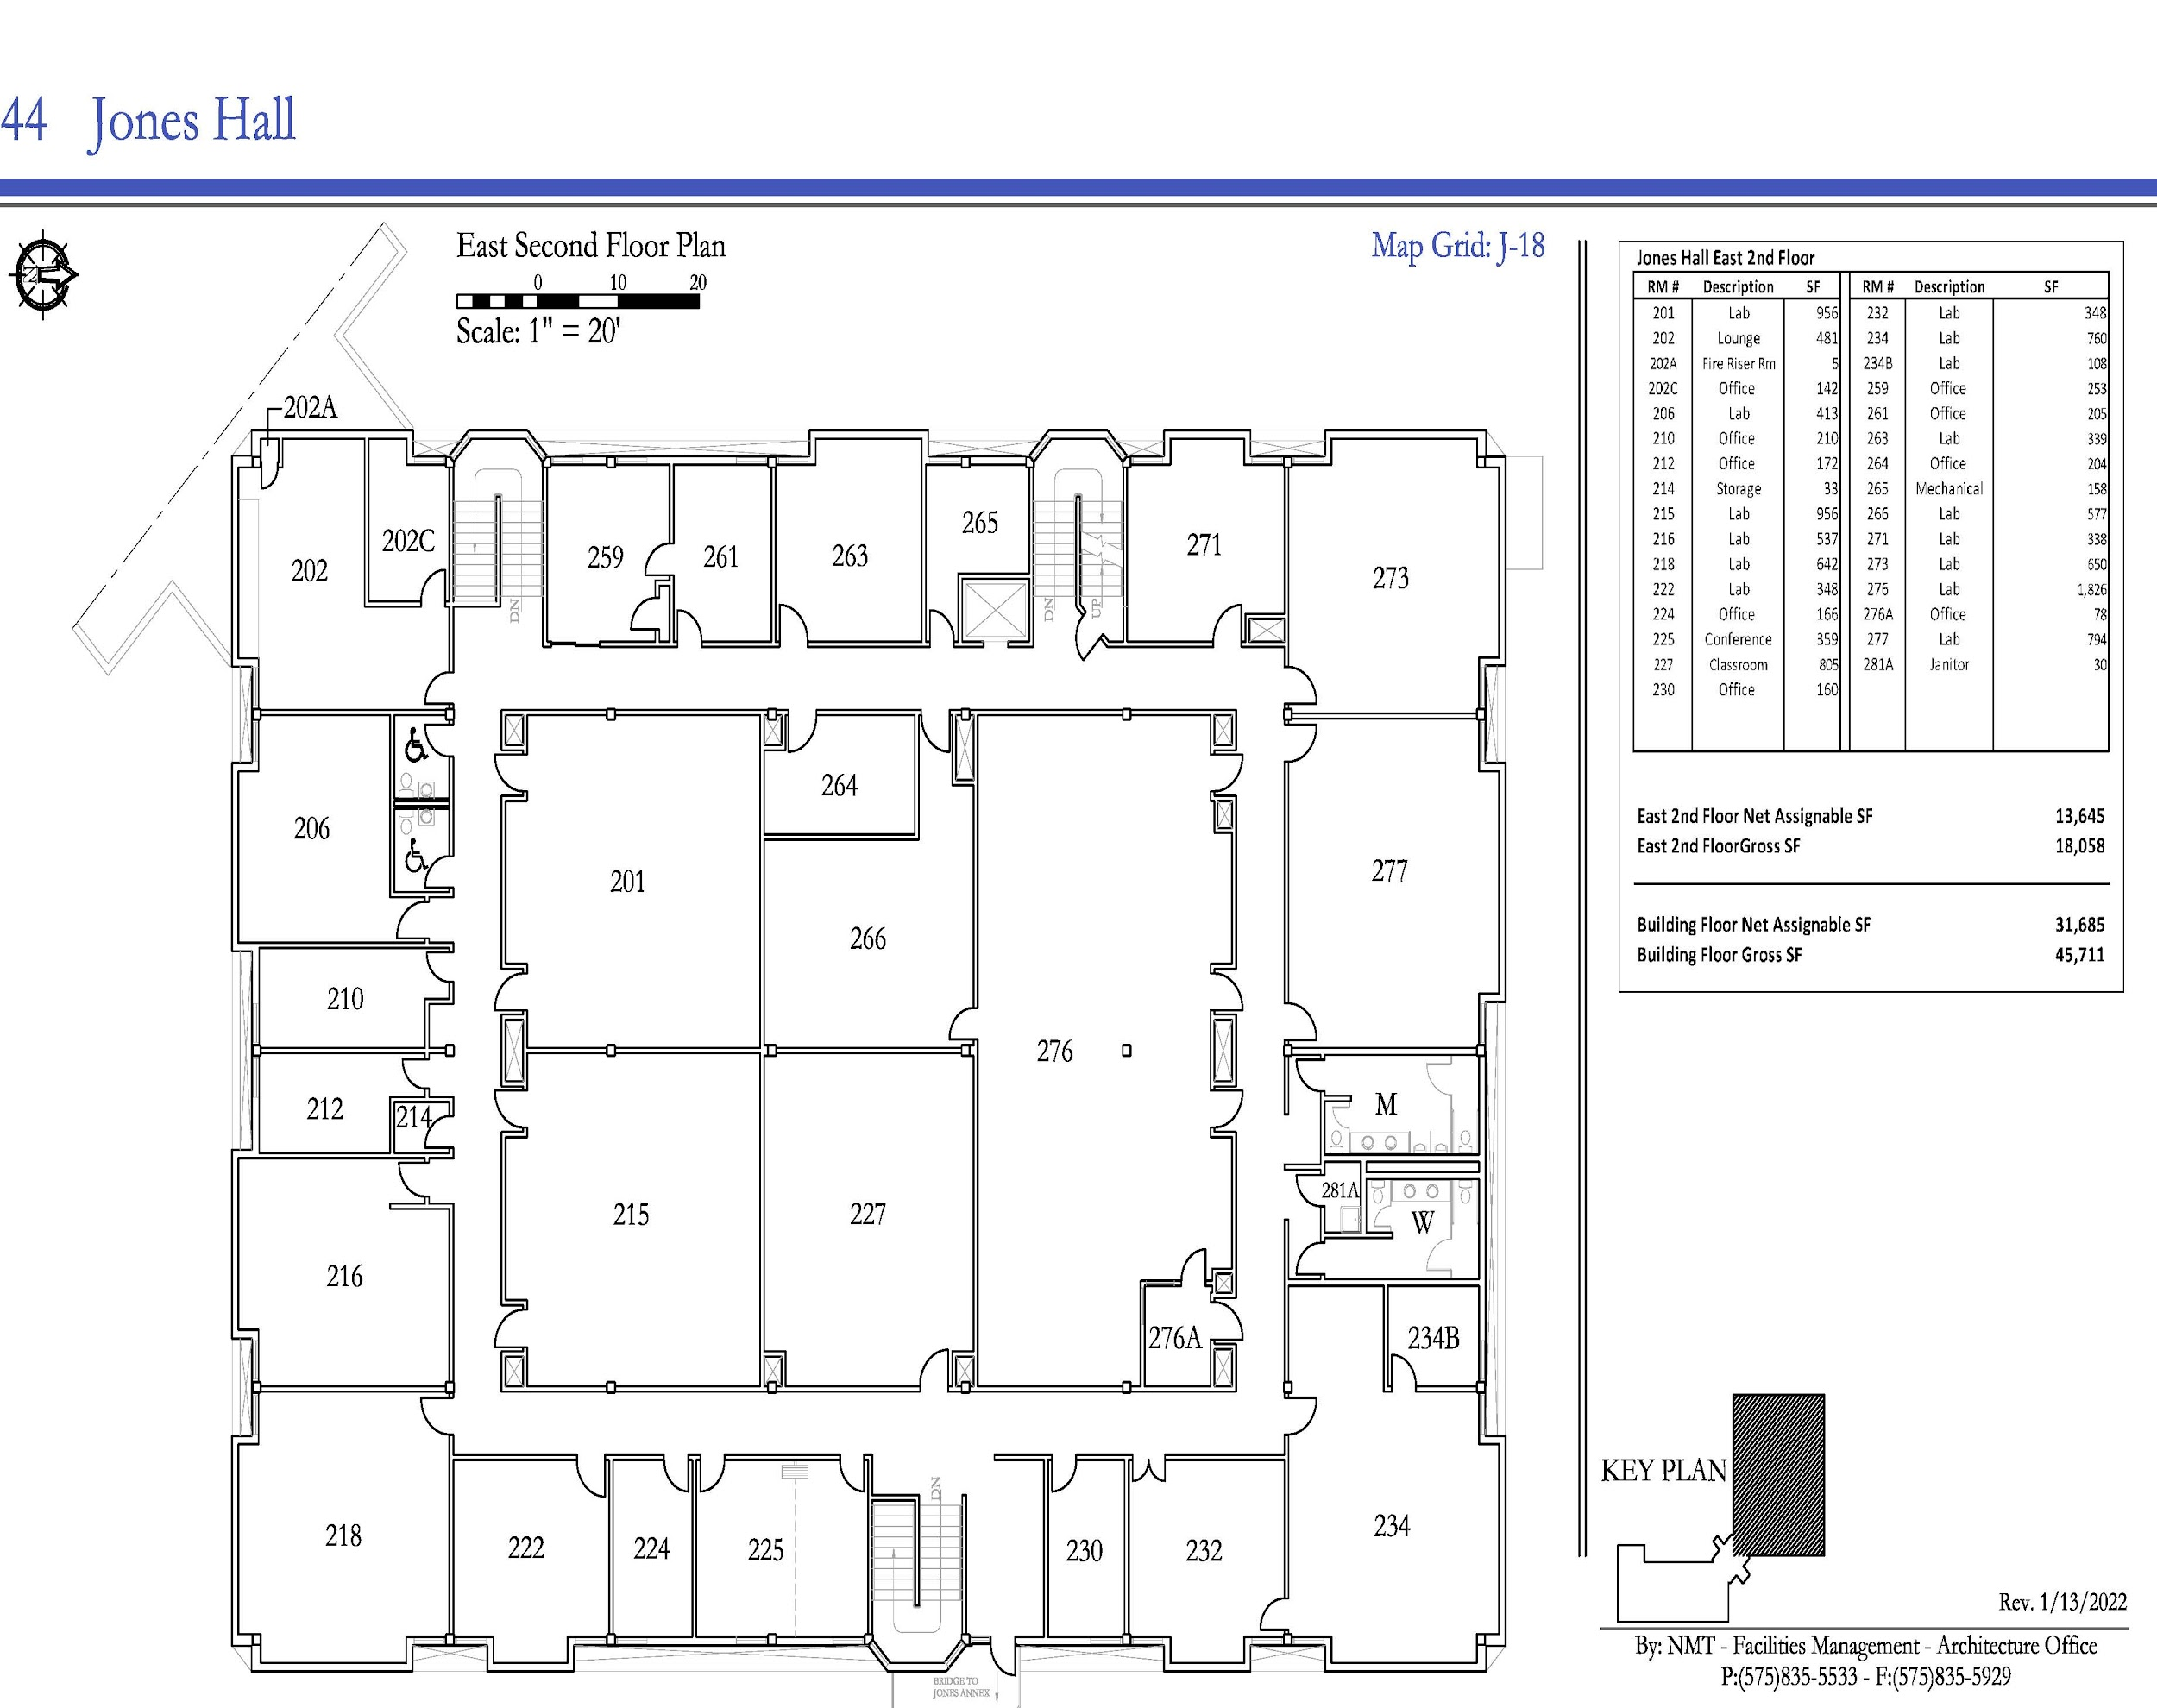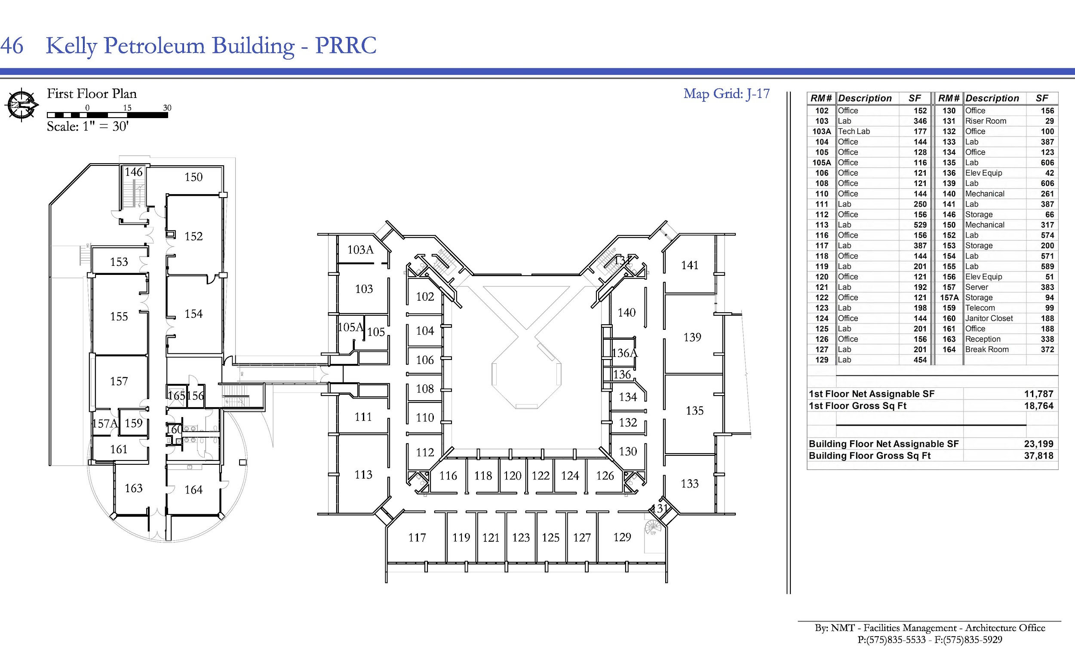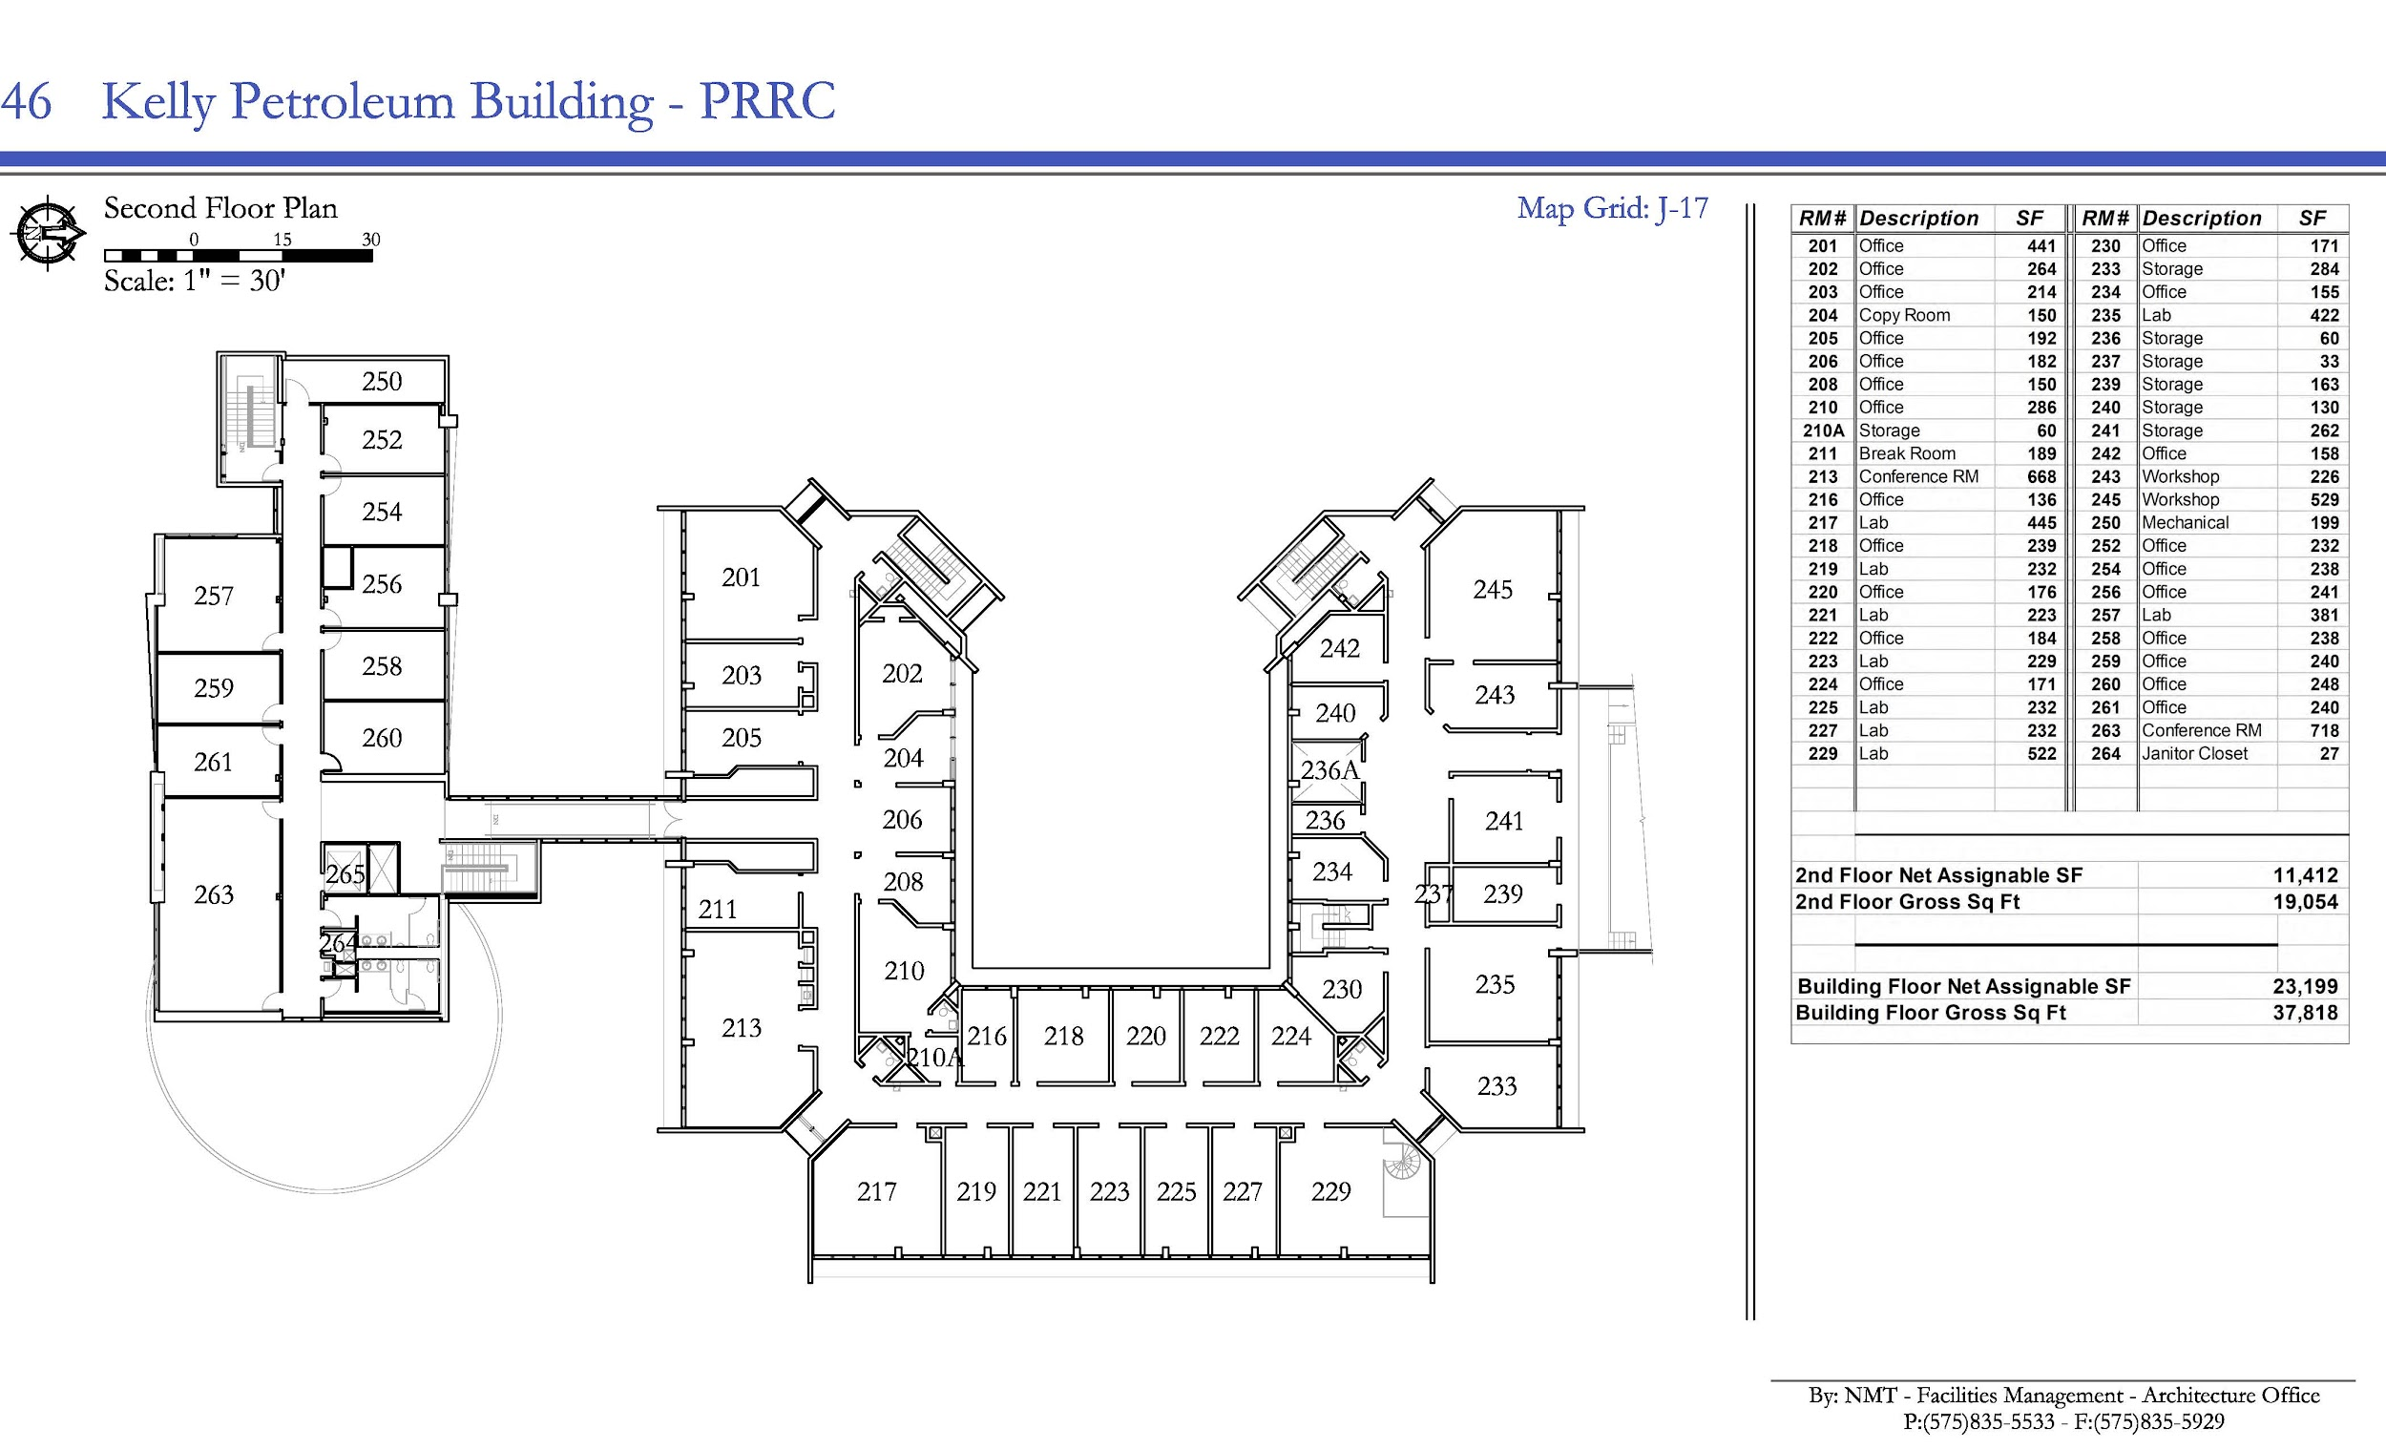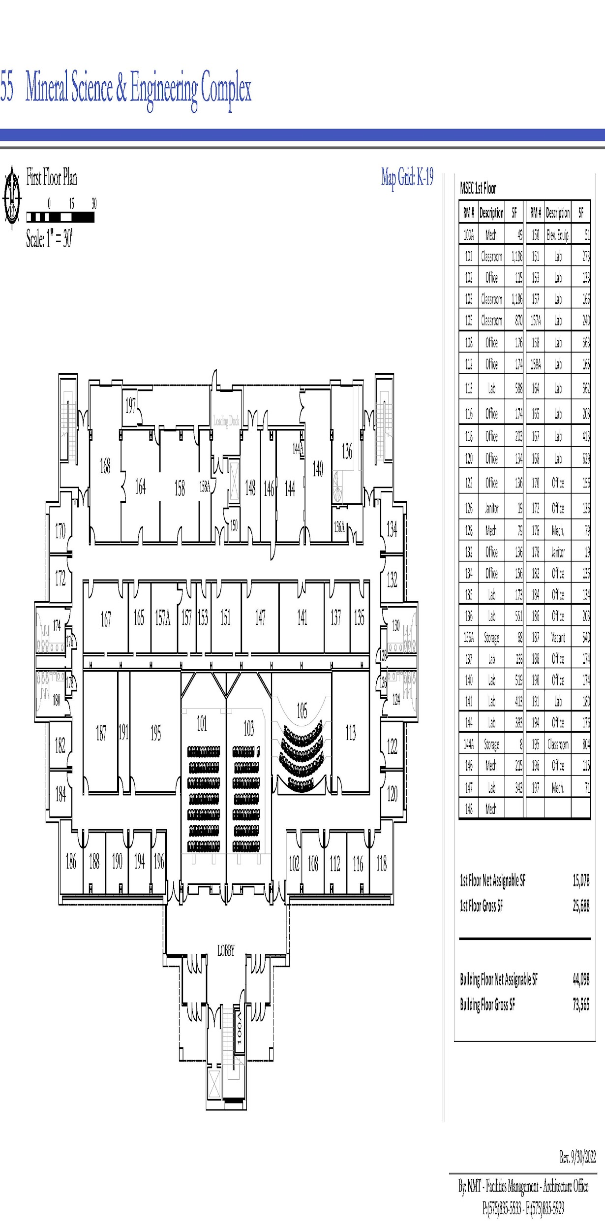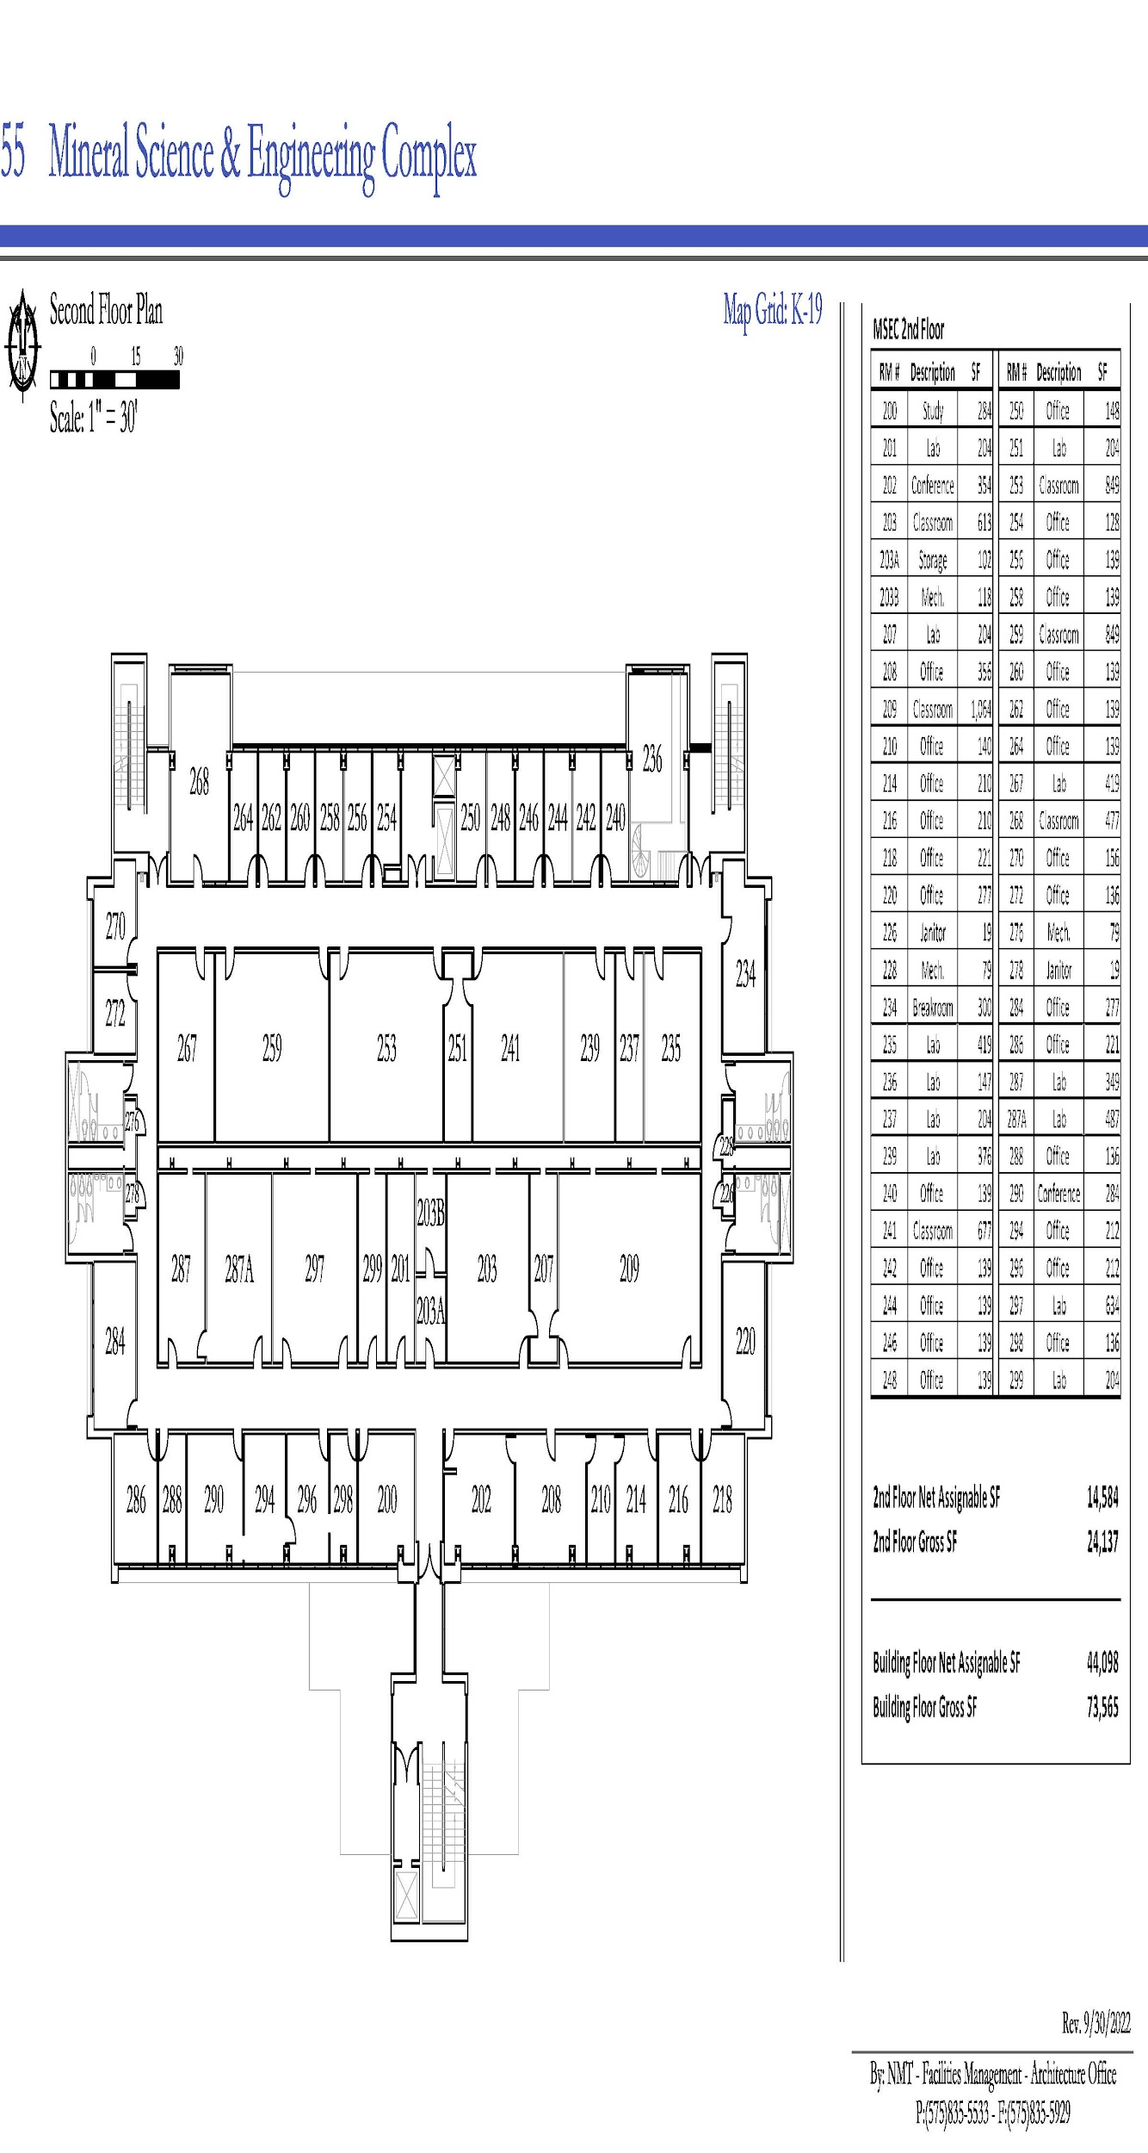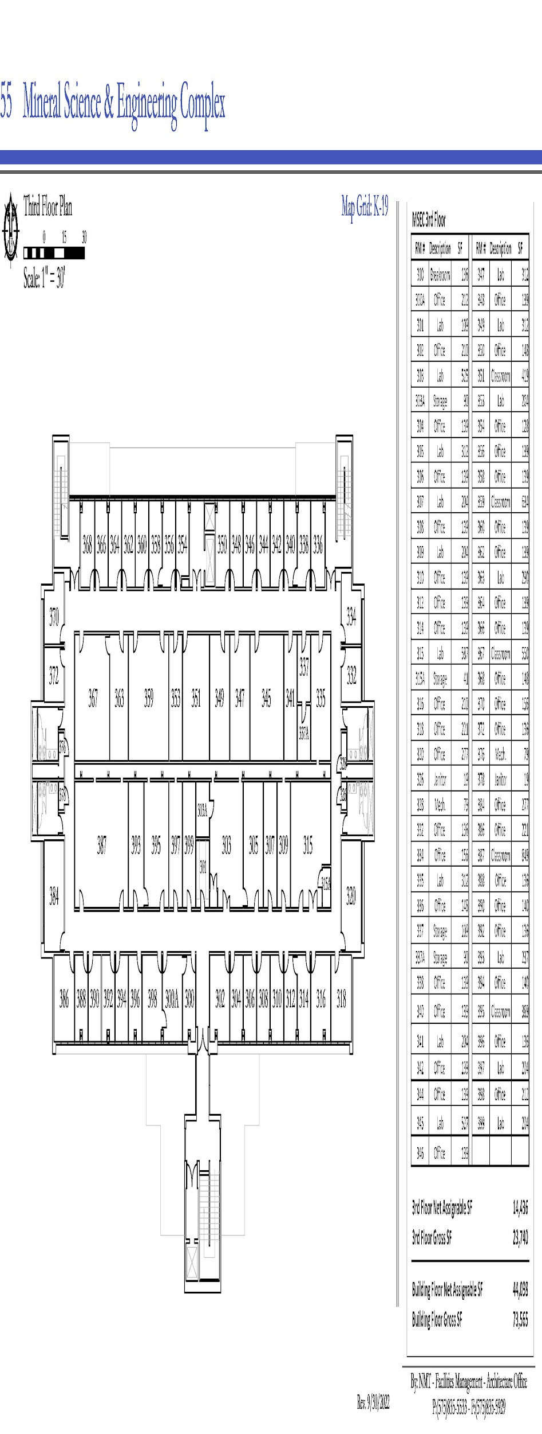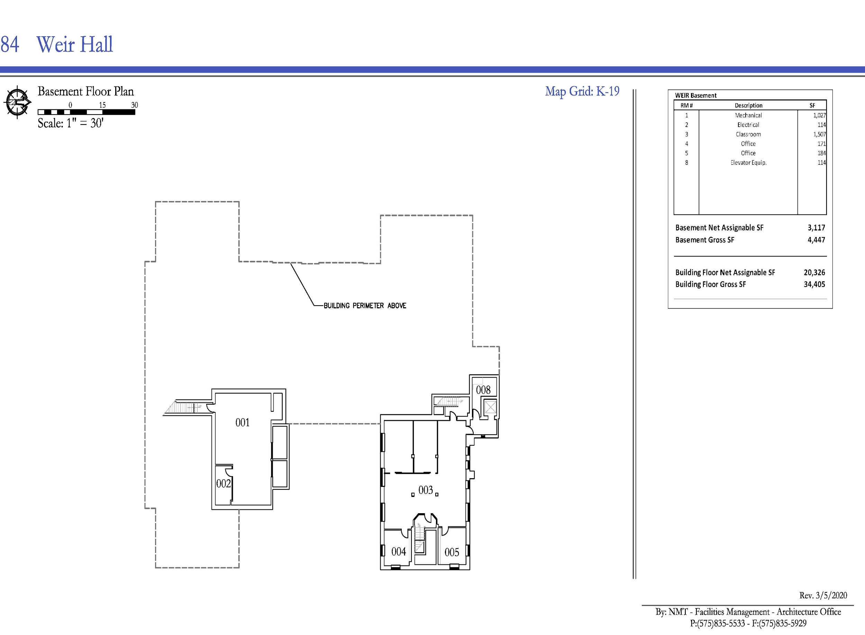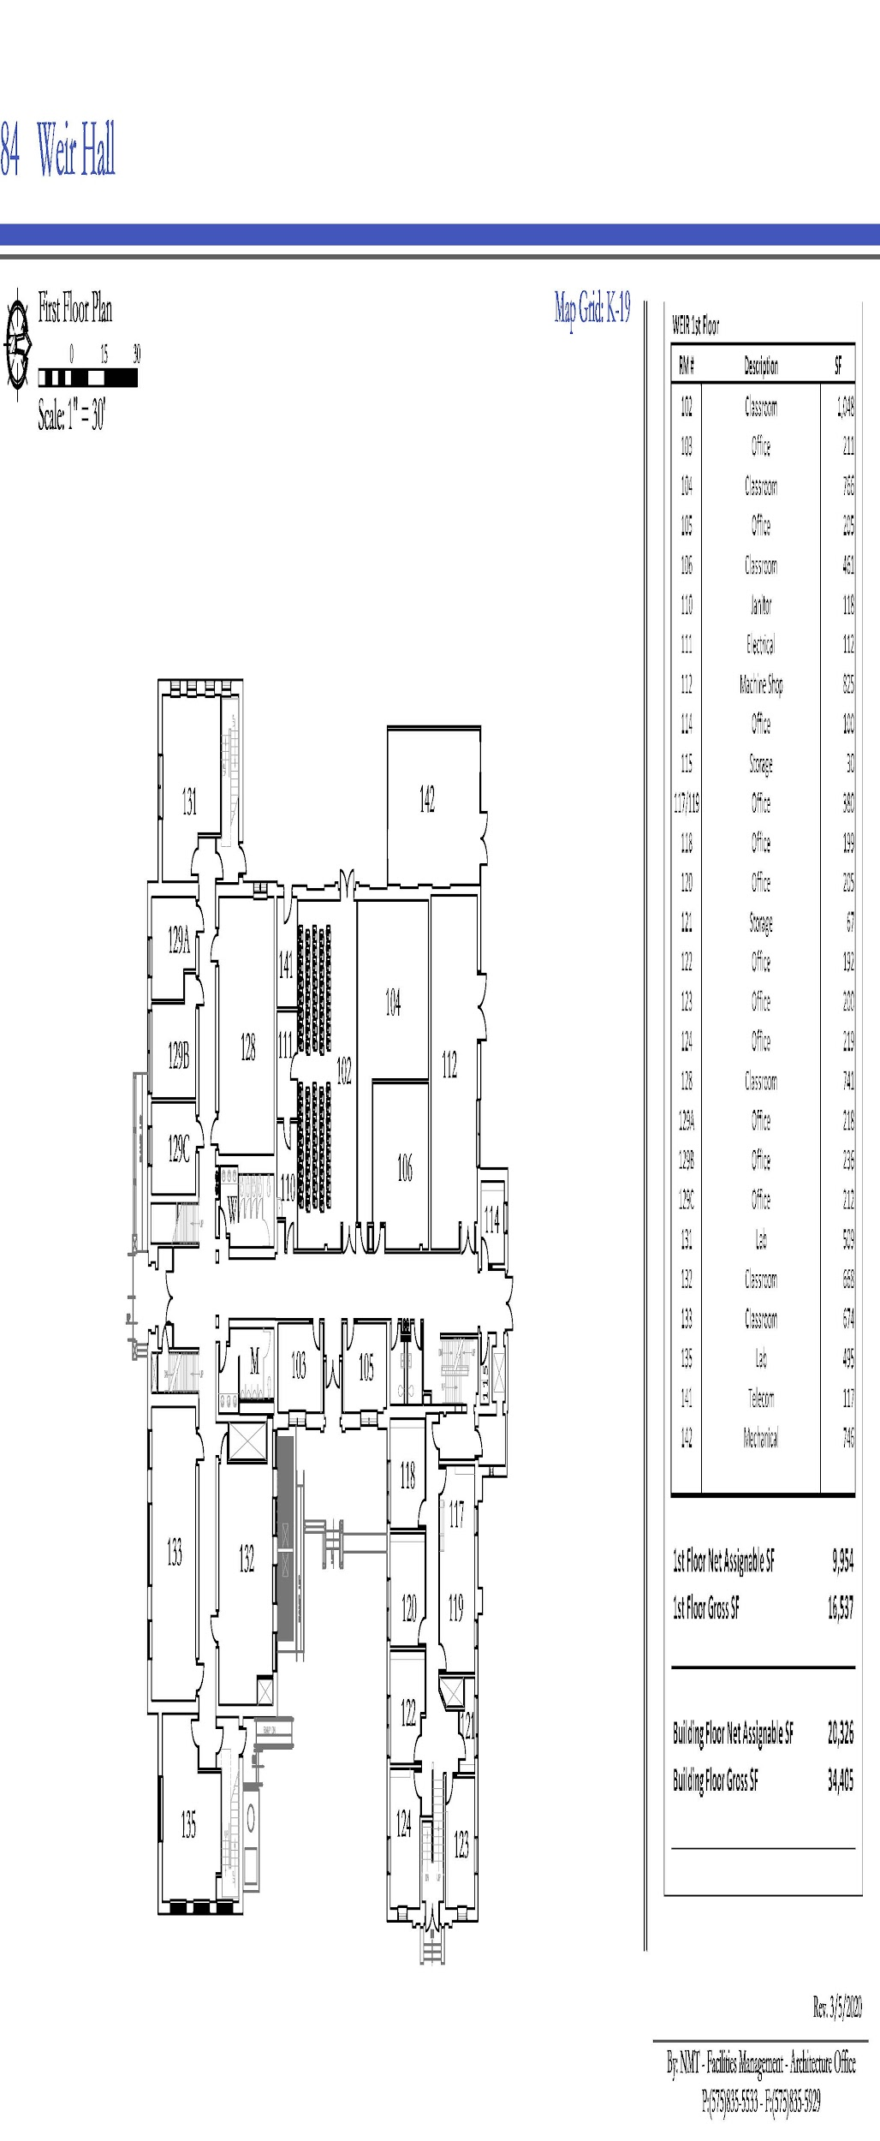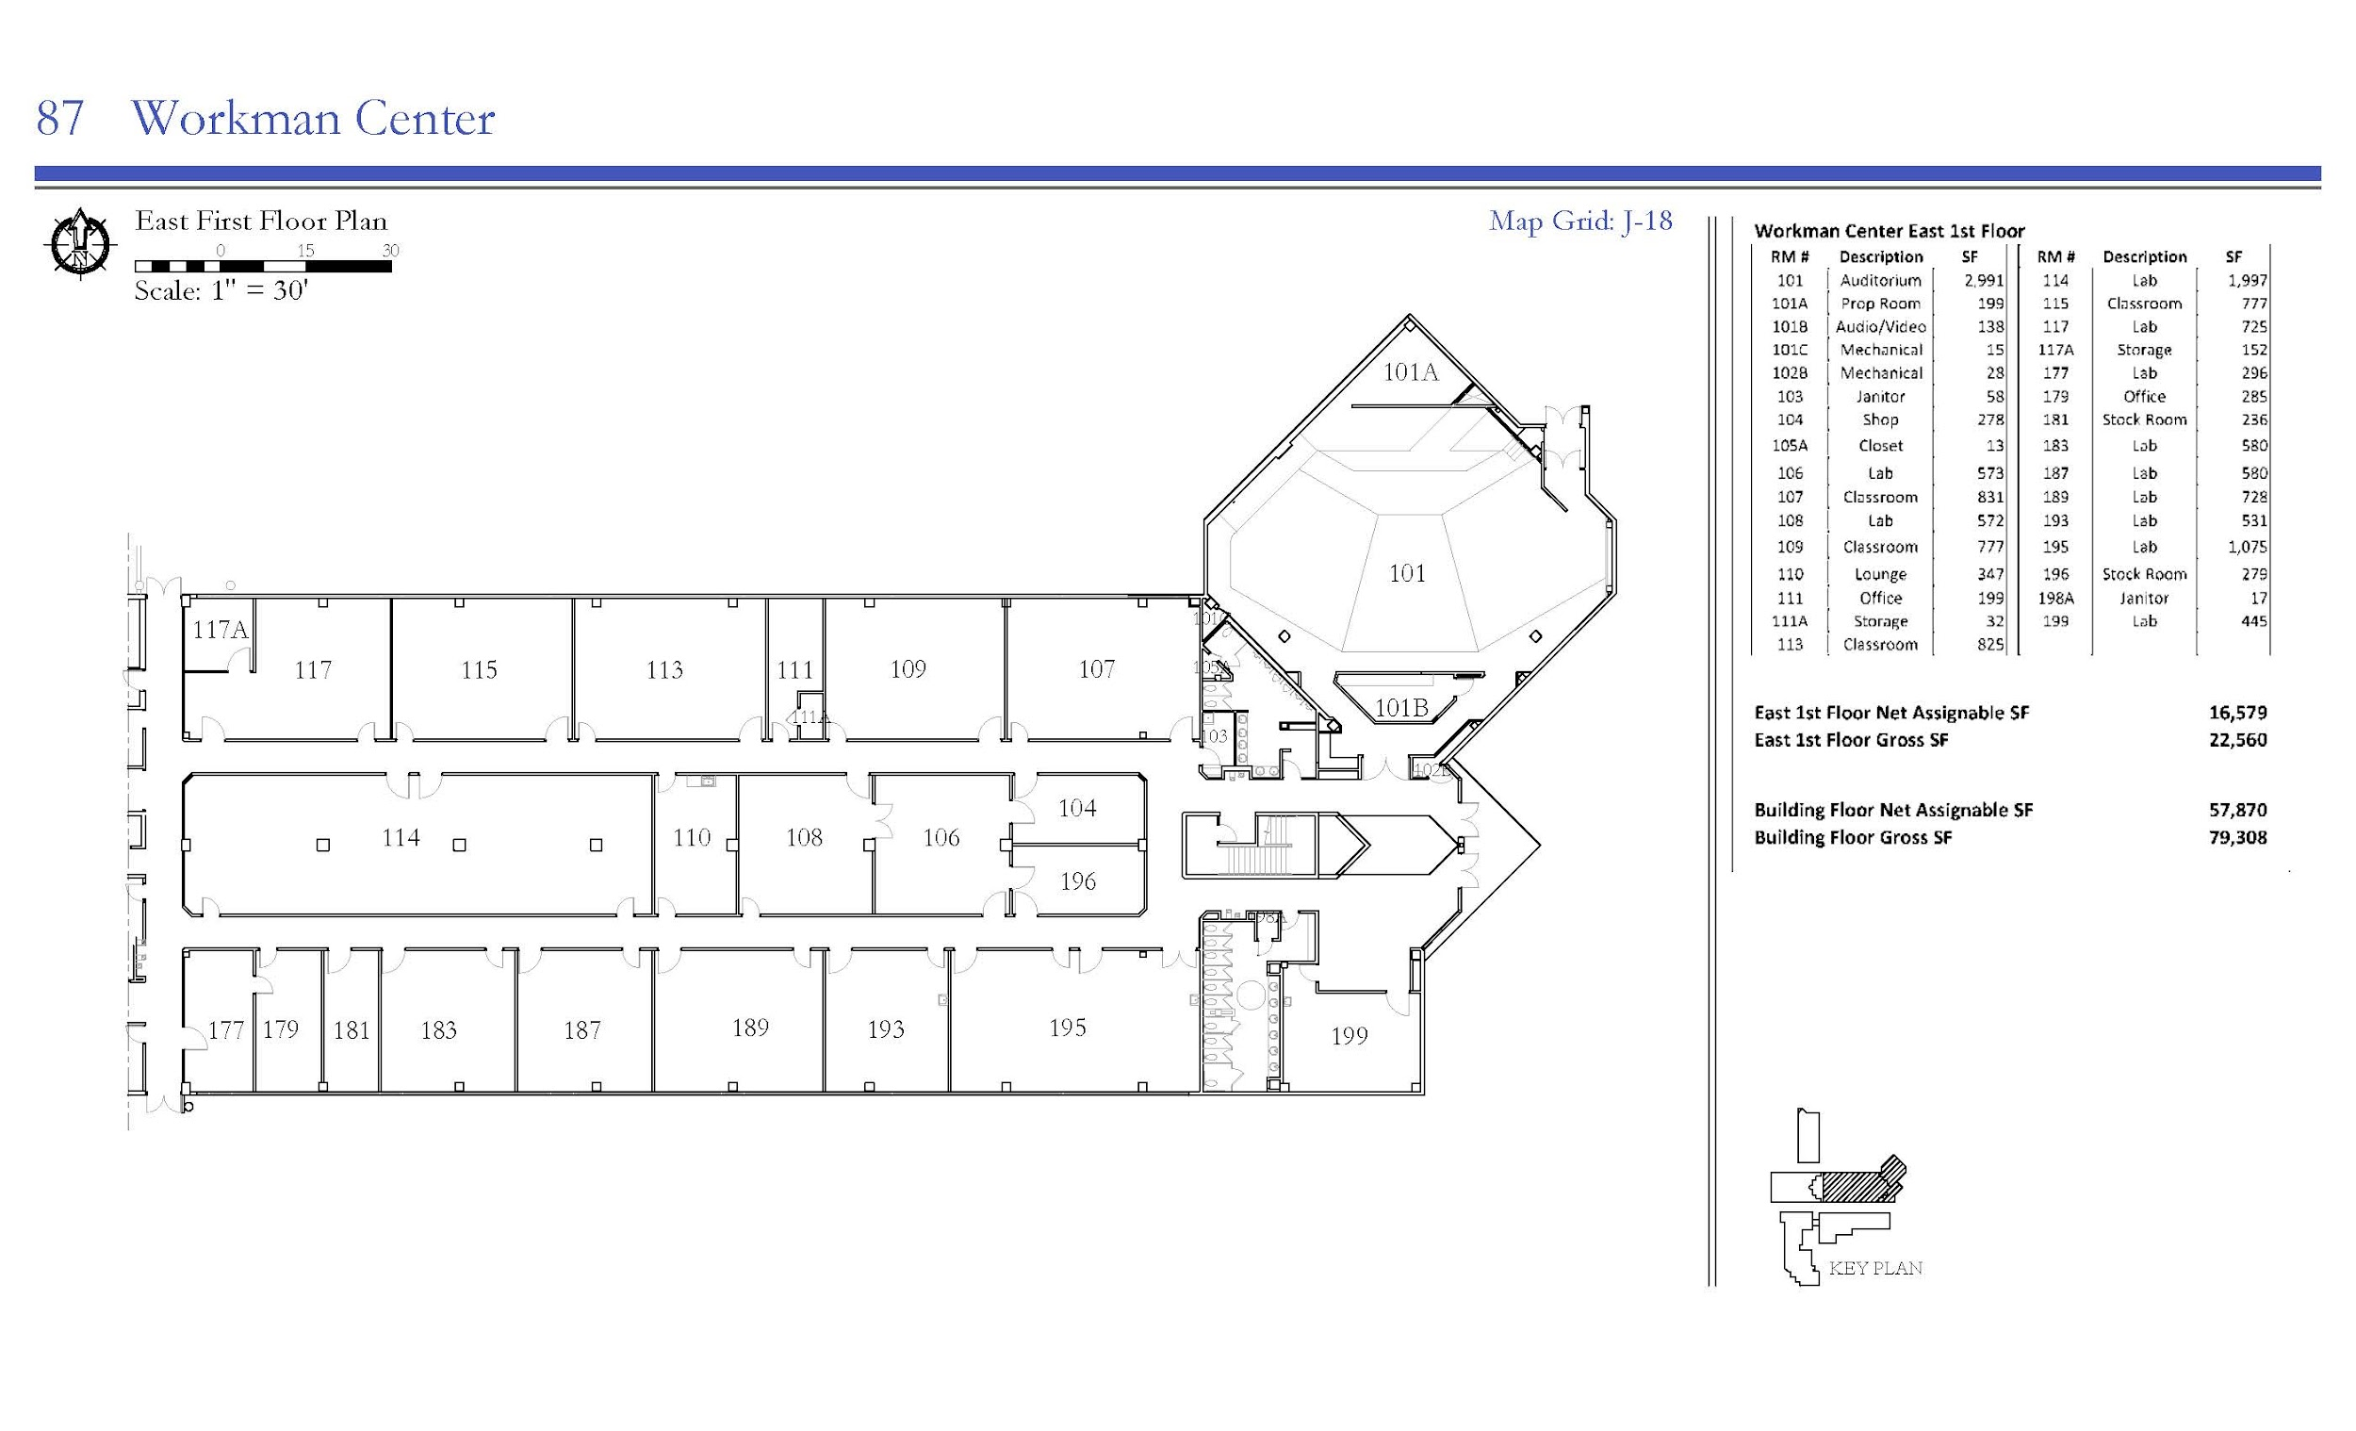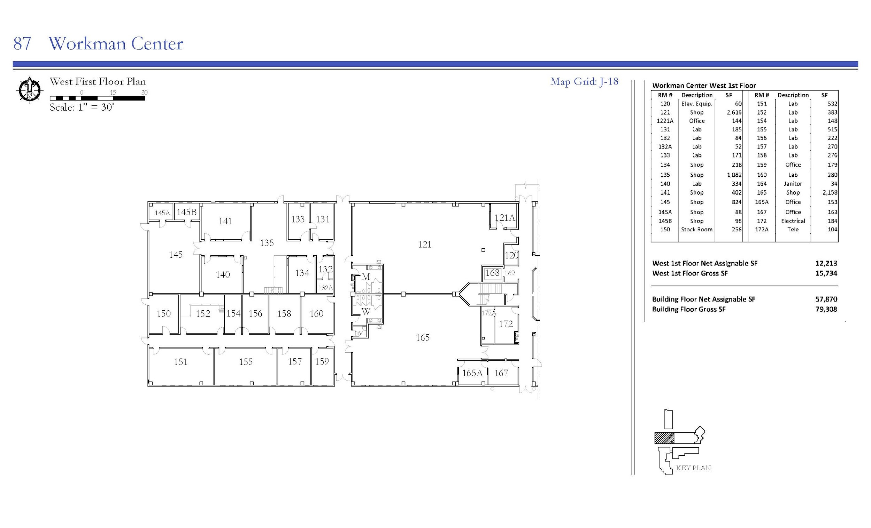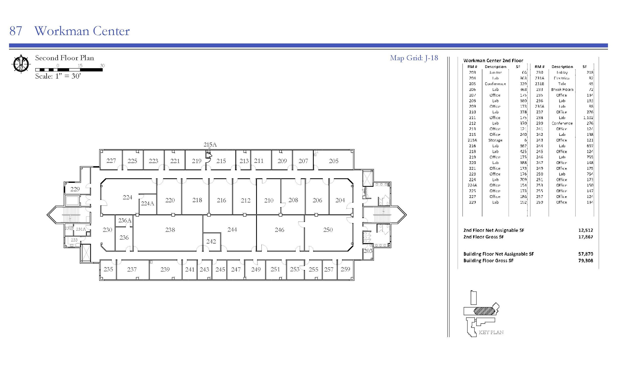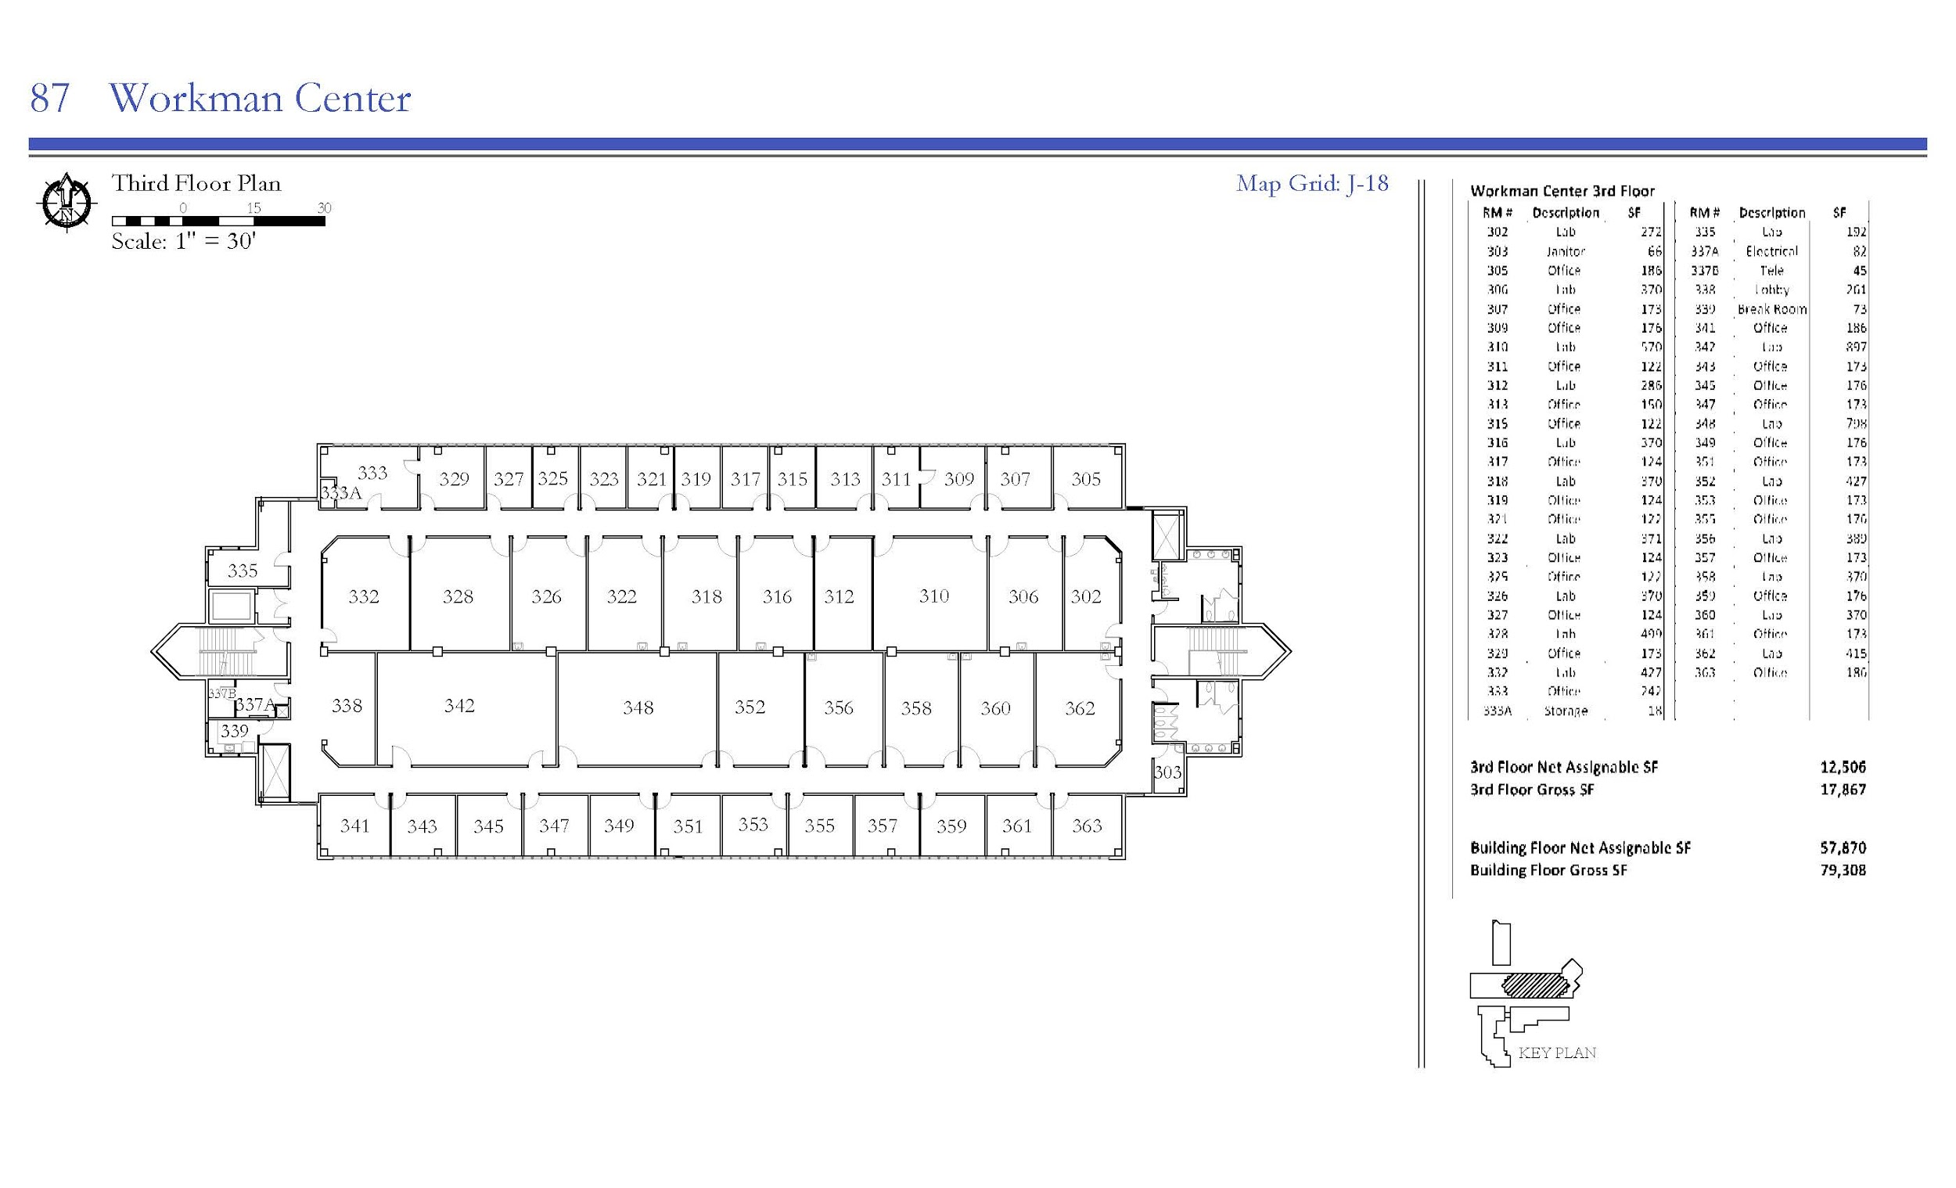
Bureau of Geology 1st Floor
Bureau of Geology 2nd Floor
Bureau of Geology 3rd Floor
Chemistry Building 1st Floor
Chemistry Building 2nd Floor
EMRTC Building Lab Spaces
Jones Annex 1st Floor
Jones Annex 2nd Floor
Jones Annex 3rd Floor
Jones Hall High Pressure Building
Jones Hall 1st Floor (West)
Jones Hall 1st Floor (East)
Jones Hall 2nd Floor (West)
Jones Hall 2nd Floor (East)
Kelly Building 1st Floor
Kelly Building 2nd Floor
MSEC Building 1st Floor
MSEC Building 2nd Floor
MSEC Building 3rd Floor
Weir Hall Basement Floor
Weir Hall 1st Floor
Workman Center 1st Floor (East)
Workman Center 1st Floor (West)
Workman Center 2nd Floor
Workman Center 3rd Floor

IX. Appendix II: Types of Chemicals and Waste

A. Categories of Generated Hazardous Waste

NMT uses a variety of chemicals within the academic and research setting, as well as for general facility operations and maintenance. Waste materials generated on-site include various quantities of characteristic and listed Hazardous Wastes. Most laboratory wastes are generated in volumes of less than 1 liter.

General hazardous wastes may fall under one or more of the following categories:

- Flammable Waste as defined in 40 CFR 261.21
  - It is a liquid, other than an aqueous solution containing less than 24 percent alcohol by volume and has a flashpoint less than 93℃ (200℉)
  - It is not a liquid and is capable, under standard temperature and pressure, of causing fire through friction, absorption of moisture, or spontaneous chemical changes, and when ignited, burns so vigorously and persistently that it creates a hazard
  - It is an ignitable compressed gas
- Corrosive Waste as defined in 40 CFR 261.22
  - It is aqueous and has a pH less than or equal 2, or a pH greater than or equal to 12.5
  - It is a liquid and corrodes steel [Society of Automotive Engineers (SAE) 1020]
- Reactive Waste as defined in 40 CFR 261.23
  - It is normally unstable and readily undergoes violent change without detonating
  - It reacts violently with water
  - It forms potentially explosive mixtures with water
  - When mixed with water, it generates toxic gasses, vapors, or fumes in a quantity sufficient to present a danger to human health or environment
  - It is a cyanide or sulfide bearing waste which, when exposed to pH conditions between 2 and 12.5, can generate toxic gasses, vapors, or fumes in a quantity sufficient to present a danger to human health or the environment
  - It is capable of detonation or explosive reaction if it is subjected to a strong initiating source or if heated under confinement
  - It is capable of detonation or explosive decomposition or reaction at standard temperature and pressure
  - It is a forbidden explosive as defined in 49 CFR 173.51, or a Class A explosive as defined in 49 CFR 173.53, or a Class B explosive as defined in 49 CFR 173.88
- Toxic waste as defined in 40 CFR 261.24
  - A solid waste (except manufactured gas plant waste) exhibits the characteristic of toxicity if, using the Toxicity Characteristic Leaching Procedure, Test Method 1311 in “Test Methods for Evaluation Solid Waste, Physical/Chemical Methods”, EPA Publication SW-846, as incorporated by reference in §260.11 of this chapter, the extract from a representative sample of the waste contains any of the contaminants listed in table 1 at the concentration equal to or greater than the respective value given in that table. Where the waste contains less than 0.5 percent filterable solids, the waste itself, after filtering using methodology outlined in Method 1311, is considered to be the extract for the purpose of this section.
  - A solid waste that exhibits the characteristic of toxicity has the EPA Hazardous Waste Number specified in Table 1 which corresponds to the toxic contaminant causing it to be hazardous.
- Listed Hazardous Waste as defined in 40 CFR 261 Subpart D may also be generated by the university.

