Appendix D - Electrical Safety

Only trained and knowledgeable electricians may work on/fix electrical issues and hazards. Always contact facilities management (575) 835-5533 to get a qualified electrician to work on your electrical hazards and requirements.

Effects of Electrical Current on the Human Body

Current | Effects
Below 1 milliampere | Generally not perceptible
1 milliampere | Faint tingle
5 milliampere | Slight shock felt, not painful but disturbing. May experience strong involuntary reactions, and can lead to other injuries.
6-30 milliampere | Painful to extremely painful shock with loss of muscle control. Hard to let go but can be thrown away from the circuit if extensor muscles are stimulated.
50-150 milliampere | Extreme pain, respiratory arrest, severe muscular contractions, can be fatal.
1,000-4,300 milliampere | Disruption to the rhythmic pumping of the heart, damage to muscles and nerves, likely fatal
10,000 milliampere | Cardiac arrest and severe burns, most people die
15,000 milliampere | Lowest occurrence at which a circuit breaker or fuse open the circuit*
Source: CDC NIOSH Electrical Safety Student Manual April 2009 p. 7
*Note that home outlets carry 15,000 milliampere and most outlets on campus are 20,000 milliampere

General Requirements

The average person can receive a shock that is potentially fatal before a circuit breaker or fuse will break the circuit.

- Never handle anything electric unless your hands, clothing and everything else are thoroughly dry. The drier you are the more you resist electricity.
- Never alter plugs, or use an adapter. If the plug doesn’t fit don’t use it.
- Do not use extension cords in offices and labs (see extension cords for more information).
- Do not overload circuits (see circuit loading for more information).
- Check electrical cords before each use and have them professionally repaired if damaged. Never use electrical tape on electrical cords.
- Only use intrinsically safe electrical equipment when flammables are present.All outdoor outlets, and indoor outlets within 4 ft. of water must be GFCI or be connected to a GFCI circuit breaker/fuse. GFCI outlets must be tested once a month. GFCI provides better protection than regular circuit breakers and fuses. See more below under GFCI.
- Discontinue use of any damaged outlets until they are repaired (see damaged outlets for more information).
- Do not try to pull someone away from a circuit while they are being shocked unless you are trained and know how to do so safely. Shut off the electrical source if you can do it safely, and call 911.

Outlet Use

Only use outlets that are in good condition. If an outlet shows any signs of damage do not use it until it has been repaired. Damage includes loose, broken, or missing covers, signs of burn or melting from an overload or arc, prong/s stuck in the outlet, and rusty screws (indicates overheating).

Examples of Broken Covers:

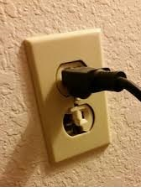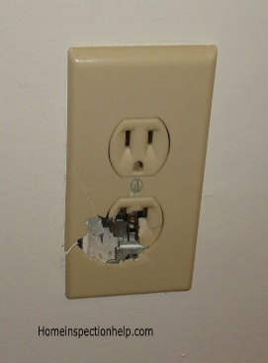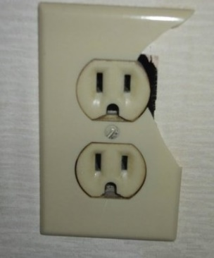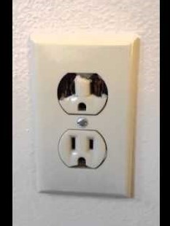

Even if only one outlet appears to be affected it is unsafe to use the entire outlet. Foreign objects, dust and debris can get into the outlet and potentially create an arc-a continuous electrical current that develops so much heat from the charge carrying ions or electrons that it can vaporize or melt anything within the range of the arc.

Examples of Burnt Covers:
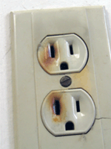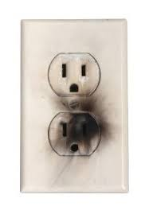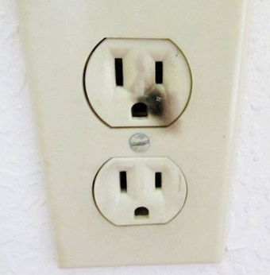

These outlets were overloaded or had an arc making them unsafe to use.

Examples of Loose Outlets:

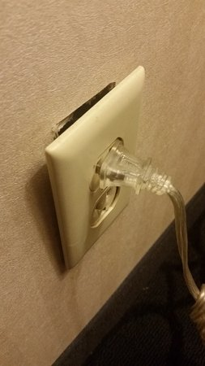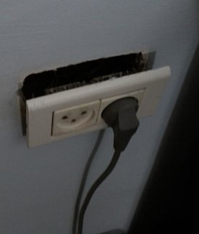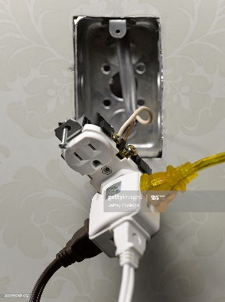

Examples of missing covers:

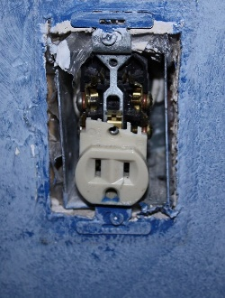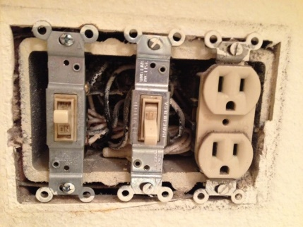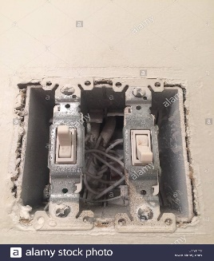

Loose and missing covers put you at risk of coming into contact of a live wire and increase the probability of an arc from dust and debris.

Circuit Loading. Be aware of your outlet’s amperage and the amperage needs of the equipment you are using to avoid overloading the circuit. An overloaded circuit can cause an electrical fire and/or arc. You can tell how many amps your outlet has by looking at it.

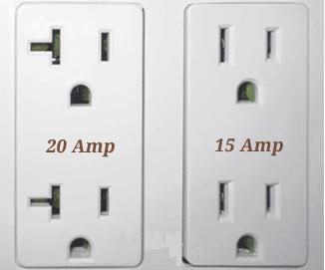

Never daisy chain power strips even if you think your circuit can handle the load.

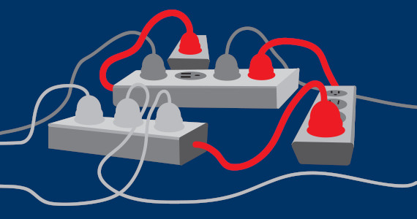

It is illegal to daisy chain under any circumstances. “A power strip needs to be connected directly to an outlet that is permanently installed. “(NFPA/OSHA)

GFCI Outlets are inexpensive life savers. GFCI (Ground Fault Circuit Interrupter) detects any difference in current between two circuit wires, and are designed to protect workers from electrocution. GFCI are required for outlets within 4 ft. of water, outdoor outlets, and all extension cords. GFCI must be tested once a month. Each lab must have an allocated person to perform this task each month and keep a log of the tests in their safety binder.

To test the GFCI just press the test button. This should trip the circuit, which you can now reset by pressing the reset button. Some GFCI are color coded: black is test, red is reset. Test is always the bottom button and reset is always the top button.
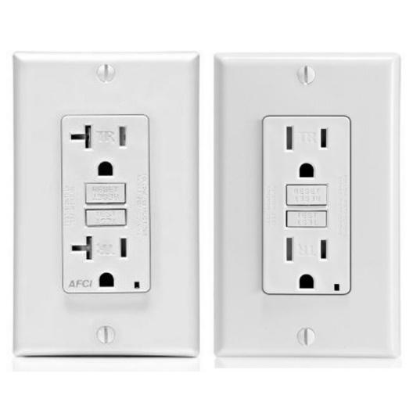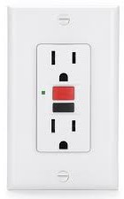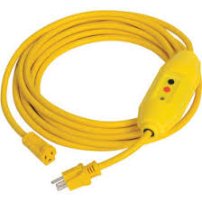

Even with GFCI protection is best to avoid water and dampness.

Extension Cords are not allowed in labs unless approved by HAZMAT. OSHA prohibits the use of extension cords as permanent wiring except under very specific circumstances that very rarely apply to lab work. If extension cord use is approved, it must be suitably rated and tested, and have GFCI protection. Extension cords must be inspected prior to each use and stored in a manner that will not damage the cord. Never use a damaged extension cord or attempt to repair it, buy a new one. All the rules for cords and plugs apply to extension cords.

Cords and plugs must be examined before each use. If a cord or plug is damaged do not use that piece of equipment. Send it back to the manufacturer for repair or buy a new one. When not in use, store equipment in a manner that allows safe storage of cords and plugs so they are not damaged. Avoid over bending cords to prevent damage to the internal wires. If you have to use any force you are over bending it. Do not twist wires. Do not pull a cord out of the socket while holding the cord, always pull while holding the plug. Do not alter the plug or use an adapter to make the plug fit. If the plug does not fit the outlet in your lab you should not be using that piece of equipment. All equipment used at NMT must have a grounding pin on the plug.

High Voltage is defined by OSHA as 600 volts and above. For NMT, high voltage is over 240 volts, and using high voltage requires special training and approval by HAZMAT for anyone who is not a trained and knowledgeable electrician.

