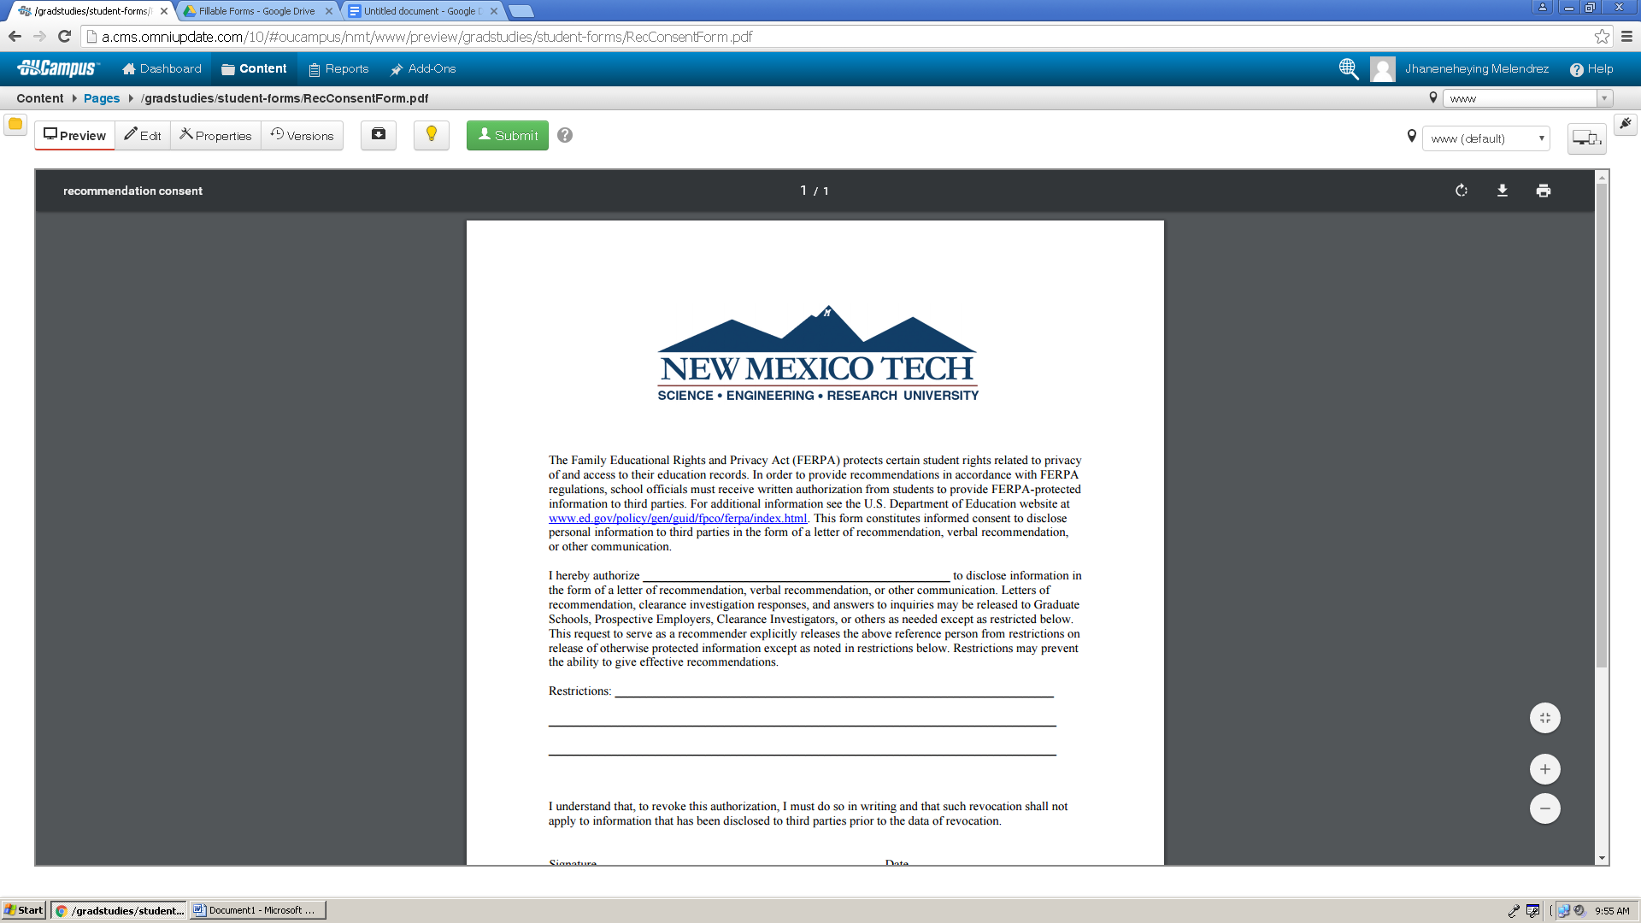
The Family Educational Rights and Privacy Act (FERPA) protects certain student rights related to privacy of and access to their education records. In order to provide recommendations in accordance with FERPA regulations, school officials must receive written authorization from students to provide FERPA-protected information to third parties. For additional information see the U.S. Department of Education website at www.ed.gov/policy/gen/guid/fpco/ferpa/index.html This form constitutes informed consent to disclose personal information to third parties in the form of a letter of recommendation, verbal recommendation, or other communication.

I hereby authorize _________________________________________________ to disclose information in the form of a letter of recommendation, verbal recommendation, or other communication. Letters of recommendation, clearance investigation responses, and answers to inquiries may be released to Graduate Schools, Prospective Employers, Clearance Investigators, or others as needed except as restricted below. This request to serve as a recommender explicitly releases the above reference person from restrictions on release of otherwise protected information except as noted in restrictions below. Restrictions may prevent the ability to give effective recommendations.

Restrictions: ____________________________________________________________________________ ________________________________________________________________________________________________________________________________________________________

I understand that, to revoke this authorization, I must do so in writing and that such revocation shall not apply to information that has been disclosed to third parties prior to the data of revocation.

Signature ____________________________________________ Date _______________ Printed Name _______________________________________

