Purchasing Services Office
801 Leroy Place
Socorro, NM 87801
(575) 835-5881

Letter of Addendum

TO: All Bidder’s

FROM: Lisa Valles Buyer II

DATE:

RE: RFB Number: RFB# 0022318E, Amendment No. 1 Commodity: Bundled Construction Supplies

Please note:

This amendment is issued to provide a list of questions that have been received by NM Tech.

Q1) I’m thinking that this is a typo – 500’ and 1000’ long non-electric detonators are not a normal product. Should they be 50’ and 100’ long?

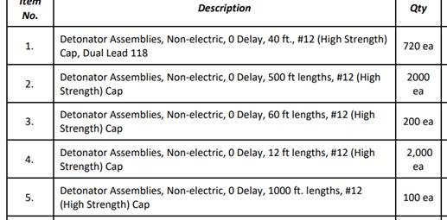

Also, can you verify that the quantity on the Leadline is actually 800 rolls?

A1) Descriptions and quantities listed in the items list are correct.

Q2) Are we penalized if we are unable to provide all items listed?

A2) Bidders are allowed to bid on only the items they can provide, and bypass any items they are unable to supply. The bid will be awarded to the lowest bid per line item.

Q3) Will this be a bulk order, one-time purchase?

A3) This is a multi-year award and not a one-time bulk order. Items will be ordered on an as-needed basis. Pricing does need to be provided to cover any orders placed throughout a one-year period. Pricing can be adjusted each year when the Pricing Agreement is renewed.

All other terms and conditions of the RFB remain unchanged. All Offerors are required to confirm the receipt of this amendment in their bid response. The proposal due date is April 05, 2024 at 2:00 p.m. MST.

Xc: File

NEW MEXICO TECH
Pricing Agreement RFB#

COMMODITY: Multi-Year Pricing Agreement –

CONTRACTOR:

Telephone:

Contact:

SCOPE: The Contractor shall provide in accordance with the terms, conditions, and specifications of New Mexico Tech’s RFB# as amended.

TERM: The term of this agreement shall consist of an initial term of one
(1) year with renewal options for three (3) one (1) year extension periods, not to exceed four (4) years total. The base

period of performance shall begin on expire .
and

EXTENSION PERIOD: Each one (1) year renewal option shall be accomplished by New
Mexico Tech issuing a formal bilateral pricing agreement amendment. Each renewal option extension shall be subject to the Institute’s ability to receive appropriated funds to support this pricing agreement.

INSTITUTE LIABILITY: No legal liability on the part of New Mexico Tech for payment of
any funds shall arise until goods or services are ordered and received by New Mexico Tech.

PRICE ADJUSTMENTS: The prices offered by the Contractor in their bid response are to
be firm for the first year of the agreement. Pricing may be decreased at any time by a Contractor and price adjustments may be permitted when the Contractor experiences price increases. The Contractor shall provide the earliest practicable notice of any impending price increases to assist in maximizing

the Institute’s purchasing opportunities. Price increases must be supported by third party documentation for all price increase requests.

ORDERING METHOD: New Mexico Tech shall issue purchase orders throughout the
term of this pricing agreement for .

FIRM PRICE: When placing purchase orders, the Institute will rely on the Contractor’s current price list provided in the Contractor’s bid response and maintained in the contract file. The prices of the resulting purchase order shall prevail upon acknowledgment of the order, or shipment of the items, by the Contractor.

PRSBI Bundles at $ IRTB Bundles at $

SUBSTITUTIONS: Substitutions shall not be allowed without the prior approval of
New Mexico Tech. Pricing for specialty services will be determined at the time of order.

SHIPPING CHARGES: All prices quoted shall be F.O.B. Destination.

DELIVERY: Deliveries shall be made consistent with schedule(s) provided by
.

PAYMENT TERMS: Net 30 days

TERMINATION: This agreement may be terminated by either party by providing
written notice to the other party at least sixty (60) days prior to the effective expiration date.

AUTHORIZED USERS: New Mexico Tech and others per NMSA 13-1-129.

Signatures:

For New Mexico Tech For

Kimela Miller
Title: Chief Procurement Officer Title:

Date:
Date:

