
Dynamic Forms Travel Reimbursement Voucher Instructions
- Please follow the link below to access the Travel Reimbursement Voucher Form: https://dynamicforms.ngwebsolutions.com/Submit/Start/3e7404e7-821a-4867-8a94-ce39f4d26f34
The Travel Reimbursement Voucher Form is also located on the NMT Travel Office web page: https://www.nmt.edu/finance/travel.php
- If this is your first time using Dynamic Forms, create a new account using your NMT email address as your username (i.e. first name “.” last name@nmt.edu).
- If you already have an account, log in.

- Enter the following information:
  - The travel number will be filled in by the Travel Office.
  - Select yes or no on whether you are the traveler.
  - Select a contact person that the Travel Office can contact with any questions.
  - Enter a funding department which is the department you are traveling on behalf of. If the Federal Per Diem box is checked, you will not have to enter the time of departure or the time of return.
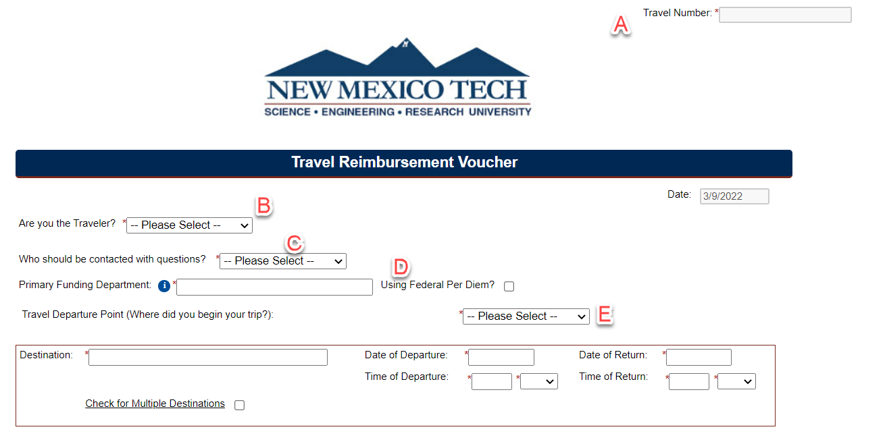
  - Select where the trip began. If other, enter the departure address in the box provided.

- Enter the city and state of the travel destination. Check the box for multiple travel destinations. Select the date of departure and date of return. Please note that travel reimbursements issued greater than ninety (90) days, per the IRS Accountable Plan, after a traveler returns become taxable to the traveler and will be forwarded to the Payroll Office for tax withholdings. Any amount not substantiated must be reported as wages or other compensation on the traveler’s W2 and is subject to withholding and payment of employment taxes. Enter the time of departure and time of return.

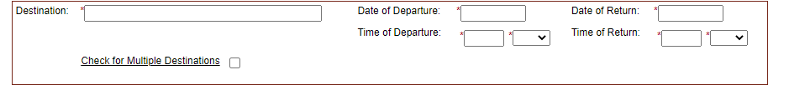

- Provide all that applies to your Travel Actuals.
  - If applicable, select either NMT Per Diem, Board of Regents Rate or Federal Per Diem. The total reflects the first and last day reduction rules.
  - If NMT Per Diem is selected:
    - If Meals and Incidental Expenses is selected, enter the number of FULL 24 hour days/nights. Then select the number of hours for partial days. A Date/Time calculator link is provided on the form for your use.
    - If Lodging is selected, choose whether it is in state or out of state travel and enter the number of days/nights.
  - If Board of Regents Rate is selected:
    - Select either Physically Attending < 4hrs or Virtual OR Physically Attending > 4hrs.
  - If Federal Per Diem is selected:
    - If Meals and Incidental Expenses is selected, enter the number of days/nights along with the rate provided by GSA. The prorated amount will automatically be calculated.
    - If Lodging is selected, enter the number of days/nights along with the rate provided by GSA.
    - The link to the GSA website is provided on the Travel Reimbursement Voucher for your use and information.
  - Select yes/no if any meals were provided during the trip. If yes, enter the number of meals for each breakfast, lunch and/or dinner. Your per diem will be calculated and reduced.
  - If Hotel is selected:
    - Select Actual amount, or as limited by GSA or Actual Rate Exceeds GSA max.
    - Select payment method.
    - Enter the total amount of the hotel expense.
  - If applicable, select Transportation and select all transportation that applies. Next, select the payment method and enter the rate or amount
    - If selecting Personal Vehicle, select either the current year mileage rate or other depending on when the travel occurred. There is a drop down option that provides the standard roundtrip mileage from Socorro to multiple destinations in NM. You can use the miles provided and enter it in the miles input box or enter the miles traveled based on the map you attach showing the departure address and arrival address that includes the total miles traveled.
    - If selecting Official Vehicle, you can enter the vehicle number along with the odometer beginning and ending numbers which will calculate the total miles traveled.
  - If applicable, select Registration, enter the name of the vendor being paid for the registration, the payment method and the amount
  - For any other travel expenses that were not listed above, select Miscellaneous, choose from the options listed or enter the description of the expense and the expense amount.
  - Descriptions of the payment method selections are below:
    - Select prepaid by traveler when the traveler has already paid for the expense and the receipt/proof of purchase is attached to the reimbursement voucher.
    - Select NMT Purchase/Paid by University if expenses were paid by Direct Payment or Rio Grande Travel.
    - Select P-Card if the expenses were paid with a purchase card and the receipt/proof of purchase is attached.
    - Select Gas Card for fuel expenses paid for with the traveler’s gas card during the trip and the receipt/proof of purchase is attached.
    - Select Paid by Traveler During Trip if the traveler paid out of pocket for expenses and the receipt/proof of purchase is attached.
  - If you received an advance and/or prepayment check before the trip, enter the amount of the check(s) in the Amount of Prepayment and Advance Received before the Trip box so the amount to be reimbursed can be reduced by the advance and/or prepayment.

- Please note, if you have checked an expense box, selected a payment method and entered an amount and then want to delete that information, you cannot simply uncheck the expense box. You must delete each amount that you no longer want included and back your way out of the entry be deselecting all of the information. There will also be a “Reset” box available to check if you would like to reset the travel estimate portion of the form and start over. Only one reset will be allowed. If you need to start over again, please delete your current form and start a new one. You are also welcome to contact the Travel Office for assistance.

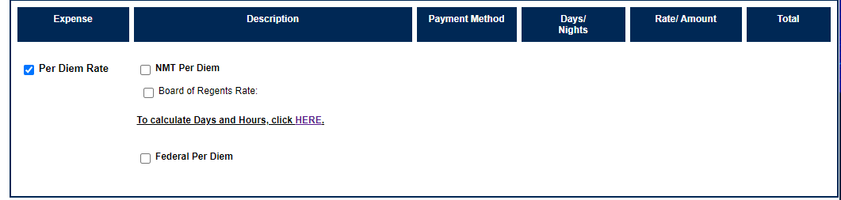
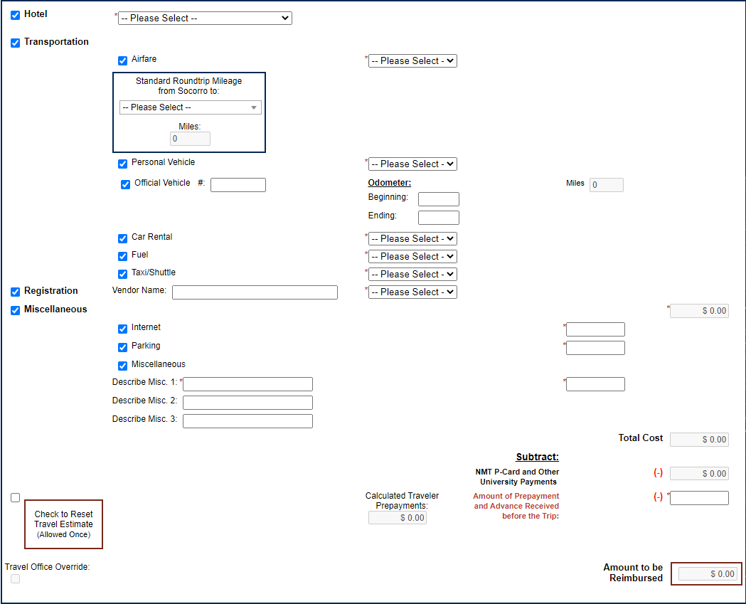

- If you have any special instructions or a specific remit to address/type, please specify in the boxes provided.

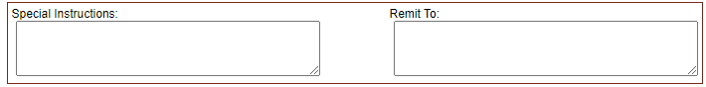

- Funding Source
  - Distribution: select whether you would like to distribute the amount charged to the Index by percentage or dollar amount.
  - Enter the Index.
  - Select the Account code from the selection box.
  - Enter Activity Code if needed.(If you are unfamiliar with this, please disregard).
  - If multiple indexes are being used, select the Add More Rows checkbox.

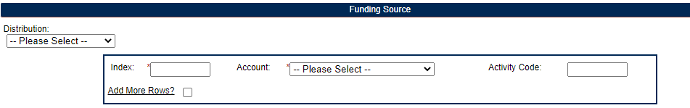

- Receipts and Documentation
  - Choose file box to upload any receipts, i.e. airfare, registration, hotel reservation/confirmation, etc.
  - If a receipt has been lost/never received, check the No Receipt Expense Statement box and after you submit the Travel Reimbursement Voucher, you will be directed to the No Receipt Expense Form to fill out.
  - Note: The preferred method of attachments is to combine all documents and receipts into one document before attaching to the form.

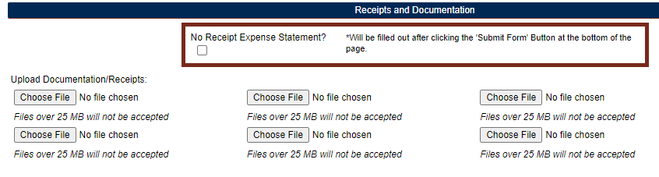
- Form Initiator Signature

  - Click to electronically sign the form.
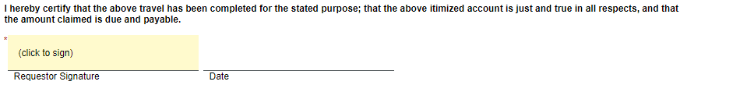

- If the requestor is filling out the form on behalf of the traveler, the form will route to the traveler for electronic signature once submitted.

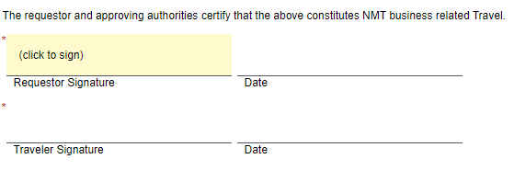

- Supervisor, Dept. Division Head or P.I. This voucher cannot be processed without their signature(s).
  - Please enter contact information of the Supervisor, Dept. Division Head or P.I. approving the Travel Reimbursement Voucher.
  - If additional departments are required to approve the Travel Reimbursement Voucher, choose yes or no from the selection box and enter their information.
  - Please ensure the email address is entered correctly so the form will route to the authorized signer. If it is entered incorrectly, the form will not route until the email address is corrected.

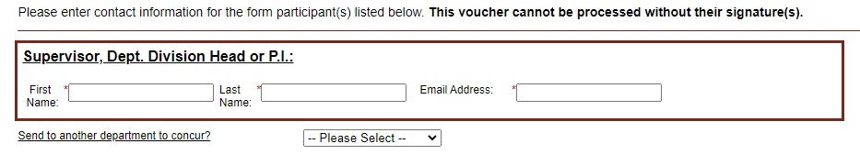

- Submission and Saving Progress
  - If at any point, you need to gather more information about the trip, scroll down to the bottom of the form and click Save Progress.
  - When finished filling out the form, scroll down to the bottom and click the Submit Button. This will trigger the form to route for approvals.
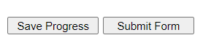
- Reimbursement Approvals

  - Click to electronically sign the form, add comments if needed.
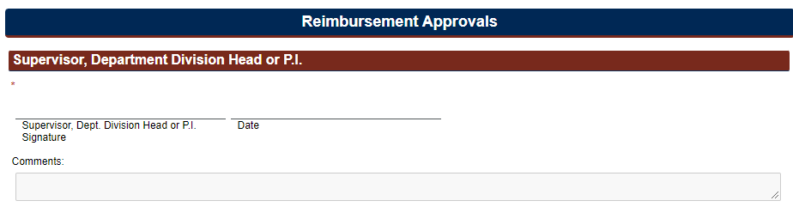

- Once the Travel Reimbursement Voucher is received by the Travel Office, it will be reviewed and processed. If the Travel Office has any questions, requires corrections to be made or needs additional documentation, the Travel Office will return the voucher through Dynamic Forms back to the form initiator. Once the initiator re-submits the voucher, it will then re-route to the approvers and back to the Travel Office for processing.

- If you have any questions or need help filling out the Travel Reimbursement Voucher Form through Dynamic Forms, please email the Travel Office at traveloffice@npe.nmt.edu.

