New Mexico State University

PROPOSAL FOR A GRADUATE MAJOR (MASTER OF SCIENCE DEGREE) IN CLINICAL PSYCHOPHARMACOLOGY OFFERRED BY THE DEPARTMENT OF COUNSELING AND EDUCATIONAL PSYCHOLOGY

Submitted by the College of Education

January 2016

Prepared by:

Enedina García Vázquez, PhD
Associate Dean of Academic Affairs
PO Box 30001, MSC 3AC
Las Cruces, NM 88003
575-646-7556
evazquez@nmsu.edu

Gladys De Necochea, PhD
Interim Department Head
Counseling and Educational Psychology
PO Box 30001, MSC 3CEP
Las Cruces, NM 88003
575-646-2121
gdenecoc@ad.nmsu.edu

TABLE OF CONTENTS

BACKGROUND INFORMATION AND SUMMARY
- PURPOSE OF THE MAJOR 4
- Purpose
- Institutional Priority of the Proposed Major
- Admission Policy
- Curriculum
- APA Accreditation Designation
- JUSTIFICATION FOR THE MAJOR 6
- Need
- Duplication
- Inter-institutional collaboration and cooperation
- CLIENTELE AND PROJECTED ENROLLMENT 8
- INSTITUTIONAL READINESS 8
- Program director
- Teaching faculty
- Library support
- Physical facilities
- Equipment and technology resources
- Other operating resources
- External facilities
- PROJECTED COSTS OF THE PROGRAM 10
- QUALITY OF THE PROGRAM 11
- Advising
- Program of study
- Field experiences and placements
- Program handbook
- Supervision
- ASSESSMENT OF OPERATIONS AND IMPACT
- ADMINISTRATIVE RESPONSIBILITY AND
INSTITUTIONAL COMMITMENT

Appendices
Appendix 1 House Bill 170
Appendix 2 Letters of Support
Appendix 3 Market Analysis
Appendix 4 Sample List of Instructors
Appendix 5 APA Designation Letter
Appendix 6 Program Handbook
Appendix 7 Program Director CVs
Appendix 8 Library Resources Memo

BACKGROUND INFORMATION

Introduction. In March 2002 the 45th Legislature passed House Bill 170, which was signed by Governor Gary Johnson to grant prescriptive privileges to licensed psychologists (See Appendix 1 or view online at http://cep.nmsu.edu/academic-programs/clinical-psychopharmacology/new-mexico-rxp-law/). With the signing of this law New Mexico becomes the first state in the nation to authorize appropriately trained and specially licensed psychologists to prescribe psychotropic medications to increase mental health accessibility to residents of New Mexico. Prior to the passage of the New Mexico state law, only the US Island territory Guam (1998) and the Department of Defense Psychopharmacology Demonstration Project (1991-1997) granted psychologists prescriptive privileges.

New Mexico State University became the first land grant, public state university, Hispanic-Serving Institution (HIS) to offer educational and training preparation in clinical psychopharmacology to licensed psychologists. The training has been provided under the auspices of the Counseling and Educational Psychology (CEP) Department. Offered initially as a certificate program, the training is now offered in an interdisciplinary graduate degree. Graduates earned the Interdisciplinary Master of Arts degree reflecting the cooperation between the CEP and Special Education/Communication Disorders (SPED/CD) departments. In more recent years, a partnership with the Nursing Department was forged in order to more accurately reflect accreditation requirements requiring specific training in conducting head-to-toe physical assessment.

Over time, the field of psychopharmacology has expanded. The states of Louisiana (in 2004) and Illinois (in 2014) passed similar prescription laws. Other institutions such as California School of Professional Psychology-Alliant International (in Texas, Louisiana, California), Fairleigh Dickinson, Fielding Institute, Nova Southeastern, University of Hawaii, and Massachusetts School of Professional Psychology developed programs offering the MS in psychopharmacology. Most of these programs have yet to receive designation status from the American Psychological Association (as described below). Further, many of these institutions are sited in states that have yet to pass governing legislation.

The CEP Department hereby submits a formal request for a major in Clinical Psychopharmacology (MS degree) to more accurately reflect the academic degree program offered, align itself with the program evolution within the profession and to remain competitive with states offering similar academic degree programs. This request proposal outlines the curricular requirements and field experiences consistent with the law and designation requirements of the American Psychological Association.

The CEP Department has a long history of rigorous program development and is perfectly suited to continue this tradition with the psychopharmacology program. With its 8th iteration (cohort) currently underway, the clinical psychopharmacology program of study has proven itself sustainable and now is ready to move to the next phase. The critical next step in this process is to more clearly specify the program major associated with the MS degree. At present, the CEP department is the academic home to three graduate programs in counseling, school psychology and counseling psychology, all of which are nationally accredited. Given the infancy of accreditation of psychopharmacology programs, the American Psychological Association reviews and grants designation of postdoctoral education and training programs in psychopharmacology in preparation for prescriptive authority. The CEP Psychopharmacology Program received APA Designation in 2015 (See Appendix 5).

- PURPOSE OF THE MAJOR

Overall purpose. The primary purpose of the psychopharmacology major is to meet the mental health needs of the residents of the state of New Mexico. In addition, the program will address the following priorities:
- Facilitate access to mental health services for New Mexico residents, with particular emphasis on serving the needs of rural populations,
- Provide appropriate training to licensed psychologists to become highly qualified practitioners in clinical psychopharmacology. The program continues to prepare graduates to apply practices consistent with the American Psychological Association. Students learn to apply psychopharmacological principles and specialized knowledge in “domains of basic science and neurosciences, psychopathology, physical assessment and laboratory examinations, clinical medicine and pathophysiology, clinical and research pharmacology and psychopharmacology, clinical pharmacotherapeutics, and psychopharmacological research” (APA, 2015),
- Increase the number of prescribing psychologists,
- Provide a training model for states throughout the country and abroad,
- Continue interdisciplinary collaborations with other programs and the community and
- Provide internship/externship placements in community agencies, thus providing mental health services to people in need.

Institutional priority of the proposed major. The institutional priority of the clinical psychopharmacology major is to serve the mental health needs of the poor, particularly in rural New Mexico. As a result, the program provides “practical” training allowing graduates to apply their knowledge and skills to serve the mental health needs of the population. The purpose of this major is consistent with the land-grant mission of the University along with the educational priorities set forth by the federal program designation of Hispanic-Serving Institution (HSI).

By virtue of its APA Designation along with its recognition within the College of Education as a program of distinction, the psychopharmacology major remains a high priority within the college.

Admission policy. The postdoctoral MS in Clinical Psychopharmacology is like no other major at NMSU because it requires that applicants have completed a doctoral degree in psychology and hold a current state license to practice psychology independently. Currently the New Mexico Board of Psychology Examiners licenses psychologists. Doctoral graduates with training in counseling psychology, school psychology, clinical psychology and rehabilitation psychology are eligible to sit for the Examination for Professional Practice of Psychology (EPPP), the written licensing exam developed by the Association of State and Provincial Psychology Boards. Once the EPPP exam is passed, an individual seeking a license applies directly to the state’s Board of Psychology Examiners.

Curriculum. The clinical psychopharmacology program prepares psychologists to meet the mental health needs of patients using a combination of psychotherapy and pharmacotherapy. At the completion of the program, graduates are able to define, identify, and use key concepts in the content areas of the five units comprising the program of study. Graduates understand and apply theories of pathophysiology, etiology, mental health disorder symptoms and relevant psychopharmacological treatment, effectively assess, diagnose and treat in solving clinical psychopathological cases using Subjective, Objective, Assessment and Planning (SOAP) notes. Graduates are able to conduct analyses, interpretations, integration and evaluation of psychological problems using a pharmacological base. Graduates are able to conduct a head-to-toe examination. The training provided prepares graduates for the Psychopharmacology Examination for Psychologists (PEP).

The program prepares graduates following the psychobiosocial model. According to LeVine and Foster (2010), central to the model is the patient’s phenomenological view of psychotherapy and medication. Assessment of resilience and vulnerability within all of the patient’s functioning (perceptions, personal values, needs) helps to establish biological, psychological and social interventions. First line interventions include least restrictive and invasive empirically based treatments. Critical to the model is the integration of medication management in therapy, serving varied goals through various therapy phases.

The program of study consists of five (5) units with 36 credits of coursework plus 500 clock-hours of internship, supervised by a licensed physician with experience with psychotropic intervention, including but not limited to psychiatrists. The full program of study is described in Section F below.

APA designation. In 2010 the American Psychological Association announced the designation process for programs in psychopharmacology. “The review process for designation is a threshold assessment through documentation that assures that the education and training experience is sufficient to prepare students to be eligible for credentialing in that domain. Those programs identified as meeting these criteria would be referred to as an APA designated program in psychopharmacology for prescriptive authority” (APA, 2010). The current program offering met this threshold and has APA Designation in 2015 (See Appendix 5). However, to maintain this designation the major in Clinical Psychopharmacology (associated with the MS degree) will enhance the CEP department’s ability to obtain/maintain this designation status.

- JUSTIFICATION FOR THE MAJOR

Need. According to the World Health Organization (2001) mental illness is at 24% nationally. In New Mexico, particularly in rural parts of the state, the lack of access to mental health care is critical. Access to psychiatrists is at an all time low and in the ratio of psychiatrists to patients in metropolitan New Mexico is 21:100,000. On the other hand the psychologist to patient ratio is 41:100,000. In contrast, rural New Mexico reports only 5.8 psychiatrists and 13 psychologists to every 100,000 patients. In both instances, patients have more access to psychologists. Prescribing psychologists have responded to the critical need to serve the often-underserved rural communities of New Mexico. When the needs of patients are not met, the greatest burden of mental health disorders falls on the poor (World Health Organization, 2001).

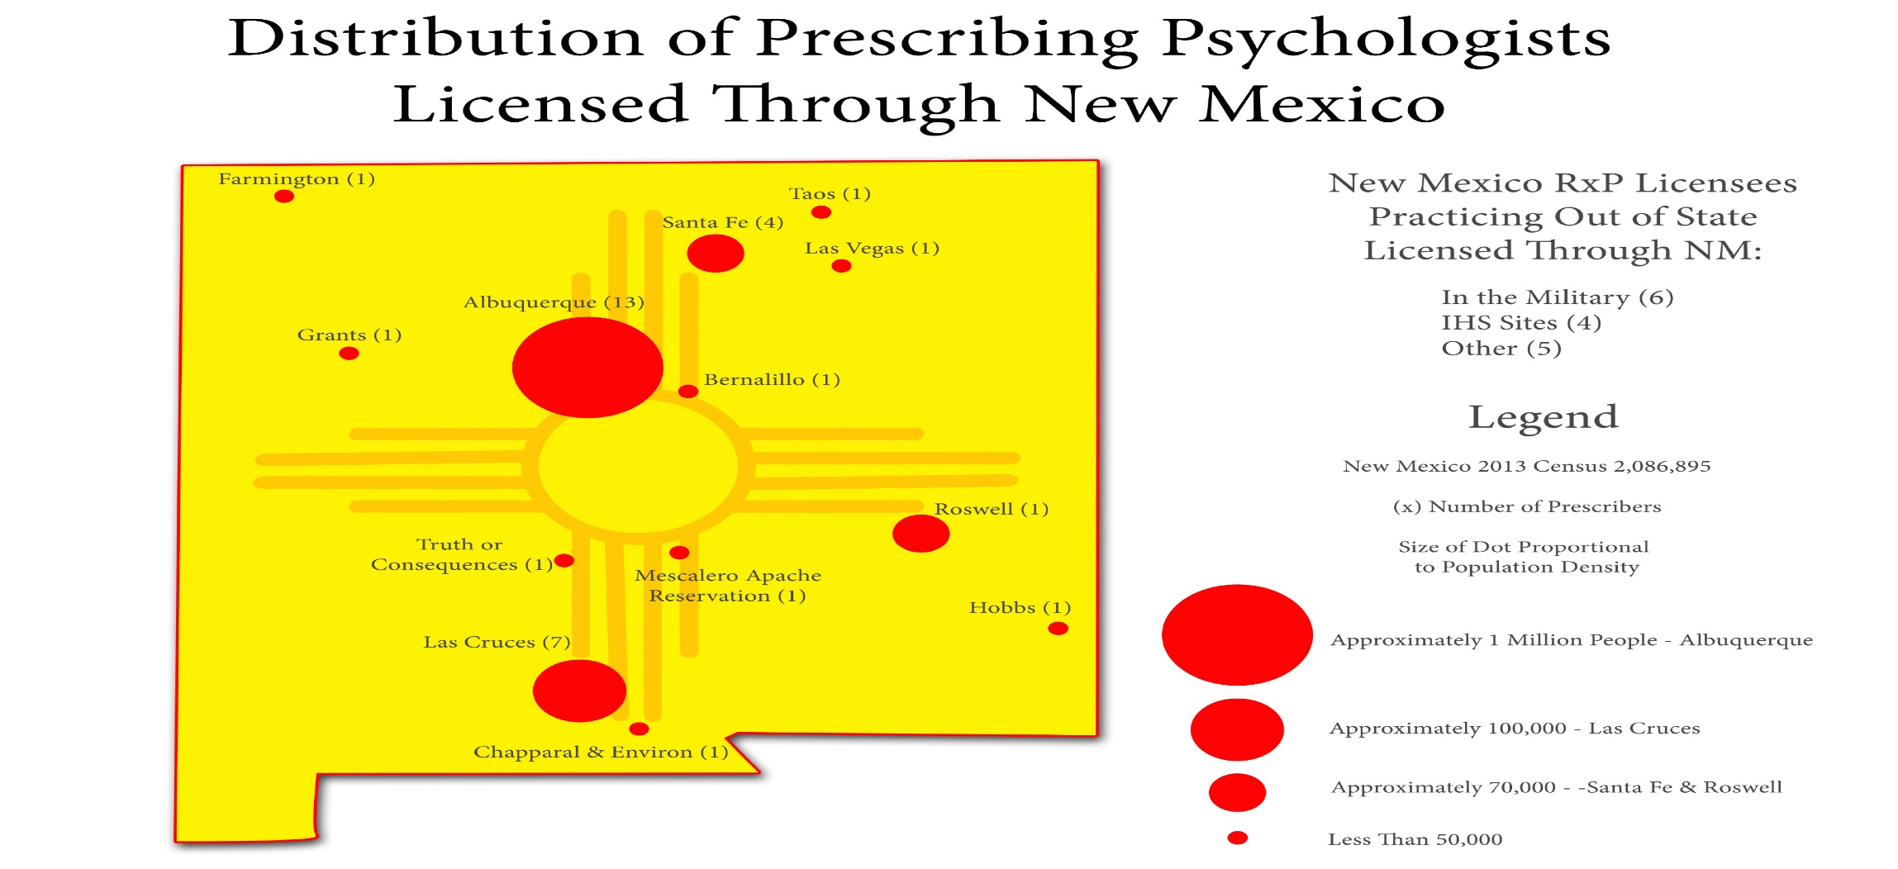

Prescribing psychologists serve the poor and mentally ill in New Mexico. New Mexico has approximately 2,000,000 residents of which 72,000 adults and 22,000 children are diagnosed with serious mental health challenges. Only 24% receive public mental health services, 15,000 are incarcerated and 40% of the children with serious mental illness dropped out of high school. In 2012, the directory of OptumHealth (servicing the poor through public service, “Medicaid”) listed 17 psychiatric nurse practitioners, 38 psychiatrists and 40 prescribing psychologists (half of whom are located in rural areas). While prescribing psychologists have offered more comprehensive services, mental health needs continue to rise and an increasing number of highly qualified personnel are needed.

In a 2001 survey, 95 psychiatrists in the State were surveyed. Most were located in Albuquerque and/or Santa Fe. Many worked at the Medical School of the University of New Mexico. Survey results demonstrated that the number of prescribing psychologists had reportedly increased and psychopharmacological care increased by about 50%. Therefore, providing psychopharmacology training to practicing psychologists serves to increase access to a more comprehensive array of services combining psychotropic medications and psychotherapy to meet patients’ mental health needs.

Prescribing psychologists in New Mexico are successful. According to the Chair of New Mexico’s Board of Psychology Examiners, Robert Sherrill (2007), “In the five years that psychologists have been prescribing in New Mexico, there have been no complaints at all to the State Board of Psychologist Examiners of patients having been harmed by prescribing psychologists. None. Also, there have been no allegations of improper or inappropriate prescribing which have been verified after review by the State Board of Pharmacy.” More recently, Lopez (2016) in a letter to Daniel Ullman, a psychologist seeking to advocate for passing of legislation to grant prescriptive authority to psychologists in Nebraska, reported no disciplinary actions against prescribing psychologists in New Mexico (see letter in Appendix 2).

The clinical psychopharmacology program is intended to address workforce shortages and address the mental health shortages throughout the state of New Mexico. The program will (continue to) increase the pool of prescribing psychologists to safely manage medications and patient access.

Duplication. New Mexico State University is unique in its clinical psychopharmacology program of study and is not offered at any other institution in the state of New Mexico. In fact, the psychopharmacology program stands apart nationally. Therefore no academic program duplication exists within the state.

While New Mexico psychologists have access to other programs offered across the country, including those that are online, the program at NMSU is a more affordable investment, charging tuition that is well below the program costs charged by private for-profit institutions. A Hawaii public institution is a campus-based program that poses geographical/travel challenges that render that program an unfeasible option for practitioners situated within the continental US. Further, it lacks the field experience required for licensure as specified in New Mexico House Bill 170.

Inter-institutional collaboration. As noted in the preceding section on duplication, currently there are no other programs in the state that provide preparation in psychopharmacology. Such programs offered outside of New Mexico are housed in academic departments offering doctoral level preparation in counseling psychology. Since no other New Mexico higher educational institutions house such programs it is unlikely that an inter-institutional (academic) collaboration could be established with other New Mexico Universities.

Collaborations, however, have been forged with agencies across the state in order to provide the delivery of clinical services. Placements include, but are not limited to, Presbyterian Clinic in Gallup, School Based Heal Clinic in Gadsden La Clinica de Familia in Las Cruces, Federally Qualified Health Clinics in Taos, Española, Truth or Consequences, General Hospital in Farmington, Taos-Picarus Indian Health Service and Lovelace Outpatient Clinic in Albuquerque.

- CLIENTELE AND PROJECTED ENROLLMENT

While the primary purpose of the proposed program is to increase the number of prescribing psychologists in the state of New Mexico, psychologists throughout the country can be recruited, particularly from states where prescribing laws have been passed. The program is primarily a campus-based program, however, delivery modes can be adapted to reach applicants across the country, internationally, and the military.

It is anticipated that the demand for the program across a broad geographical range will grow in subsequent years given the need for prescribing psychologists and particularly at NMSU because the university is one of the best buys in the country. Other states considering legislation (Michigan, Missouri, Montana, Nebraska, New York, Oregon, Ohio, Illinois, Tennessee and Texas) when passed will increase the demand for training programs in psychopharmacology. As of June 2016 the state of Iowa joined New Mexico, Louisiana, and Illinois in passing legislation allowing prescriptive authority to psychologists. Only six programs, all post-doctoral, are being offered in the continental United States of which only 3 have received APA psychopharmacology program designation.

The current interdisciplinary degree program offering has enjoyed much success in enrolling a diverse student body. The demographic profile of enrolled students reflects slightly more females (55.5%) than males (44.4%) (see Table 1); approximately 47% are non-white and 58% reside within the state of New Mexico. A brief examination of the total diversity represented across all iterations/cohorts reflects that approximately 43% are non-white, 54% are males and approximately 63% reside within the state of New Mexico. The two first psychologists to complete the psychopharmacology program and earn prescriptive privileges included one White female and one Latino-male. The first is located in Las Cruces and the second in Albuquerque, NM.

Table 1
Sex Statistics for Three Most Recent Iterations

Iteration | Male |  | Female |  | Totals
 | # | % | # | %
8 | 8 | 44.4% | 10 | 55.5% | 18
7 | 7 | 35% | 13 | 65% | 20
6 | 14 | 70% | 6 | 30% | 20
Totals | 29 | 50% | 29 | 50% | 58

The interdisciplinary program has attracted students from New Mexico and other states. As can be seen 43% of students in the three iterations are from New Mexico. Texas is the state with the next highest percent (20.7); eight (8) other states and 6 international students comprise the remainder of the enrollment in the past three iterations. See Table 2 for the breakdown of students from the three most recent iterations/cohorts (8th being the current iteration).

Table 2
States of Residence for Three Most Recent Iterations

Iteration | State of Residence Upon Admission to RXPP Program |  |  |  |  |  |  |  |  |  |  | Totals
 | NM | AZ | TX | HI | OK | CA | IL | NV | VA | MN | Inter-national
8 | 10 | 0 | 2 | 0 | 0 | 3 | 1 | 0 | 1 | 1 | 3 | 18
7 | 7 | 1 | 5 | 2 | 0 | 2 | 1 | 1 | 0 | 1 | 0 | 20
6 | 8 | 3 | 5 | 1 | 1 | 0 | 0 | 0 | 0 | 0 | 2 | 20
Totals | 25 | 4 | 12 | 3 | 1 | 5 | 2 | 1 | 1 | 1 | 3 | 58
% of Grand Total | 43% | 6.8% | 20.7% | 5.2% | 1.7% | 8.6% | 3.40% | 1.7% | 1.7% | 1.7% | 5.2%

In the most recent cohort, of 18 students ten (10) are from New Mexico; seven (7) of 20 in the 7th iteration and eight (8) or 20 in the 6th iteration are from New Mexico. Further analysis of New Mexico students reveals that of these three iterations, students hail from 10 New Mexico cities. See Table 3 for breakdown of cities of residence.

Table 3
Cities of Residence for Three Most Recent Iterations/Cohorts

 | Iteration
City of Residence | 8th Iteration | 7th Iteration | 6th Iteration | Totals
Albuquerque | 3 | 1 | 3 | 7
Alamogordo | 0 | 1 | 0 | 1
Aztec | 1 | 0 | 0 | 1
Bloomfield | 1 | 0 | 0 | 1
Cloudcroft | 1 | 0 | 0 | 1
Holloman | 0 | 1 | 0 | 1
Las Cruces | 1 | 2 | 4 | 7
Rio Rancho | 1 | 1 | 1 | 3
Santa Fe | 1 | 0 | 0 | 1
Silver City | 1 | 1 | 0 | 2
Totals | 10 | 7 | 8 | 25

- INSTITUTIONAL READINESS

Program director. Given the 14-year history of the psychopharmacology program of study as an interdisciplinary post-doctoral master's program, the institution is ready for the proposed major. Current funding is available to fully execute the program. A program director position is in place to manage the program, including organizing courses, facilitating admissions, recruitment, field experience placements and serving as the liaison to the graduate school. The program director is expected to be an appropriately credentialed (doctoral level) psychologist (licensed in New Mexico and eligible to sit for the PEP, if not fully licensed as a prescribing psychologist).

Teaching faculty. Like the program director, faculty is appropriately credentialed. Many of the courses are taught either by prescribing psychologists, physicians, or nurses. A selected listing of teaching faculty is presented in Appendix 4.

Elaine LeVine, co-Program Director, was the 1st prescribing psychologist in the state of New Mexico and one of preeminent pioneers in prescriptive authority in the psychology field. Following a celebrated faculty retirement from NMSU, she continued to champion the psychopharmacology-training program for practicing psychologist and would return to campus periodically to provide leadership to the campus effort.

Patrick Quinn, co-Program Director, is also a successful completer of the interdisciplinary psychopharmacology program of study. He assumed a shared role as Co-Director of the post-doctoral psychopharmacology-training program for practicing psychologists in fall 2015. Together, Drs. LeVine and Quinn are working diligently to refine the program’s curricular offerings and position the program for expansion. Program Director curriculum vitae are in Appendix 7.

Library support. Given that the applied-nature of the psychopharmacology program, the journals already available for programs in psychology and medicine suggest that the library resources are sufficient to support the psychopharmacology program. Further, the applied nature of the major requires fewer library resources. Nonetheless a request to the library to evaluate current resources was made (see Appendix 8 for memo). The clinical psychopharmacology program will seek additional resources to support library needs.

Physical facilities. Since the program inception, meeting space for students and office space for the program director and faculty was assigned. In addition, classrooms equipped with Adobe Connect web conferencing software are available for use when out-of-state students are unable to attend sessions on campus. The same Adobe Connect software is used to link graduates to meetings, as needed.

Equipment and technology resources. A desktop office computer has been assigned to the program for file retention and preparation of documents to administer the program. Printing and copying supplies are available, as well as a laptop computer for the program director. As noted previously, access to technology software such as Adobe connect is available. Students have access to Wi-Fi. No other equipment is needed at this time or within the next five years.

Other operating resources (clerical, graduate assistants). A graduate assistant has been assigned to the program to assist the program director in administering the program. The 10-hour per week (.25 FTE) graduate student assists the director with compiling lists of students, monitoring academic progress, communicating with students, and other duties as required. In addition, the program is supported by the CEP department program coordinator who assists the program director with arranging weekend courses, contracting teaching faculty, securing classrooms, communicating with students and keeping track of assessment and admissions data.

External facilities. The program has an agreement with the NMSU Nursing Department housed within the College of Health and Social Services for use of the simulation labs. Nursing faculty are contracted to deliver some of the medical components of the psychopharmacology training program. The agreement with nursing is appended in Appendix 2 – Letters of Support.

- PROJECTED COSTS OF THE PROGRAM

New costs for program start-up. There will be no new costs requested to start the program. Since the program has been functioning as an interdisciplinary program, the current resources afforded to the program will continue.

Teaching faculty. It is important to note that this program is unique in that faculty are hired, who are appropriately credentialed for the medical components of the curriculum. Courses are taught either by psychologists, prescribing psychologists, physicians, or nurses. What makes this program unique is that faculty instructors are hired as affiliated faculty and are paid as a proportion of the credits taught. Each 3-credit course costs the College of Education only $4440 (plus fringe but no benefits), a nominal fee for faculty who earn much higher wages in their full-time positions. Further, the College saves on benefits.

Should the major be approved, the program will be in a position to offer concurrent cohorts instead of iterations, beginning spring 2017. Additional detail on cohorts is offered below. Costs for faculty/instructors are also noted in Table 4.

State support and admissions projections. A four-year projection (calculated by semester) of revenue generated from tuition and fees given current enrollment and forecasting an increase enrollment of 22 students per cohort is listed in the attached spreadsheet. Program goals would be to market the program with the new major in order to admit at least 22 students in spring 2017. Spring 2017 will also be the last semester the current students will enroll, resulting in 33 students enrolled in that semester. By also admitting a new cohort in fall 2017, the program will enjoy a high number of candidates (total of 44). Following these two cohorts, the program can move to admitting new cohorts once/year (in the spring) similar to other programs in the Counseling and Educational Psychology Department. Following this admission pattern will yield five semesters with a total enrollment of 66 followed by a semester of 44 students. The pattern repeats in subsequent semesters. As a result additional projections years can easily be determined by following the pattern,

The current tuition/ credit hour cost is $274.50 with a total cost of $1869.50 (including fees) for every 6 credits. With an enrollment of 44 students tuition and fee revenue will total $83,182.00 and for 66 students tuition and fees will be between $124,311.00 and $124,773.00. Each student will pay a total annual tuition cost of $11,142.00.

To determine revenue generated the cost for faculty instruction was subtracted from tuition generated. The revenue earnings projected are highlighted in green. As can be seen, the program has the potential to make between $61,674.64 and $92,511.96. See Table 4.

Please note that the figures presented do not include the current reimbursement for semester credit hours the state reimburses NMSU using the state funding formula. Figures to determine the differences between reimbursements for Arts (MA) versus Science (MS) courses were not made available for this proposal.

Table 4
Four-year projections tuition revenue and costs

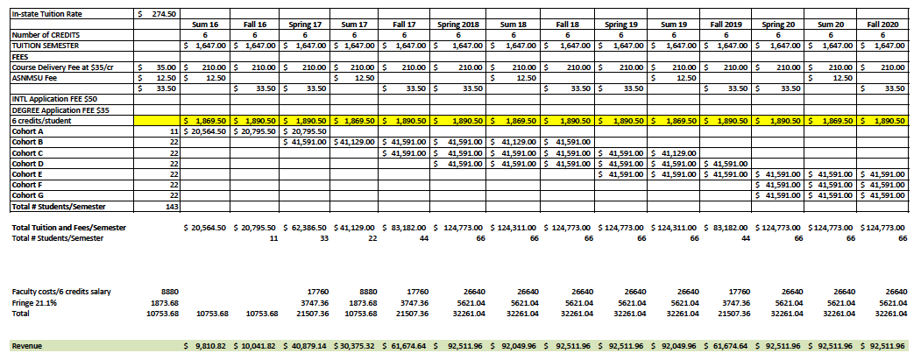

Other support and economic impact. A Psychopharmacology Program Advisory Board comprised of current and former psychopharmacology program teaching faculty and community-based allies provide ongoing support for the enhancement of the program as well as practicum placement for the program participants.

An additional economic impact of the program is the funds expended by each student that does not live in Las Cruces. For those who drive, the cost for gas impacts state/city funds as do room and board costs to attend courses during the weekends. Flight costs also contribute to economic development. It is important to take into consideration the program’s impact to economic development.

- QUALITY OF THE PROGRAM

The program meets NMSU Board of Regents’ policies, rules and regulations and complies with HED criteria for evaluation of graduate programs and NMAC policy 5.3.12.8, General Principles Guiding Instructional Funding, Part B, Academic Quality. Program faculty has the relevant credentials, supervisors are appropriately licensed, and student entry requirements meet accepted principles of program quality. Program effectiveness is documented by various means: student exams, reports, presentations, clinical supervisor evaluations and pass rates on the PEP exam.

Admissions. The prescribed admissions process the Graduate School establishes for programs and departmental/program policies are followed. As noted previously, applicants must already possess the doctoral degree (PhD, PsyD) and psychology license.

Advising. All students will receive advisement on the timeline to complete the program. The program director will facilitate an annual review of progress.

Program of study. The program consists of 36 credits of which 6 credits are for practica. Field-experiences are required as part of the degree, as per New Mexico law.

COURSEWORK/PROGRAM OF STUDY

UNIT 1: FOUNDATION OF PSYCHOPHARMACOLOGY

RXPP 601- Introduction to Psychopharmacology for Psychologists I (3 credits)
Prerequisite: Doctorate in psychology

Introduction to Gross Anatomy
Introduction to Neuroanatomy and Chemical Anatomy of the Nervous System
Neuroanatomical Dissection

RXPP 602- Introduction to Psychopharmacology for Psychologists II (3 credits)
Prerequisite: Doctorate in psychology

Neuroanatomy and Chemical Anatomy of the Nervous System
Chemistry and Biochemistry for the Prescribing Psychologist
Chemistry and Biochemistry for the Prescribing Psychologist- continued
Human Physiology and Neurophysiology and Related Drug Groups for Treatment

UNIT 2: PHARMACOLOGY

RXPP 603- Clinical Psychopharmacology I (3 credits)
Prerequisite: Doctorate in psychology

Principles of Pharmacology-I
Principles of Pharmacology-II
Principles of Pharmacology-II– continued

UNIT 3: PATHOPHYSIOLOGY AND EVIDENCE-BASED MEDICINE

RXPP 606- Pathophysiology for Psychologist I (3 credits)
Prerequisite: Board Certified Licensed Psychologist

Pathophysiology of the Integumentary system for Prescribing Psychologists
Physical Assessment of the Integumentary System
Neuropathophysiology and Neurological Disorders for Prescribing Psychologists.
Neurological Disorders and Neurological Assessment for Prescribing Psychologists.

RXPP 607- Pathophysiology for Psychologist II (3 credits)
Prerequisite: Board Certified Licensed Psychologist

Pathophysiology of the Cardiovascular System for Prescribing Psychologists
Physical Assessment of the Cardiovascular System for Prescribing Psychologists
Pathophysiology of the Chest and Pulmonary System for Prescribing Psychologists
Physical Assessment of the Chest and Pulmonary System for Prescribing Psychologists
Pathophysiology of the Immune, Hematologic and E.N.T. System for Prescribing Psychologists
Physical Assessment of the Immune, Hematologic and E.N.T. System for Prescribing Psychologists

RXPP 608- Pathophysiology for Psychologist III (6 credits)
Prerequisite: Board Certified Licensed Psychologist

Pathophysiology of the Renal and the Male Genitourinary Systems for Prescribing Psychologists
Physical Assessment of the Renal and the Male Genitourinary Systems for Prescribing Psychologists
Pathophysiology of the Gastrointestinal System for Prescribing Psychologists
Physical Assessment of the Gastrointestinal System for Prescribing Psychologists
Pathophysiology of the Endocrine and Exocrine Functions and the Female Reproductive System for Prescribing Psychologists.
Physical Assessment of the Endocrine and Exocrine Functions and the Female
Pathophysiology and Physical Assessment-Advanced Discussion of Psychopathology and Laboratory Assessment for Prescribing Psychologists
Head to Toe Physical Examination for Prescribing Psychologists.–
Exam Demonstration by Students

UNIT 4: CLINICAL PSYCHOPHARMACOLOGY

RXPP 604- Clinical Psychopharmacology II (3 credits)
Prerequisite: Doctorate in psychology

Clinical Psychopharmacology- Diagnosis and Treatment of Affective Disorders using a Psychobiosocial Model of Care for Prescribing Psychologists
Clinical Psychopharmacology- Diagnosis and Treatment of Affective Disorders for Prescribing Psychologists
Psychopharmacology of Bipolar Disorders for Prescribing Psychologists
Psychopharmacology of Anxiety Disorders for Prescribing Psychologists

RXPP 605- Clinical Psychopharmacology III (3 credits)
Prerequisite: Doctorate in psychology

Psychopharmacology of Psychotic Disorders for Prescribing Psychologists
Psychopharmacology of Psychotic Disorders– continued
Treatment of Children and Adolescents for Prescribing Psychologists
Psychopharmacology of ADHD and Developmental and Conduct Disorders for Prescribing Psychologists

UNIT 5: SPECIAL TOPICS

RXPP 609- Psychopharmacological Treatment in Special Populations I (3 credits)
Prerequisite: Doctorate in psychology

Geriatric Psychopharmacology and Treatment of the Elderly for Prescribing Psychologists
Psychopharmacological Treatment of Sleep-wake Disorders for Prescribing Psychologists
Ethnopsychiatry and Gender considerations for Psychopharmacology
Chronic Medical Illness for Prescribing Psychologists
Somatoform Disorders and Chronic Pain for Prescribing Psychologists

RXPP 610- Psychopharmacological Treatment in Special Populations II (3 credits)
Prerequisite: Doctorate in psychology

The Ethical Practice of Integrated Behavioral Care, Ethic Issues And Informed Consent Integrated Healthcare for Prescribing Psychologists
Diagnostic Rating Scales and Psychiatric Rating Instrument s for Prescribing Psychologists
Synthesis and PEP Review

PRACTICA/FIELD EXPERIENCE

RXPP 611 Practica – Must be completed between a timeframe of nine to thirty-six months; and

RXPP 612 Practica - The 400 clock hour, 100 patient practicum must be completed between nine to thirty-six months.

The graduate program leading to the Master’s Degree must be completed within seven years (or eight successive summers) including completion of the Master’s Thesis or final project (Capstone Exam). Any coursework more than seven years old at the time of the final examination will not be included.

Field experiences and placements. The program director will arrange field placements for students. Where needed, Memoranda of Understanding/Agreement will be created to formally place students in agencies, hospitals and clinics. All field placements will be pre-approved.

Program handbook. Program handbooks will provide all the necessary information students need to successfully complete the program. They outline the expectations for students, faculty, the program, department and field placements. When any changes occur, such as modifications to the curriculum, students will be asked in writing if they choose to move to the new curriculum or any need program policies and regulations. The Program Handbook is an official contract between the program/department and the student. A field experience handbook provides students with all necessary information on the supervised clinical experience. The field experience handbook is available in Appendix 6.

Supervision. The primary program supervisor is the program director. For field placements, the university supervisor serves as the overall supervisor. However, the on-site supervisor will provide the relevant training and mentorship in applying knowledge to gain skills in practice. Students apply pedagogy at their sites. Supervisors provide face-to-face supervision consistent with APA rules and regulations.

- ASSESSMENT OF OPERATIONS AND IMPACT

Progress monitoring. The student annual evaluation will include feedback from instructors, class attendance and grades. Students meet the criterion of a minimum grade of “8”. Students are expected to repeat a course when the criterion is not met.

Field site supervisors will complete the field experience evaluations. Students are expected to meet criterion relevant for field placement experience. Students in early or first practica will be evaluated formatively and summatively. The final field experience evaluation is summative and will be the data collected to determine quality of student experiences and be available for program evaluation and improvement.

Student evaluations. Students will be expected to complete evaluations of courses regularly. Poor evaluations will result in faculty being reviewed and appropriate support for improvement will be provided. In cases where faculty do not meet the quality needed, other faculty with the relevant background and expertise will be assigned to these courses.

Alumni survey. Completer surveys will be created for implementation in fall 2016.

- ADMINISTRATIVE RESPONSIBILITY AND INSTITUTIONAL COMMITMENT

Location of the program. The clinical psychopharmacology program is housed in the Counseling and Educational Psychology Department in the College of Education. At this time, the School of Nursing within the College of Health and Social Services is the sole academic program that contributes facilities support to the overall operation of the clinical psychopharmacology program.

Administrative support for the program and approvals. The Counseling and Educational Psychology Department lends full support for the program through the provision of administrative oversight, program staffing, administrative support staffing and graduate assistant support. The dean of the College of Education fully endorses the program as demonstrated by the pronouncement of clinical psychopharmacology as a program of distinction within the college.

The proposal for this major was evaluated and approved by all relevant bodies at NMSU beginning with the CEP department faculty and concluding with the NMSU Board of Regents (including approval by Faculty Senate, Provost and President).

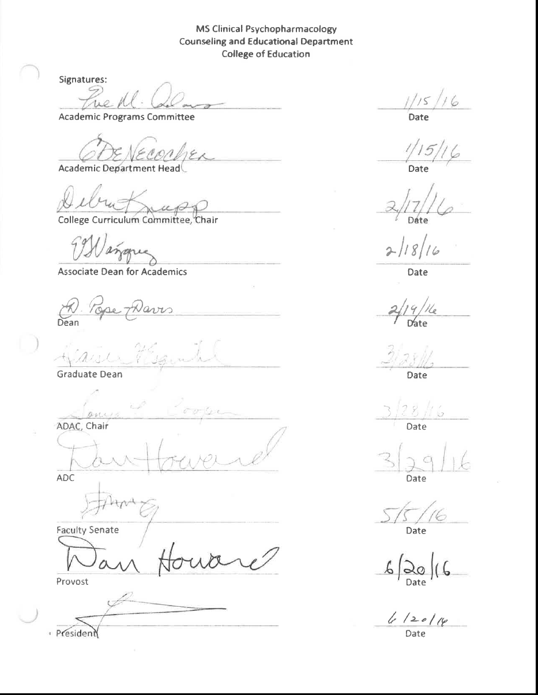

References
American Psychological Association. (2010). APA announces the designation process for psychopharmacology programs. Retrieved from http://www.apapracticecentral.org/advocacy/authority/psychopharmacology-designation-process.aspx?_ga=1.107385803.835438606.1389291399

American Psychological Association. (2015). Psychopharmacology. Retrieved from http://www.apa.org/ed/graduate/specialize/psychopharm.aspx

LeVine, E & Foster, E. (2010). Integration of psychotherapy and pharmacotherapy by prescribing psychologists: A psychobiosocial model of care. In R. McGrath & B. Moore, Therapy for Psychologists: Prescribing Collaborative Roles. Washington, DC: American Psychological Association.

Murray, F. & Lopez, A. (1999). The global burden of disease: A comprehensive assessment of mortality. Cambridge, MA: Harvard School of Public Health.

World Health Organization, (2001). Retrieved from http://www.who.int/whr/2001/media_centre/press_release/en/

OptumHealth New Mexico. (2012). Behavioral health provider directory. Retrieved from https://www.optumhealthnewmexico.com/consumer/en/docs/OHNM_Provider_Direcotry.pdf

