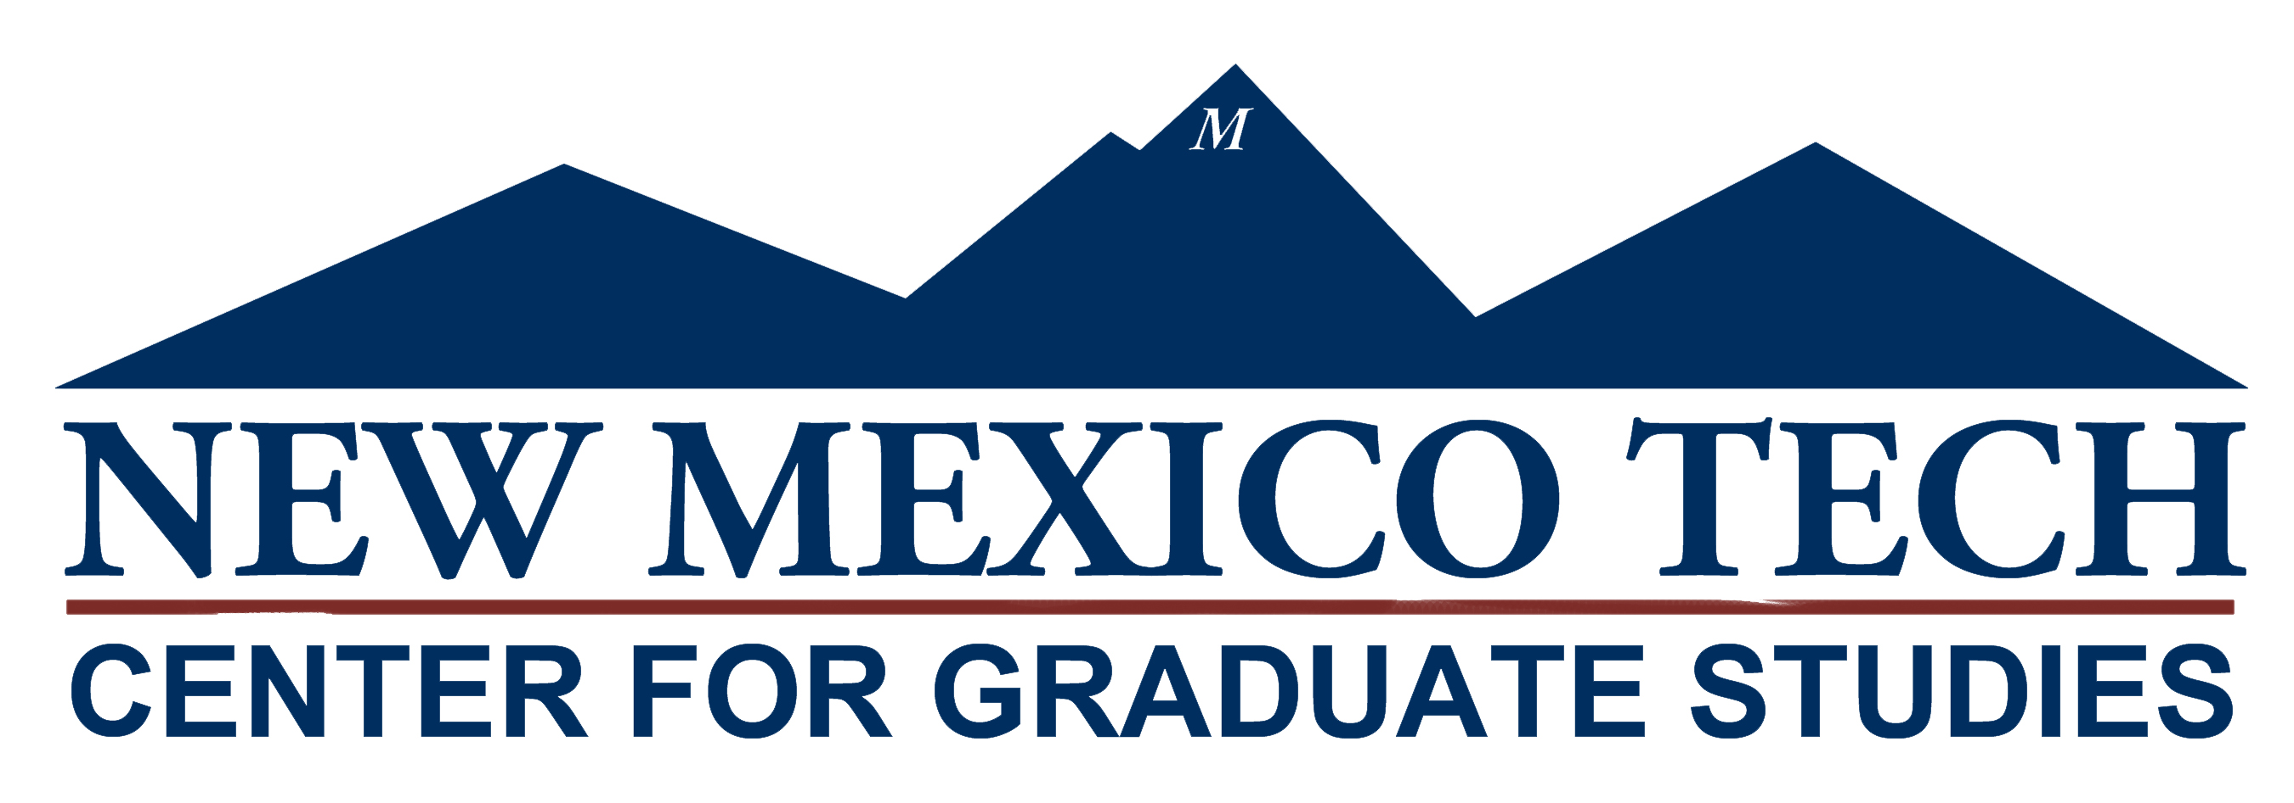
New Mexico Institute of Mining and Technology
Center for Graduate Studies
Fidel Center
801 Leroy Place
Socorro, NM 87801
Telephone (575) 835-5513
.Fax (575) 835-5476

CROSS ENROLLMENT PETITION

Graduate cross enrollment simplifies the process for a graduate student enrolled at one (Home) university in New Mexico to easily take a course at another university (Host) in New Mexico. Cross enrollment allows graduate students to have access to courses and expertise not available at the home institution. NMT Students must complete the form below. You must also obtain approval of the official instructor(s) of record at the Host University. E-mail approval is permitted. Please submit instructor approval with this form.

Graduate students, please print or type this section clearly.
- Personal Information
NMT ID Number: Date:
Gender: Female Male Date of Birth:
Name (as it appears on NMT record):
NMT Email Address:
Degree Program:
- Are you on an Assistantship or other form of financial aid? Yes No
- What type of aid?
- Host School Information

Name of Institution | Course # | Course Title | Instructor

- Transcript Request
I request and authorize the Host Institution to send my official transcript to the following address upon completion of my cross-enrollment course: New Mexico Tech, Center for Graduate Studies, 801 Leroy Place, Socorro, NM 87801.

Signature of Student

Date

To be completed by Graduate Unit / Department.

Signature of Graduate Advisor

Date

Signature of Department Chair or Graduate Coordinator

Date

To be completed by Center for Graduate Studies. Please forward the form with department signatures to Graduate Studies

This request is:

Approved
Denied

Signature of Dean of Graduate Studies

Date

If denied, explanation:

