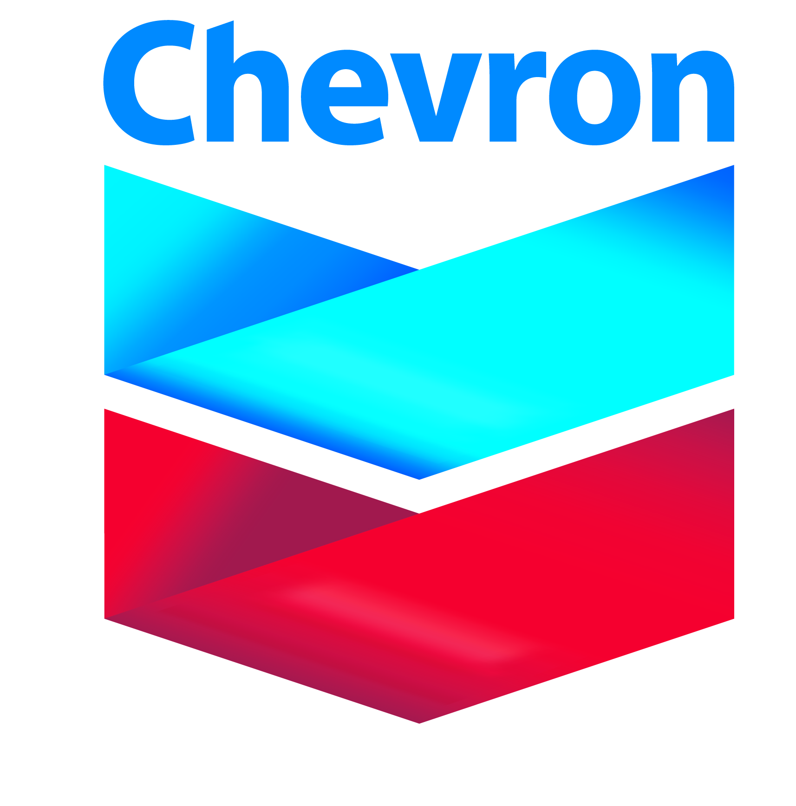

Chevron Scholarship Application

Criteria: All recipients must meet these minimum requirements to be considered:
- Full-time student
- Minimum 3.0 GPA
- Must be pursuing a degree that is beneficial to Chevron business (Recruiting Team Leaders will communicate degree types)
- Must demonstrate knowledge and interest in Chevron and energy industry
- Applicants who will need sponsorship to work in the United State now or in the future must be pursuing a PhD
Students from sanction countries may be considered for awards on a case-by-case www.treasury.gov/resource-center/sanctions/programs
- A minimum of 1 noteworthy achievement/recognitions (Dean’s List, etc)

Name:___________________________________ SSN:_____-____-_____ ID:_____________

Address (local):_________________________________________________________________

Major:_____________________________ GPA:________ Soph___ Jr___ Sr___ Grad___

Expected graduation date:__________________

List any achievements/recognitions (Dean’s List, etc.) _____________________________________________________________________________

Clubs or Organizations Membership: _____________________________________________

______________________________________________________________________________

Leadership Role(s) in Club or Organization:____________________________________

______________________________________________________________________________

Freshman/Sophomore: Did you have an energy related internship OR non-technical work experience? If yes, where: ____________________________________________________

Junior/Senior: Did you have a technical internship related to your field of study? If yes, where: ____________________________________________________

Seniors: Do you intend to seek a graduate degree immediately following graduation?
____________________________________________________

M.S./Ph.D.: Did you have a technical internship related to your field of study? If yes, where: ____________________________________________________

What is your Thesis/Dissertation topic-must be related to energy industry:
______________________________________________________________________________
_____________________________________________________________________________
Career Interests/Goals in Chevron and energy industry:______________________________________________________________________

______________________________________________________________________________

I am a full time student attending New Mexico Tech. I certify that the above information is complete and accurate to the best of my knowledge. Misrepresentation in any statement by me will be considered adequate grounds for denial or cancellation of any award. I also give my consent for New Mexico Tech to release my academic information to the scholarship donor (Chevron).

_______________________________________________ _______________________
Student Signature Date

Please return completed electronic copy to:

Kimberly Aragon (MSEC 300A) : kimberly.aragon@nmt.edu

Questions can be directed to Prof. Rahnema (Petroleum Engineering)

